ORACLE SOA 12C

1. TABLE OF CONTENTS

1 SOA introduction 5

1.1 Basic Concepts of SOA 5

1.1.1 What is a Service? 5

1.1.2 Anatomy of Service 5

1.1.3 What is Web Service? 5

1.1.4 What is Web WSDL? 5

1.1.5 What is Web BPEL? 6

1.1.6 SOA Definition 6

1.1.7 Why SOA 6

1.1.8 SOA Architecture 6

1.1.9 SOA-Framework 7

1.1.10 Principles of SOA 7

2 Oracle SOA 12C 9

2.1 Development experience 9

2.1.1 New Database Connection Types 10

2.1.2 Continuous Integration 10

2.1.3 File Based MDS 11

2.1.4 BPEL 11

2.1.5 Updated XSLT mapper: 11

2.1.6 New XQuery support (including own mapper) 12

2.1.7 Use nXSD anywhere 12

2.1.8 Adapters 12

2.1.9 UMS Adapter 13

2.1.10 MFT Adapter 13

2.2 Adapters in SOA 12c 21

2.2.1 Database Adapter 21

3 INSTALLATION OF ORACLE SOA 12C 29

3.1 Installation of SOA 12c 29

4 create and execute simple composite 32

4.1 Working with JDeveloper 32

4.1.1 Creating Hello World Application in JDeveloper 32

5 ADVANCED SOA CONCEPTS 40

5.1 Encryption and Decryption of Sensitive Data 40

5.2 Transaction Management in Oracle SOA (BPEL) 40

5.3 Domain Value Maps 41

5.3.1 Domain Value Map Features 42

5.3.1.1 Qualifier Support 42

5.3.1.2 Qualifier Order Support 42

5.3.1.3 One-to-Many Mapping Support 43

5.4 Protecting Personally Identifiable Information 43

5.4.1 Overview of PII Data 43

5.4.2 Understanding the PII Security Policy 44

5.4.3 PII Policy XPath Expressions 44

5.4.4 When Can You Use the PII Policy? 46

5.5 Subprocess in Oracle SOA Suite 12C 46

6 SOA TASKS 51

6.1 Working with AQ Tables, AQ Adapter, Files and File Adapter 51

6.1.1 Configuring AQ Adapter 52

6.1.2 Composite to Read the message from xml file and Enqueue Message in AQ 55

6.1.2.1 Create a file adapter to read message from XML file 55

6.1.2.2 Create AQ Adapter for Enqueue operation 57

6.1.2.3 Create Mediator component to route the messages 58

6.1.3 Composite for Dequeue Message from AQ and write into XML file 59

6.1.3.1 Create AQ Adapter for Dequeue operation 59

6.1.3.2 Create a file adapter to write messages into XML file 61

6.1.3.3 Create Mediator component to route the messages 62

6.2 Working with Database Adapter 63

6.2.1 Selecting the data from Database 63

6.3 Working with Transformations 80

6.3.1 Using if in Transformation 80

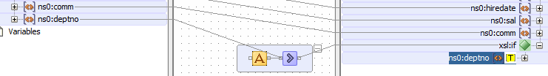 80

6.3.2 Using for-each in Transformation 80

6.3.3 Using for-each for parent-child in Transformation 81

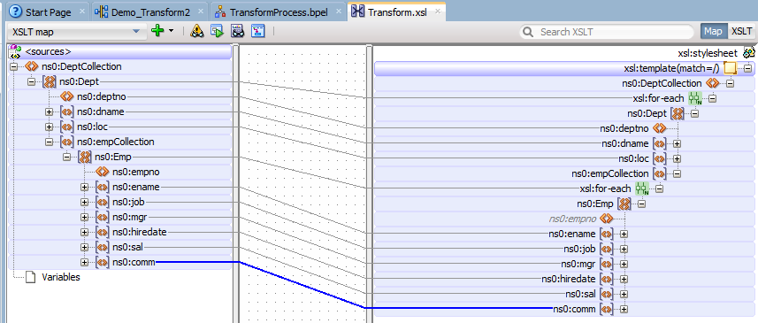 81

6.3.4 Using choose in Transformation 81

6.4 Create Domain Value Maps 82

6.4.1 Create a domain value map 82

6.4.2 Use domain value map in Assign activity 84

6.4.3 Use Domain Value Map Functions in Transformations 86

6.5 Security 88

6.5.1 Web Service Authentication and Authorization using OWSM Policies in SOA 88

7 Realtime scenarios 102

7.1 Date Handling 102

7.2 Flow and Instance ID 102

7.3 Java Embeded activity to conver base64 binary 102

8 Oracle Service bus 103

8.1 What is Bus? 103

8.2 Resources in Oracle Service Bus 103

8.3 Proxy Services and Business Services 103

8.4 Message Flows and Pipelines 104

8.5 Pipeline Pairs 104

9 Oracle Service bus TASKS 105

9.1 Pipeline Pairs 105

9.2 Conditional Branch in SOA 112

Business case requirement: 112

Assumptions: 112

Business Service 116

Proxy Service 121

# SOA introduction

A **service-oriented architecture** (**SOA**) is a style of software design where services are provided to the other components by application components, through a communication protocol over a network.

### Basic Concepts of SOA

#### What is a Service?

* A service is a package of closely related standardized functions which are called repeatedly in similar fashion and should therefore implemented by dedicated facility which is specific to perform them.
* A service can be partitioned and have multiple service functions
* The smallest subset within service functions are called service primitives

#### Anatomy of Service

#### What is Web Service?

A **web service** is any piece of software that makes itself available over the internet and uses a standardized XML messaging system. XML is used to encode all communications to a **web service**. For example, a client invokes a **web service** by sending an XML message, then waits for a corresponding XML response.

#### What is Web WSDL?

A **WSDL** is an XML document that describes a web service. It actually stands for Web Services Description Language

#### What is Web BPEL?

BPEL (Business Process Execution Language) is an XML-based language that allows Web services in a service-oriented architecture (SOA) to interconnect and share data. Programmers use BPEL to define how a business process that involves web services will be executed. BPEL messages are typically used to invoke remote services, orchestrate process execution and manage events and exceptions. BPEL is often associated with Business Process Management Notation (BPMN), a standard for representing business processes graphically. In many organizations, analysts use BPMN to visualize business processes and developers transform the visualizations to BPEL for execution.

#### SOA Definition

Architecture based on reusable, well defined services implemented by IT companies.

* Components are loosely coupled
* Provide platform, technology and language independent.

#### Why SOA

SOA functionality is not depending on any vendor, product or application.

#### SOA Architecture

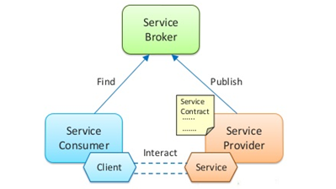

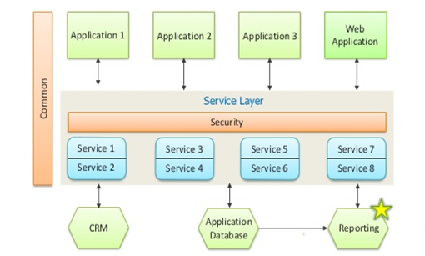

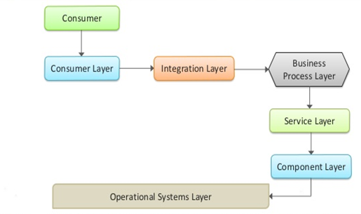

#### SOA-Framework

* **Consumer Interface Layer** – This layer is used by the customers
* **Business Process Layer** – Provides the business Process flow. Also accommodates new changes in the business easily, hence this layer is provided
* **Service Layer** – Comprises of all the services provided in the enterprise
* **Component Layer** – This layer has the actual service to be provided.
* **Operational subsystem layer** – This layer contains the data model

#### Principles of SOA

* **Service loose coupling** – Service does not have high dependency
* **Service abstraction** – Hides the implementation details
* **Service Reusability** – Services can be reused again and again without rewriting them
* **Service Statelessness** – Do not maintain the state to reduce the resource consumption
* **Service Discoverability** – Services can be registered and discovered from the service registry

# Oracle SOA 12C

Oracle has released SOA Suite 12c and lots of new features are introduced in this release. Below is list of some of the new features.

The 'c' in 12c stands for Cloud and represents Oracle’s significant investments in delivering cloud-ready products. The new additions to Cloud adapters, support for REST and JSON are direct testimony for that. Read on to see a list of differences between the 11g and the 12c versions of SOA Suite and related products.

### Development experience

* The **Integrated WebLogic Server** in JDeveloper is configured in 12c to also run SOA Suite 12c applications. This means
* A SCA Composite can be run directly from within the IDE to the integrated server – instead of explicit deployment to a standalone WebLogic Server with SOA Suite runtime.
* You can put breakpoints and step through your composite, in real time !!!
* The IDEs for Service Bus and SCA Composites will be integrated in 12c in JDeveloper.
* **Templates** will be available throughout the SOA Suite 12c IDE – allowing blue prints with placeholders for SCA Composites, Pipelines, BPEL processes to be prepared and reused when developing the real artifacts. The new SOA starter templates provide an easy way to package SOA composites, components or fragments of a BPEL process and distribute them to other departments, partners or customers
* **Debugging and refactoring** support is available in the 12c IDE, for both Service Bus and SCA Composites.
* **Dependency Explorer:** This allows to "visualize" the dependencies between various SOA composites as well as Service Bus projects which typically consist of fair number of artifacts that hang together in ways that are sometimes not so easy to track down. It will leverage all its built in knowledge about potential dependencies and it will visualize these dependencies.
* **Testing:**Develop and test without having to go to EM. It is very simple to test the web services (SOAP and REST) exposed by SOA composites from the comfort of your own IDE. Using a simple right mouse click on the composite’s service interface (in the Application Server overview window), we can start the HTTP Analyzer for the service – with the right endpoint set, the WSDL (or WADL) loaded and the request message entry form ready to be filled in.
* **Property inspector window:** Before release 12c, editing activities in a BPEL process was done in the wizard that could be activated by double clicking the activity or by selecting edit from the context menu on an activity. Alternatively, a developer could resort to the BPEL process source file to make changes to the definition of activities. In 12c, the property inspector has been extended to also support editing the properties of BPEL activities. When the property inspector window is available, it will synchronize with the currently selected activity in the BPEL editor.
* Component and Property palette undergone a metamorphosis. In the Component palette the Components and adapters are now logically separated and it is possible to display the items in a list view.
* The JDeveloper IDE acknowledges Folders as a construct that the developer needs control over. Until now, folders were visible in JDeveloper because they existed on the file system. They could not be manipulated from within the IDE. Now, in the 12.1.3 release, they can be created, from the New Gallery
* **Enterprise Scheduler(ESS)** SOA 12c comes with its own OOTB scheduler. It is integrated in em
* It provides the ability to schedule SOA components or services and manages the complete life cycle of a job definition: development, distribution, scheduling, and monitoring
* Polling adapters can now be restricted to certain times of the day, for example outside of business hours, to avoid resource overload. Users can associate an inbound adapter for a SOA Service with ESS schedules to customize timings for processing of messages.
* It is also used for bulk error recovery
* Fault Policy Editor
* Design and Edit Fault Policies.
* Besides the already existed functionality a lot of new features are added.
* Graphical editor for creating Fault policies, Alerts, Actions & Property Sets
* New Default actions for invoking a WS and enqueue data (JMS).
* Alerts can be defined to send fault to JMS, Email or Log file.
* Alerts can be assigned to actions if type of Alert is desired to be triggered.
* Fault Policies can be coupled, using the Composite Binding dialog, to different levels:
* • composite • component • reference binding and service binding • New Database Connection Types
* SOA Suite 12c adds two new Database connection types when creating Database connections; JavaDB and JDE World. JavaDB (Derby) is used to run SOA Suite repository on that is used for the integrated server. With the JDE World connection you have easy access to the data in the JD Edwards database.

#### New Database Connection Types

* SOA Suite 12c adds two new Database connection types when creating Database connections; JavaDB and JDE World. JavaDB (Derby) is used to run SOA Suite repository on that is used for the integrated server. With the JDE World connection you have easy access to the data in the JD Edwards database.

#### Continuous Integration

* Continuous Integration brings agility to the systems development lifecycle (SDLC) by completing packaging, testing and deployment of every change to the code.
* Oracle SOA Suite 12c provides a Maven plugin that allows development teams to use Maven to create, build, package and deploy SOA projects.
* Through the SOA application and project archetypes, development teams can automate the instantiation of a developer's working environment.
* Through the Maven plugin goals, a Continuous Integration server such as Hudson can be used to manage SOA projects through the complete lifecycle

#### File Based MDS

In addition to the existing run-time Meta Data Services Repository, Oracle SOA Suite 12c adds a file-based SOA Design-Time MDS Repository for use during design time. The repository is automatically created when you create a SOA composite application and will typically point to the version control system location.

#### BPEL

An **in-line sub process** has been introduced. In-line sub process can best be thought of as a callable scope. It is a scope that is not part of the normal process flow, but rather a unit of encapsulated logic that can be called zero, one or multiple times from anywhere within the BPEL process – even recursively from within itself. It is in effect very similar to a private member function in a Java Class or a procedure in the body of a PL/SQL package.

A **stand-alone Sub Process** has been introduced

These are defined in a separate file (with extension .sbpel) and appear as components in their own right in the composite overview. They can be called from multiple other BPEL components (but only from BPEL components)

Encrypt/Decrypt **Personally-Identifiable Information** (PII): It assists in Protecting sensitive data from appearing in the Admin consoles in clear text.

For example a Social Security Number or Credit card Number. Specific Fields in a message can be encrypted when entering the SOA composite application in the service binding component, and decrypted while exiting the application in the reference binding component. It is available for services and adapters in both SOA (SCA Composite) and Service Bus. The PII policy is attached to the SCA Composite. The credentials/encryption to use is configured on WLS and is stored using the Credential Store framework (CSF).

#### Updated XSLT mapper:

* Better support for complex stylesheets
* Multiple templates possible, named templates possible
* You can see the XSLT execution sequence using Execution View
* Execution View shows the order of execution of templates (both named and matched) as they would be executed by the processor.
* You can see the overall flow of a complex XSLT process and provides a means to troubleshoot problems in template creation before executing the XSLT.
* In addition, the user can use the execution view to navigate to any section of the stylesheet by clicking on the desired node in the execution view dialog
* The XSLT View provides a graphical view of all XSLT statements that can highlight context nodes for the selected template rule allow the immediate error detection when creating multiple templates

#### New XQuery support (including own mapper)

BPEL has a dedicated activity to use XQuery in your BPEL code for transformations. The XQuery mapper has support for XPath 2.0 and user defined functions. The mapper is really user friendly and it’s made consistent with the XSLT mapper interface. The mapper also has an integrated Test framework and is build for reuse in both SOA & Service Bus

#### Use nXSD anywhere

nXSD translation is a first class citizen within a BPEL process, Service Bus and Mediator. Now messages can be translated anywhere within the integration flow, not only on the edges.

**Sensors can be defined at runtime**

In SOA Suite 11g sensors had to be defined at design time. In the SOA Suite 12c it also will be possible to define or change them at runtime: Design Time at Run Time (DT@RT). This functionality is added to the existing ‘SOA Composer’ application, which is already used to change other runtime metrics like the Rule Engine and Domain Values Maps (DVMs).

#### Adapters

SOA Suite 12c will have an **adapter for Coherence**– allowing information to be put on or read from a Coherence grid – doing with the in memory Coherence grid what the database adapter does with persistent data in a relational datatabase. This JCA adapter makes it easy for a Service Bus business service or a SOA composite application to interact with a Coherence memory grid. Fully declaratively and with very little trouble, data can be put on a Coherence grid (aka cache) and read from that cache. The cache is accessed like a big map: using a key, an object is saved to and retrieved from the cache. The cache is accessible across service executions and process instances, as well as across cluster nodes.

**Cloud adapter:**Oracle SOA Suite 12c simplifies cloud integration. The recently released Oracle Cloud Adapters simplify the integration of cloud applications with your existing infrastructure to allow, for example, your field sales teams to have real-time access to all of your on-premise applications.

Adaptersto connect to SalesForce has been provided. More are in pipeline like for RightNow (Oracle Service Cloud), Oracle Sales Cloud, Eloqua (Oracle Marketing Cloud) and Big Machines (Oracle CPQ Cloud)

An SDK is also being provided to create custom integrations into the cloud.

Simple to use

The adapters have the usual look and feel of Oracle adapters.

The cloud adapter configuration wizard engages users with an extremely simplified view of the business object catalog from the SaaS application from where they could browse and select one or more objects of interest for executing CRUD style interactions.

A **REST** binding has been introduced within JDeveloper to simplify mobile enablement by exposing traditional SOAP services, Enterprise Java Beans (EJBs), JCA adapters connecting backend applications or just about any other underlying implementation through REST/JSON. The REST binding is available for SOA composites and Oracle Service Bus services and allows the configuration of REST interactions as exposed services or proxy services. It also allows the invocation of externally available REST services.

**LDAP adapter**

The LDAP adapters has support for inbound and outbound integration. With this adapter you can access you LDAP directory i.g. check if a certain user has the required privileges to execute the called operation. You can perform CRUD operations on target directory servers.

#### UMS Adapter

The UMS adapter already exists in 11g, but in the 12c release of SOA Suite this adapter has gotten a major update. In 11g the UMS adapter only supports Email, but in 12c it also support SMS and IM for inbound and outbound integration. Besides that the adapter now has a new outbound operation type to get the status of a send message.

#### MFT Adapter

New Technology Adapter: MFT For integrating Managed File Transfer (MFT) with SOA Suite there is a MFT adapter available and can be used for inbound and outbound transactions. With the inbound operation a SCA Composite can receive files or file references from MFT. The MFT adapter uses an own WSDL that can also be used for other technologies i.g. Java. With the outbound operation you can send files to a MFT server (Web service endpoint of a MFT source) to be processed further.

MQ Adapter to integrate with IBM WebSphere MQ

**MSMQ Adapter** to integrate with Microsoft Message Queuing

Microsoft Message Queueing (MSMQ) is a message infrastructure and a development platform for creating distributed, loosely-coupled messaging applications for the Microsoft Windows operating system. Applications that use MSMQ create/locate a queue, connect to the queue, navigate the queue, send/receive messages from a queue and use the MSMQ queue properties to define the behavior of the queue where applicable and needed.

**Oracle Adapter for SAP R/3**

This provides native bidirectional integration with SAP R/3. It supports invocation of BAPI/RFC and IDOCs to send and receive data from the SAP R/3 application. The Adapter is natively integrated into JDeveloper and communicates with the SAP Business Object Repository to provide a graphical browser of the objects in SAP for the user to discover, search and select for the integration. In addition to browsing the objects in the repository, the adapter design-time allows searching for the objects by name or wild card expressions

  The Web Service Adapter is renamed to **SOAP Adapter**

**OSB**

The IDEs for Service Bus and SCA Composites will be integrated in 12c in JDeveloper. For Service Bus development, this means that no longer OEPE (Eclipse) is used, In fact the development of Service Bus services looks very much like the development of SCA Composites – even with a visual overview of an SB project with its Proxy services, its pipelines and its business services – very similar to an SCA Composite with its Services, Components and References.

For Service Bus 12c, the pipeline is a first class object – along with Proxy, Split Join and Business Service. Multiple proxy services can share a pipeline, and one pipeline can call another one.

**Templates**

Just like SOA Suite’s SCA Composites the SB also supports the use of templates. But it works a little different. Templates are Pipeline-based, this means that you can select a template when creating a new Pipeline. There are two types of templates; Unlinked, which is a copy of the template, and Linked, Pipeline stays connected to template. In the template you can use Placeholders so permit changes to that part of the Pipeline. If the Pipeline is linked to a template and the template is changed the linked Pipeline will inherent these changes. You create a template pipeline, instead of a normal Pipeline and place it in a centralized project or in the MDS for re-use.

You can expose a Pipeline as a REST service. When doing it creates a REST binding just like in a SCA Composite.

**Splitting Proxy from Pipeline**

Because a SB project is more like a SCA Composite (same overview) the Proxy is split from the Pipeline. This means that the Proxy and the Pipeline are two individual things. With this concept multiple Proxies can be wired to one Pipeline

**MDS support for importing shared resources (limited)**

Service Bus has now Design-Time support for MDS (MetaData Services). You can select resources from the MDS that you want to import into your SB project. Service Bus can’t connect to a Remote MDS on runtime. This choice is made, because SB can be installed separate from SOA and SB doesn’t have there own DB repository for saving MDS artifacts.

**Dynamic Validation Activity**

SB 12c updates the Validation Activity. It is now possible to Dynamically validate a variable. Using Expressions you should return a fully qualified type or element reference (i.g. {http://www.example.com}inventoryRequest). Besides the Dynamic validation you also have the option to save the validation result to a variable or to raise an error (behavior in 11g).

**Disable Activities**

In SB 12c it is possible to disable activities. This can be handy if you want to skip activities, but do not want to remove them. Every activity can be disabled in Design-Time, but also on Run-Time using the Service Bus composer.

**Test expressions on Design-Time**

It is now possibile to test expression on Design-Time. In the Expression Builder you can click on the Test Expression icon to test the expression. JDeveloper will deploy a small artifact to the Design-Time environment of SB and start a small browser window where you can test the expression.

**SB Debugger**

Just like SOA (SCA Composite) Service Bus has a debugger. It works the same as the SOA debugger.

**Enterprise Manager instead of SBConsole**

The Service Bus console has found a new home with the switch to JDeveloper. Most functionality is moved to the Enterprise manager.

Using **Domain Value Map (DVM**) in Service Bus projects

Mediator-like **re-sequencer** now available in OSB

Business transactions often span multiple technical transactions and require groups of messages to be processed in exactly the right order. Sometimes, these messages already arrive in the correct order and need to be prevented from getting out of order, or they arrive in random order and need to be re-sequenced. The re-sequencer in Oracle Service Bus orders messages based on sequential or chronological information, and then sends the messages to the target services in an orderly manner. The sequencing is performed based on the sequencing strategy selected

**Mediator**

**Translate from Native action**

At the level of the Java callout an extra action Translate from Native is added. With this action you can transfrom a CSV/JSON/String element of the request to XML using a NXSD transformation. The transformed output can then be used in the routing rules of the Mediator. This action can be done on operation level, but also on a specific routing rule for that operation.

**Override Using action**

With this action you can override routing rule options using a DVM or Business Rules. Based on a element value of the request you can change the routing rule option dynamically. With the key value you have the possibility to override the XSLT transformation file, Filter expression, Execution Type, Syntax Validation (XSD), Semantic Validation (Schematron) file instead of creating a bunch of static routing rule.

**New graphical editor for Assign action**

The graphical editor for the Assign action is the same as BPEL uses. You can create multiple copy rules by using drag and drop functionality.

**B2B**

A new facility in SOA Suite 12c will be Managed File Transfer that provides an implementation of the claim check pattern to handle large files. MFT brings an internal (S)FTP server to the SOA Suite platform. Files can be uploaded to this server and automated operations – such as decrypt, decompress and start an SCA Composite passing it the meta-data and a reference for the file – can be configured. This allows customers to load data securely into Oracle Cloud applications as well as third-party cloud or partner applications. Streaming support for large payloads

For enhanced management and monitoring B2B is also integrated with the SOA Error Hospital. It is very simple to track messages end to end by adding direct links to Enterprise Manager Fusion Middleware Control from B2B Reports and vice versa

Support for Local Policy Attachment for Web Services security configuration have also been added

**Business Rules**

The use of business phrases in 12c will allow the definition of conditions and expressions labeled with meaningful names that can subsequently be used and reused to compose rule conditions and actions.

* Enhanced SOA Composer for Business Rules.
* Rule editing has been greatly improved
* One can also export to Excel and edit the rules there

**Oracle Event Processing**

Oracle Event Processing, part of Oracle SOA Suite, can handle up to a million messages per second at extremely low latencies when running on Oracle engineered systems(1), making it the ideal solution to perform real-time filtering, geo-location, and pattern matching on the massive streams of data generated by IoT "smart" devices.

* Just like SB, OEP leaves it previous IDE Eclipse behind and is now fully integrated in JDeveloper.
* New to Oracle Event Processing 12c is the shared use of the Oracle SOA Suite user interface, providing companies the ability to seamlessly integrate filtered and correlated big data into actionable enterprise processes for corrective action
* Two new adapters, one for CSV (in-/outbound) and EDN (in-/outbound).
* Extensions added to support Hadoop and Oracle NoSQL for use as a source just like the TABLE component
* Extension for invoking/receiving Remote Method Invocation (RMI) calls.

**BAM**

* BAM has been enhanced to enable rapid and flexible assessment of key performance indicators (KPIs) by storing the data in the industry standard star schema format.
* Multi-browser support including Mobile support, so your dashboard will look and act the same on different devices and browsers.
* In the near future BAM will get a native App (IOS and Android).
* BAM implements a more advanced Security model using OPSS (Oracle Platform Security Services) to secure the data it collects.
* BAM now support a hybrid integration of CQL and SQL, these both query languages can be used together to collect data from different sources.
* It uses Coherence for report and metadata cache.
* It has better integration with SOA Suite and BPM Suite because both use the same Uniform Star Schema and can export the data during the execution of processes to BI to allow continuous monitoring.
* BAM now support a Active-Active High Availability modes so can run on a cluster.
* Continuous monitoring can be done in three ways, Real Time, One Time and Scheduled.
* It can also correlates Business Events that are streamed using OEP.
* BAM supports a side-by-side analysis between historical BI data ans operation data.
* There is even a special BAM dashboard that can be embedded into WebCenter Pages.
* The new dashboards comes more richer out-of-the-box and there is a more extensive catalog with Metrics i.g. SOA/BPM process performance and Human Workflow / Task performance.
* The new dashboards have updated geomap, tree map, watch list, shatter chart and bubble chart components

**Monitoring experience**

**SOA-Infra Dashboard**

SOA Error Hospital - used to aggregate flow instances that have generated faults and be able to perform actions on instances with common faults collectively. The aggregations can be based on various criteria based on fault types, names or composite level aggregations

* In the SOA-Infra dashboard (recoverable) faults are visual using a chart
* The flow instances tab shows faults that can be recovered, click on Error Hospital to recover them
* In Error Hospital tab faults can be recovered, with option to Bulk Recover
* During the recover attempt the number decreases
* Recovered Faults are shown in Green
* On the SOA-Infra Dashboard page you can search for instances and create/save searches.
* In the past, retrieval of large amounts of data has caused performance problems. In order to improve this, searches have been enhanced to allow for finer grained queries, including composite sensor values, to track specific business cases. Searches can also be saved and bookmarked for quicker access.
* Deployed Composites are show with status and can easily be started and stopped:
* Composite Sensor values are shown directly in the EM dashboard when you click on a instance. You can also search on these Composite Sensors
* Fault Notification Alerts
* While dashboards provide an overview of the system and application health, administrators need to be alerted automatically when something goes wrong in the system. Fault alerts can be routed to communication channels such as email, SMS and IM, while at the same time being posted to the dashboards
* SOA Composite Dashboard
* Composite Dashboard shows only components and services
* The Composite definition can be visually displayed. This is the image of the composite as we see in JDev.
* By default no flow instances are show to give page a much needed performance boost
* When selecting a flow instance more details are show about faults
* Easy to see instance sensor values
* Easy to see Composite dependencies
* The instance flow trace shows adapters in gray and SB integration
* Diagnosability reports for all adapter binding components for SOA applications. These reports provide real-time visibility into availability and message exchange statistics with the Application or endpoint. The three new report types are Configuration Reports, Monitoring Reports and Snapshot Reports.

**Weblogic**

  The runtime and footprint of the product have been optimized at every level (memory, disk, database) to support mission critical enterprise-wide deployments and web-scale performance, further enabling customers to process increasingly massive workloads. 12c is much lighter and faster then 11g. In 11g the installation and start up times were high and it has a high memory foorprint. SOA Suite 12c changes the game with faster start up times and optimized memory usage. The main reason for this is that 12c is build in a modular way and it uses lazy loading of components.

Not all SOA components may be used/needed by a customer with this in mind 12c is build in a modular way. First of all 12c has improved start up times and memory footprint with modularity profiles enabling only required components. By default the SOA_FOUNDATION profile is configured after new installation. This can then be altered in EM.

       The profiles listed below are arranged in decreasing order of (memory) footprint

           - SOA CLASSIC ~ SOA Foundation with B2B + BPM Modules

           - SOA FOUNDATION WITH HEALTHCARE ~ SOA Foundation with B2B + Healthcare UI

           - SOA FOUNDATION WITH B2B ~ SOA Foundation Enterprise + B2B

           - SOA FOUNDATION ENTERPRISE ~ SOA Foundation + Full Adapter Set

           - SOA FOUNDATION ~ Orchestration + Mediator + Rules + Partial Adapter set

           - ORCHESTRATION ~ BPEL-Only + HWF + Partial Adapter set

           - BPEL-ONLY ~ BPEL Components + SOA Common Infrastructure + Partial Adapter set

* The partial Adapter set consist of the FileAdapter, FTPAdapter, DBAdapter, JMSAdapter, AqAdapter, MQSeriesAdapter, OracleAppsAdapter and the UMSAdapter. The full adapter sets add the rest, SocketAdapter, LdapAdapter, CoherenceAdapter, MSMQAdapter, JDEWorldAdapter and the SAP Adapter.
* Composite Lazy Loading
* 12c introduces a different approach to loading Composites. Lazy loading is a staggered loading of composite artifacts which spreads out bootstrap cost. The composite loading time is itself a fixed number, but this approach delays the loading of some resources (Schemas, WSDL, XSLTs, etc) till it receives its first time request. With this the initial time for server startup is improved and the cost across for individual composites is spread out based on their demand. It reduces overhead from composites which are rarely used and retired composites.
* Work Managers
* The self tuning threading model is implemented using Work Managers. WLS leverages work managers across SOA Suite, eliminating the need to perform manual configurations to tune for performance. The required resource management and scheduling is delegated to WLS. The Event Delivery Network (EDN) and adapters do not use work managers for all their processing, but have a separate resource model.
* DB Tuning out-of-the-box
* When running RCU to create the initial DB schemas you can choose between several DB profiles; small, medium and large. When selecting a profile in RCU it enables the appropriate OOTB performance features. The medium/large profiles automatically configure DB partitioning and Global hash indexes. The latter helps with faster querying and helps with EM responsiveness and instance tracking performance. The global hash indexes also avoids full table scans and coupled with auto purge feature which keeps the overheads low and recreating of indexes periodically helps with performance.
* Purge/Partitioning Improvements - More efficient dehydration store management (like auto-purging)
* Purging of instance data is an important part of SOA Suite maintenance. In 12c Auto purge of SOA DB is enabled by default for new installations. Purging of the SOA DB can now be scheduled through the enterprise manager, which uses Oracle DB schedular. There is improved performance due to the new DB schemas which consolidate Audit and Flow instance data and eliminates orphaned instances. 12c supports Interval Partitioning which accelerates purging by targeting tables/instances within a time range.
* New manageability enhancements for private cloud deployments. Oracle Enterprise Manager 12c features "push button"-style provisioning of complete environments for Oracle SOA 12c and fast data cloning that enables rapid deployment and testing of enterprise applications.
* Oracle Traffic Director, is a new released product, that will offer HTTP requests caching, a reverse proxy function and load-balancing based on other algorithms than just round-robin. It will completely replace Oracle WebCache
* Oracle Virtual Assembly Builder is another new product announced by Oracle which will allow users to package a multi tier application into a consolidated project and move it easily into a virtual box for development, functional testing or just to accomodate a new developer joining the project, without having to build a new system. So for example if an application has a web module, but also uses Oracle Service Bus and Oracle Database, you can assemble all these into one package and use it on an Oracle VM machine.
* The integration between the Weblogic server and Oracle RAC database is even tighter in the new release, by the use of the Active Grid Link, which now introduces session/transaction affinity with the RAC node. This new feature will bring a 3x boost in performance. Actually, that is one of the new strong selling points of the Weblogic Server 12c, which promises to bring important performance improvements.
* In the new version, there is also a tighter integration with the Glassfish application server, since now Weblogic will be able to recognize Glassfish deployment descriptors. As a consequence an application that has been developed for Glassfish and deployed on that environment can easily be migrated on a Weblogic platform by a simple re-deploy. Of course, this is subject to discussion depending on the application’s security model for example, since that will have to be accomodated for the Weblogic Security Framework.
* Another good news for Weblogic administrators and developers as well is an integration between the Weblogic Diagnostic Framework(WLDF) and JRockit’s Flight Recording functionality which promises to be a big step forward in troubleshooting and performing complex diagnostics on the applications.
* Just for Development or testing purposes, Weblogic will now shift in a super lightweight version (only 168Mb) that will download, unzip and start without the need of running an installer. Even more, one will have the option to start the Weblogic server without the EJB, JMS and JCA containers if only a basic functionality is needed, simply by adding -Dservertupe=wlx to the startup parameters.

   Dynamic Cluster Support: allows the managed servers to be automatically added based on a server template.

### Adapters in SOA 12c

#### Database Adapter

**Creation of Database Adapter**

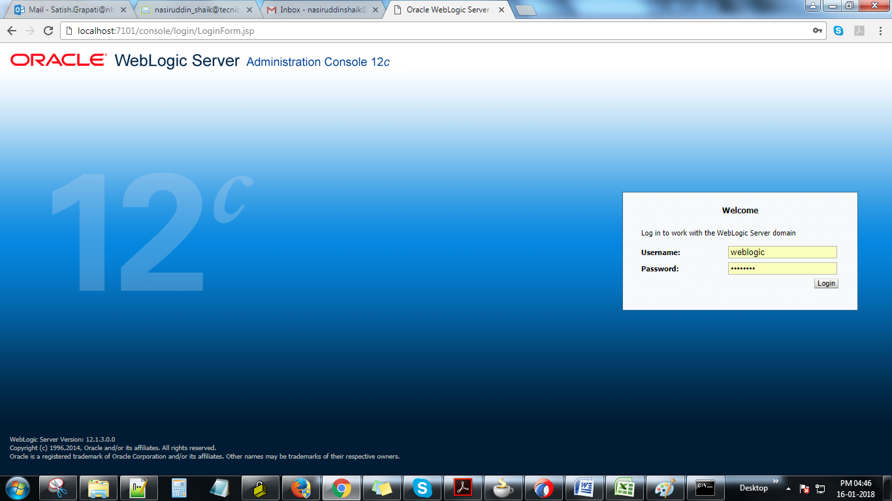

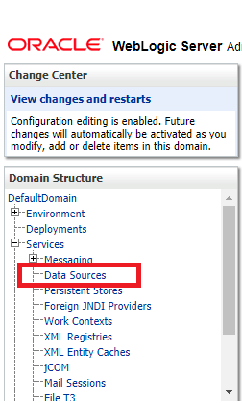

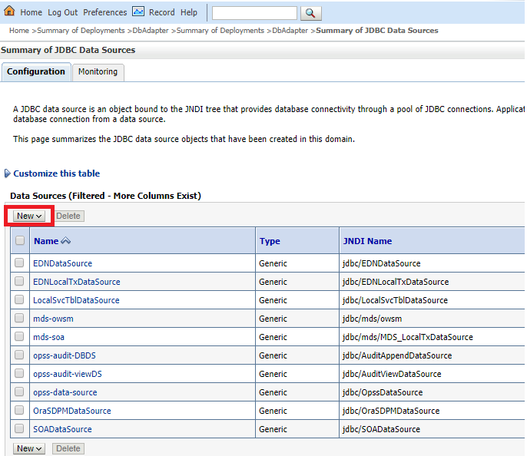

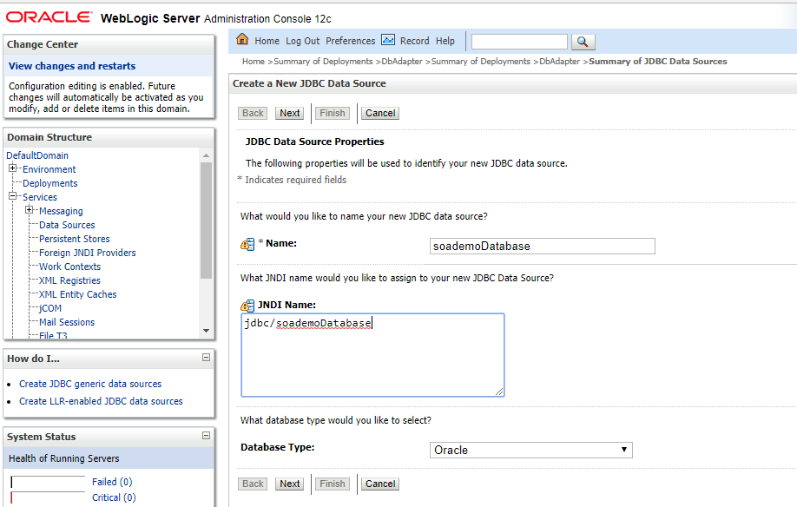

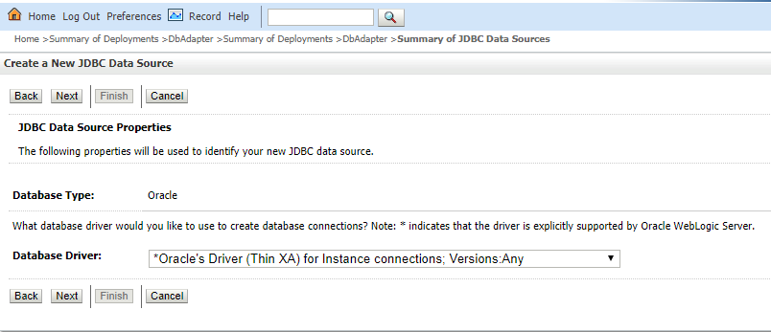

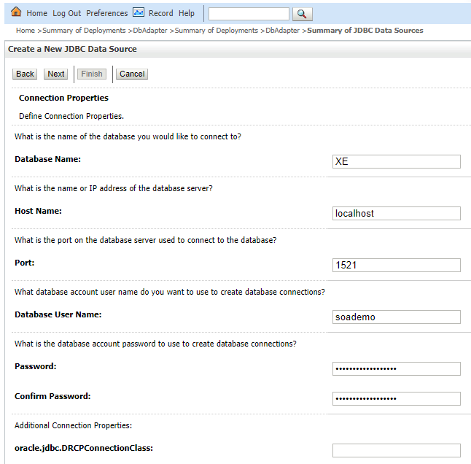

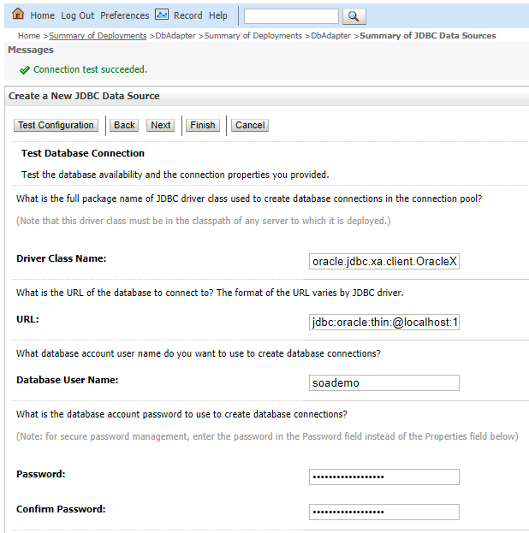

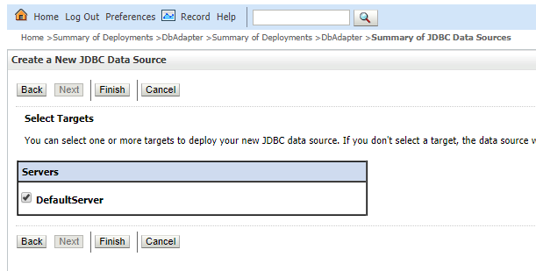

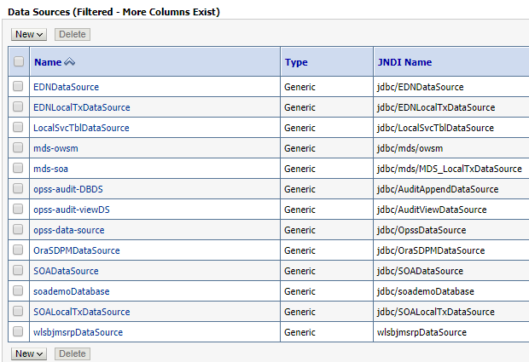

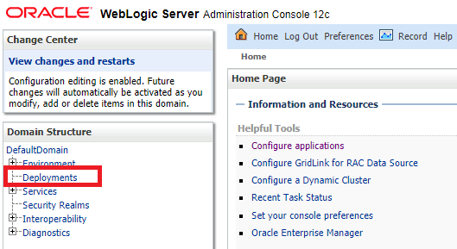

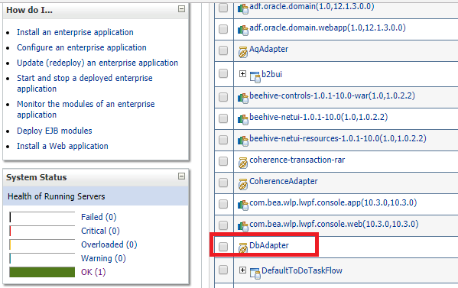

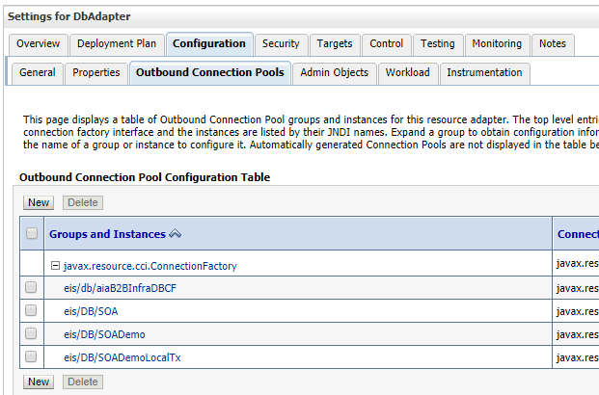

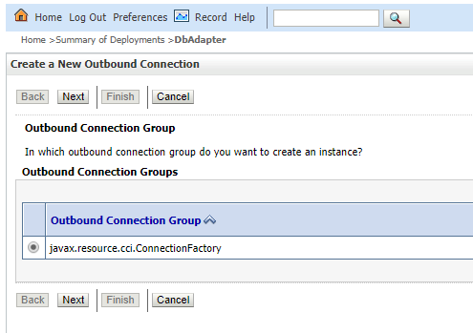

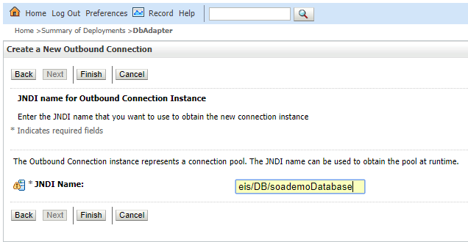

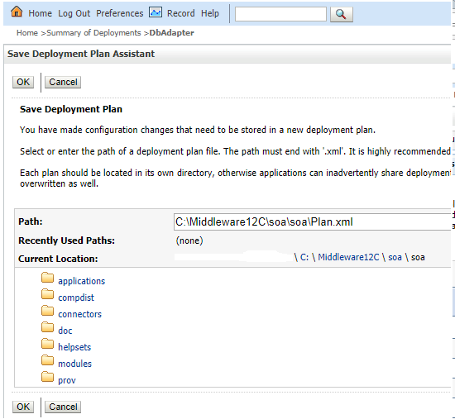

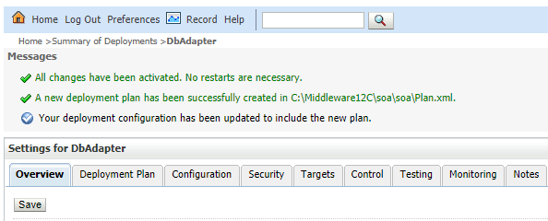

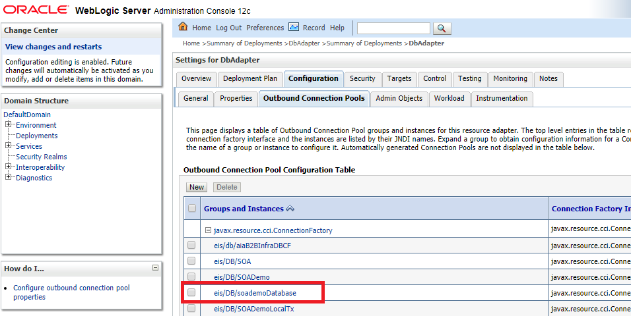

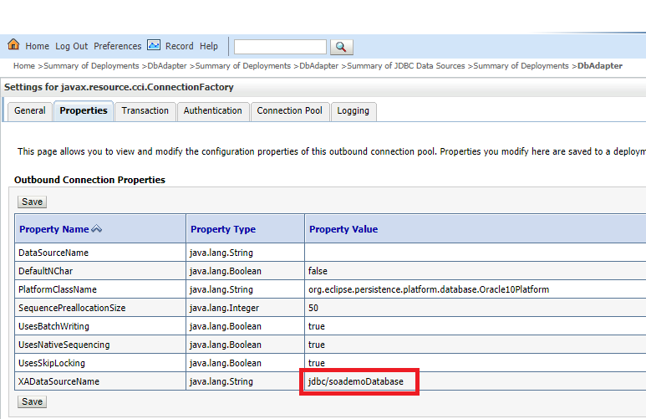

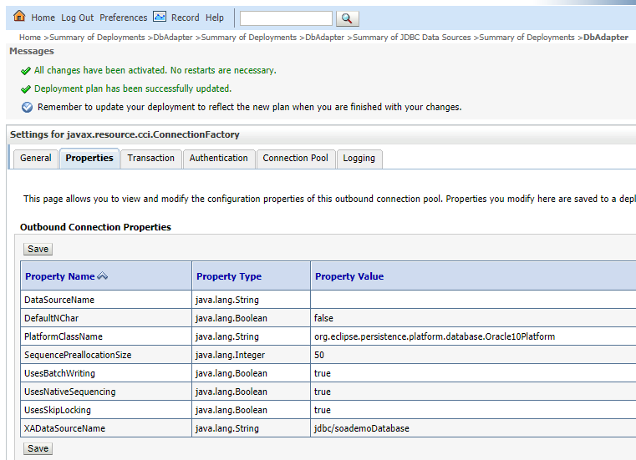

Update database adapter to activate the changes in JNDI.

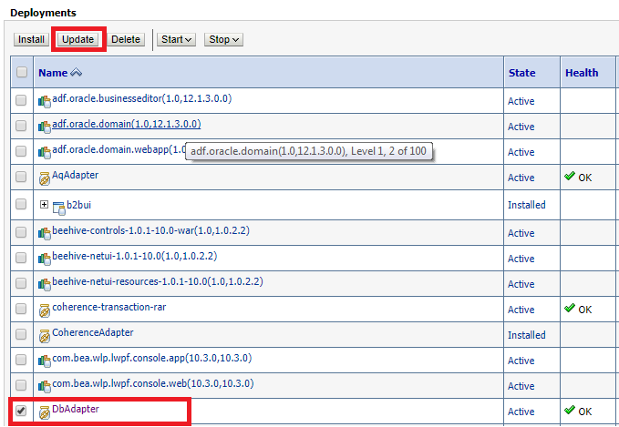

# INSTALLATION OF ORACLE SOA 12C

We create SOA application in JDeveloper and deploy it in WebLogic Server and test it. Before creating the SOA application, make sure the Admin and Managed SOA Servers are up. All the adapters need for creating the application have to be created.

### Installation of SOA 12c

Before installing SOA 12c,make sure the oracle database is installed and jdk 1.7 is installed.

* Download the oracle OSA 12c installation file named fmw_12.1.3.0.0_soa_quickstart.jar from the Oracle Technology Network (OTN).

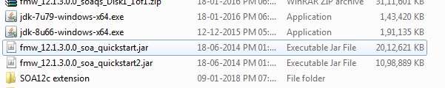

* Open the command prompt as administer.
* Go to the directory where the SOA 12c installation file is there.
* Set the jdk home (If not available in Environment variables).
* Run the jar file. Extraction will take some time and then installation window Opens.

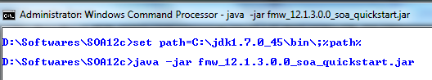

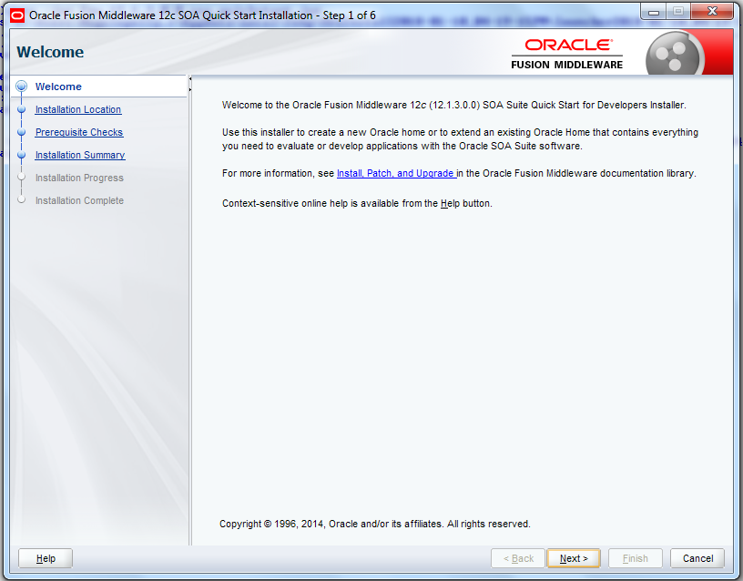

* It asks for the directory where to install the SOA 12c. You can give default location.

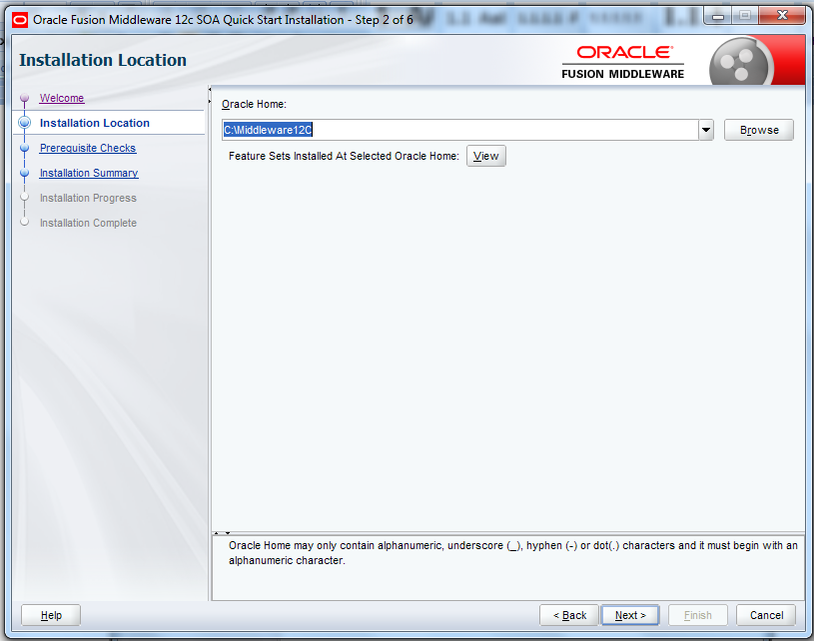

* Click next.

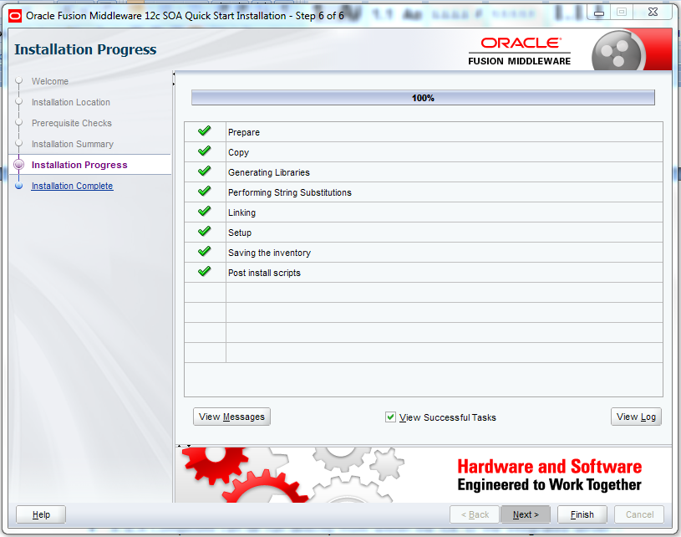

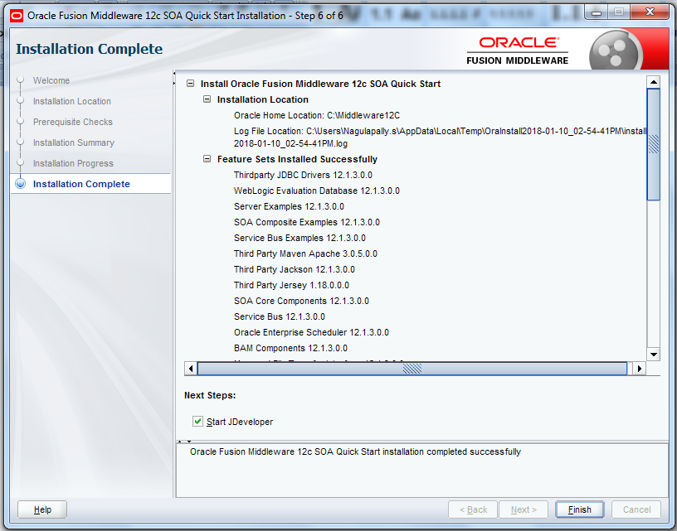

# create and execute simple composite

We create SOA application in Jdeveloper12C and deploy it in integrated WebLogic Server and test it.

### Working with JDeveloper

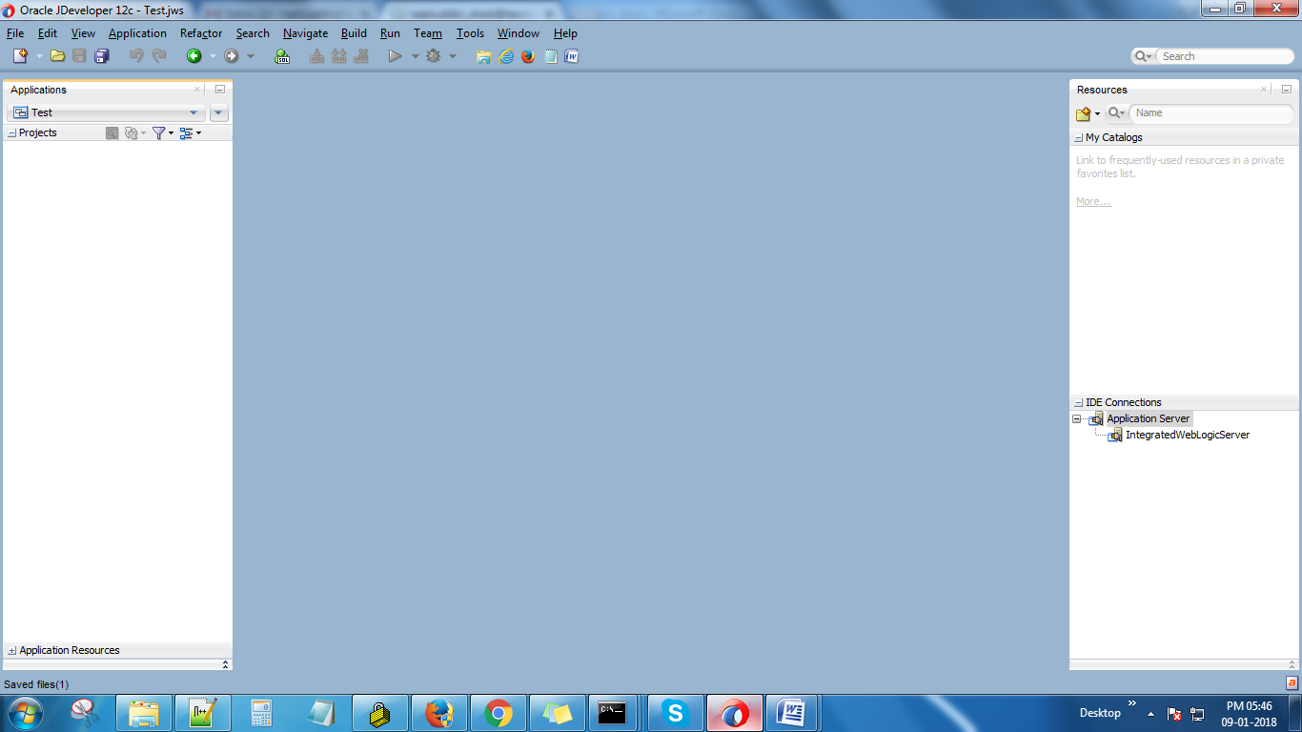

#### Creating Hello World Application in JDeveloper

An Application is the higher level of represent the interrelated or independent components. We can have multiple applications under the Application Navigator and it displays all the SOA components created under the each application.

To create Application

* Select drop down under the Application Navigator.
* Select New Application.

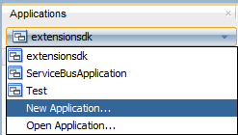

* Select SOA Application from items and click on OK.
* Give the application name and select the location where you want to save your application and select Generic in Application template.

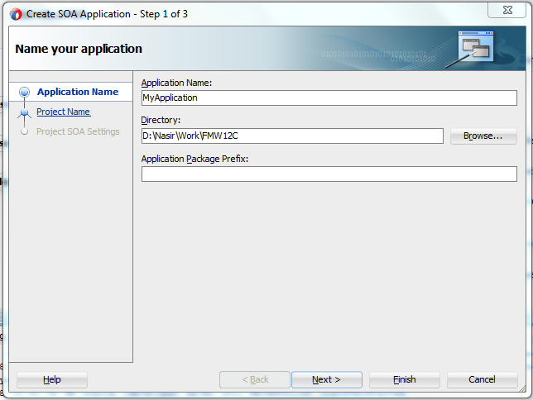

* Give the project name to create new project in the Application and click on next.

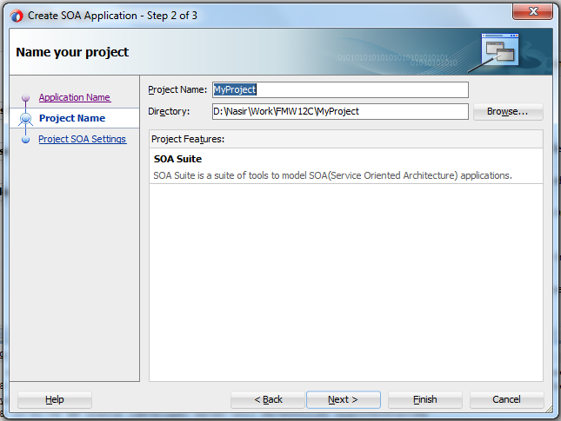

* Select ‘Composite with BPEL Process’ and click on Finish.
* Select Synchronous BPEL process and click on OK.

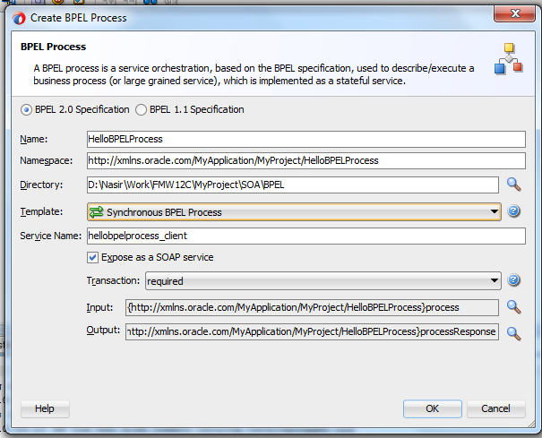

* BPEL flow is created like below image.

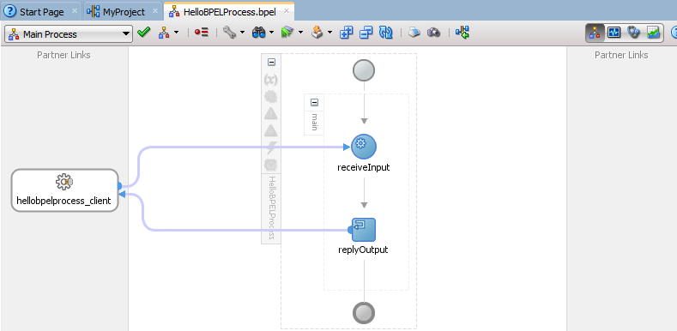

* Drag and drop Assign activity under the receiveInput.

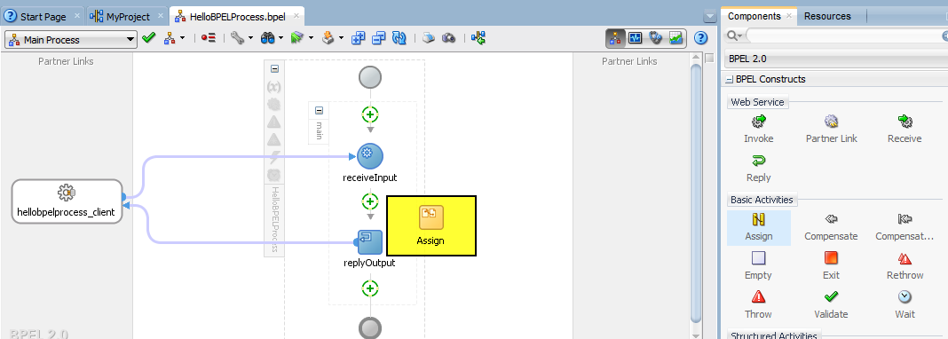

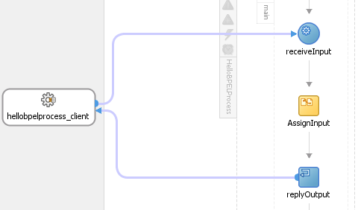

* Double click on the assign activity to open it. Add name and expression in the expression editor to assign the result to the output variable.

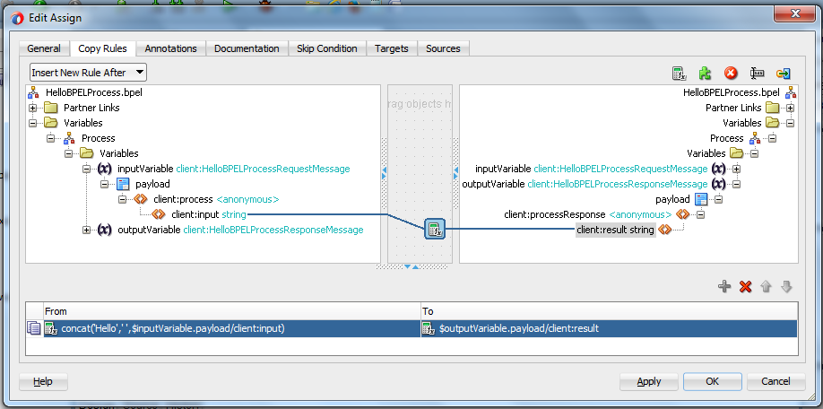

* Add the below expression in Copy Rules.

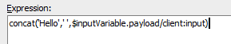

* Now the composite is complete. Compile the composite to check if any errors are there by clicking on the ‘Make Project’ icon.

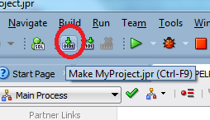

* If the composite compiled successfully then deploy the composite to Integrated Weblogic server.

**Start the Integrated Weblogic Server**

* To start the Integrated Weblogic Server, you need to select StartIntegratedWeblogic Server from Run menu.
* To run the composite in Weblogic server, right click on the project and select run.

**Deploy the application to Weblogic Server.**

* Right click on the project 🡪Deploye 🡪MyProject

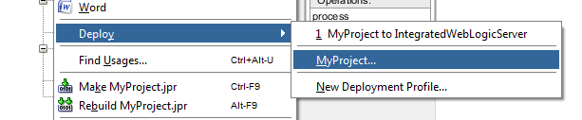

* Select deploy to application server and click on nex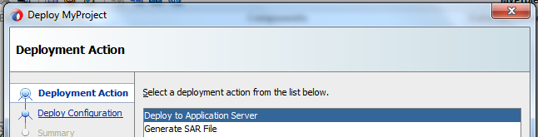
* Set the Revision ID to default and select next.

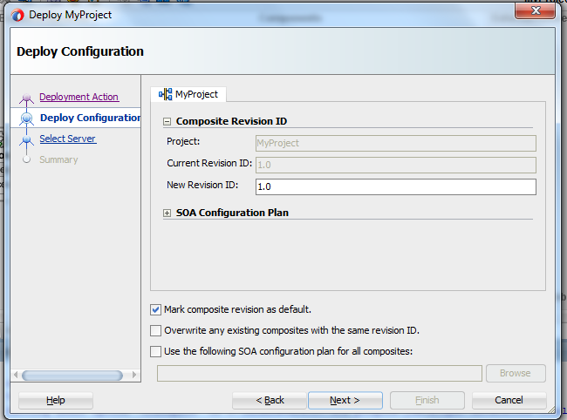

* Select the Application server you want to deploy your project.(Here we have IntegratedWeblogicServer) and click next.

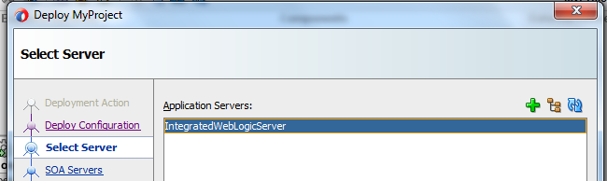

* Select the partition and click next and then finish.
* The application is deployed to the server.
* To test the composite we have deployed, we need to open the enterprise manager.

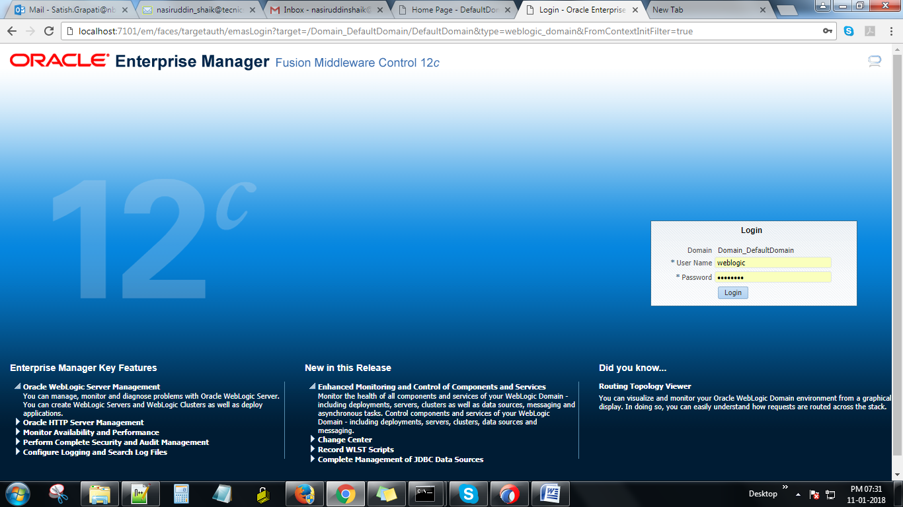

* Login to the Enterprise Manager console.
* You can browse the Composite and can see the composite.

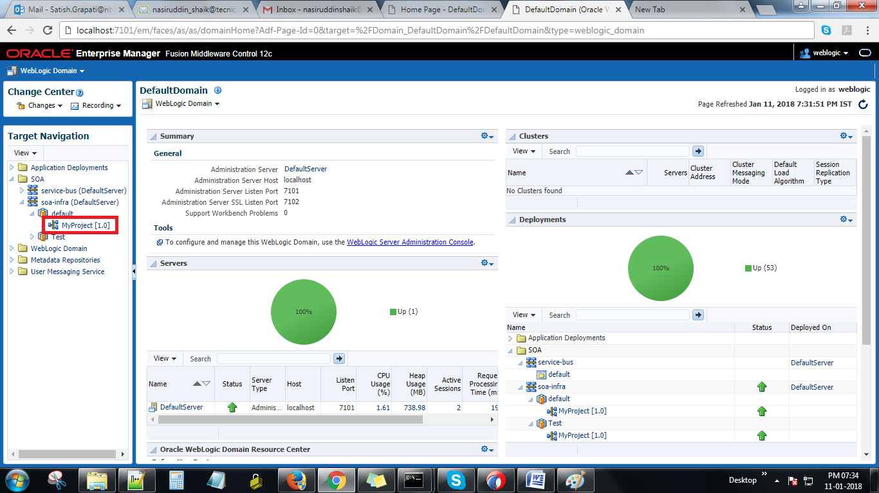

* Click on the composite to test it.

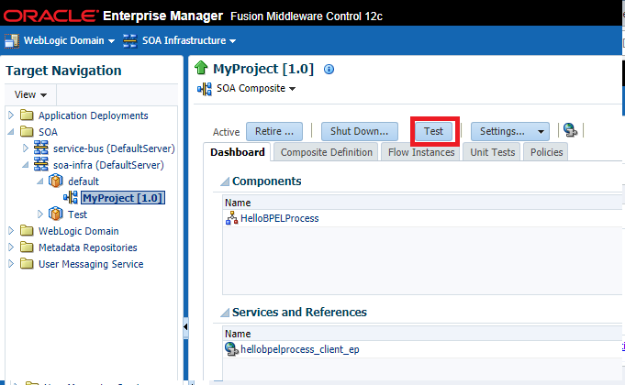

* Click on the Test button and enter the value in input field.

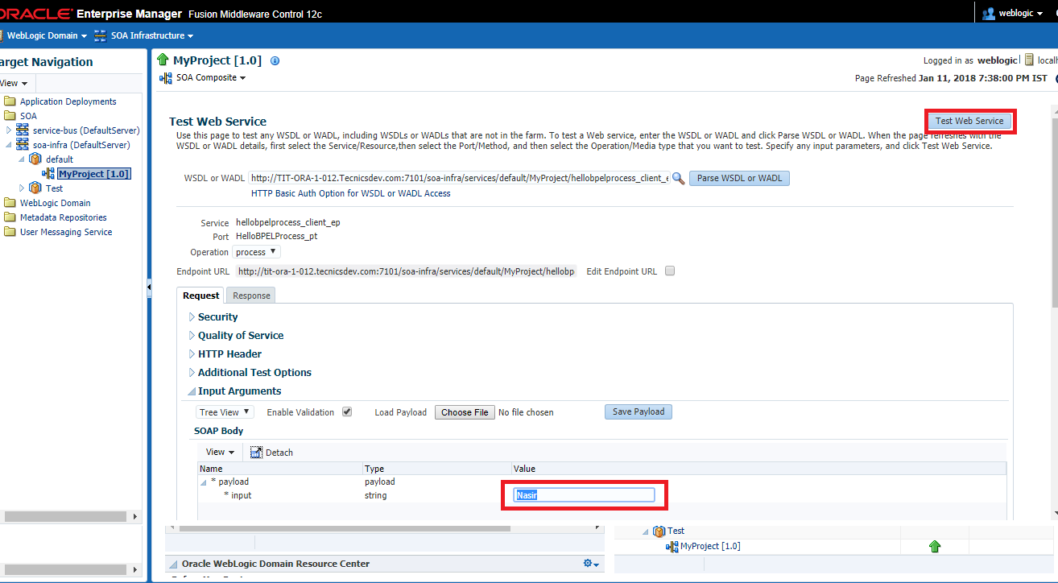

* Click on Test Web Service button to execute the composite and see the output.

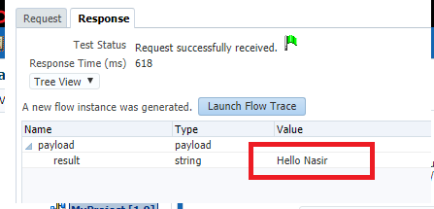

# ADVANCED SOA CONCEPTS

### Encryption and Decryption of Sensitive Data

Oracle SOA Suite is used for reliable transfer of information, it stores whole the message in SOA_INFRA schema. We can see incoming and outgoing messages in audit trail from EM console. That means user which has access to EM console can see all the messages coming and going through middleware, sometimes some of the information which is flowing through Oracle SOA Suite is very critical and SOA Suite user should not have access to see that critical piece of information. In this post we will discuss how to fulfill this requirement using Oracle SOA Suite.

### Transaction Management in Oracle SOA (BPEL)

Transaction context between different BPEL services are controlled by mainly two properties/attributes.  Those are Delivery and Transaction attributes.   
**Details**

**Case1**: If BPEL Process is Async or one-way process then, Delivery policy attribute can have three values. Those are 1)- async.persit  2)- async.cache 3)- sync

* **async.persit**: Delivery messages are persisted in the database in table dlv_message. With this setting, reliability is obtained with some performance impact on the database. When the client initiates a process instance, an invocation request is placed in an internal queue. Inside Oracle BPEL Server, a message-driven bean (MDB), WorkerBean, monitors the queue for invocation requests. When a message is dequeued, Oracle BPEL Server allocates a thread to process the message.

  <component name="BPELASynchCall" version="2.0">

    <implementation.bpel src="BPELASynchCall.bpel"/>

    <property name="bpel.config.transaction" type="xs:string" many="false">required</property>

    <property name="bpel.config.oneWayDeliveryPolicy" type="xs:string"

              many="false">async.persist</property>

  </component>

* **async.cache** : Incoming delivery messages are kept only in the in-memory cache. If performance is preferred over reliability, this setting should be considered. Message are not dehydrated into dlv_message table. Rest all is same as async.persist.

  <component name="BPELASynchCall" version="2.0">

    <implementation.bpel src="BPELASynchCall.bpel"/>

    <property name="bpel.config.transaction" type="xs:string" many="false">required</property>

    <property name="bpel.config.oneWayDeliveryPolicy" type="xs:string"

              many="false">async.cache</property>

  </component>

* **sync** : Directs Oracle BPEL Server to bypass the scheduling of messages in the invoke queue, and invokes the BPEL instance synchronously. In some cases this setting can improve database performance. So there is no role of invoke queue and worker bean here.

  <component name="BPELTest" version="1.1">

    <implementation.bpel src="BPELTest.bpel"/>

    <property name="bpel.config.transaction" type="xs:string" many="false">required</property>

    <property name="bpel.config.oneWayDeliveryPolicy" type="xs:string"

              many="false">sync</property>

  </component>

**Case2:** If BPEL Process is Sync process then, transaction context between client and bpel-process is controlled by "Transaction" Attribute. Values of these attributes are 1)- Required 2)- Requires New

* **Required**: This makes the BPEL process execute as part of the calling transaction. If no calling transaction exists, it will create a new one.

bpel.config.transaction property is set to requiresNew:

<component name="BPELProcess2" version="1.1">

    <implementation.bpel src="BPELProcess2.bpel"/>

    <property name="bpel.config.transaction" many="false" type="xs:string">required</property>

</component>

* **RequiresNew**: This is the default value and makes the BPEL process execute as a separate transaction. Any existing transaction will be suspended.

bpel.config.transaction property is set to requiresNew:

<component name="BPELProcess2" version="1.1">

     <implementation.bpel src="BPELProcess2.bpel"/>

     <property name="bpel.config.transaction" many="false" type="xs:string">requiresNew</property>

</component>

### Domain Value Maps

Domain value maps operate on actual data values that transit through the infrastructure at runtime. They enable you to map from one vocabulary used in a given domain to another vocabulary used in a different domain. For example, one domain may represent a city with a long name (Boston), while another domain may represent a city with a short name (BO). In such cases, you can directly map the values by using domain value maps. A direct mapping of values between two or more domains is known as point-to-point mapping.

Each domain value map typically holds a specific category of mappings among multiple applications. For example, one domain value map may hold mappings for city codes and another may hold mappings for state codes.

Domain value map values are static. You specify the domain value map values at design time using Oracle JDeveloper, and then at runtime, the domain value map columns are looked up for values.

#### Domain Value Map Features

This section describes domain value map functionality.

#### Qualifier Support

Qualifiers qualify mappings. A mapping may not be valid unless qualified with additional information. For example, a domain value map containing a city code-to-city name mapping may have multiple mappings from KN to Kensington because Kensington is a city in both Canada and the USA. Therefore, this mapping requires a qualifier (USA or Canada) to qualify when the mapping becomes valid, as shown in [Table](https://docs.oracle.com/cd/E25054_01/dev.1111/e10224/med_dvm.htm#CACBDHCH).

| **Country (Qualifier)** | **CityCode** | **CityName** |
| --- | --- | --- |
| USA | BO | Boston |
| USA | BELG_NC | Belgrade |
| USA | BELG_MN_Streams | Belgrade |
| USA | NP | Northport |
| USA | KN | Kensington |
| Canada | KN | Kensington |

You can also specify multiple qualifiers for a domain value map. For example, as shown in [table](https://docs.oracle.com/cd/E25054_01/dev.1111/e10224/med_dvm.htm#CACICCFB), BELG to Belgrade mapping can also be qualified with a state name.

| **Country (Qualifier)** | **State (Qualifier)** | **CityCode** | **CityName** |
| --- | --- | --- | --- |
| USA | Massachusetts | BO | Boston |
| USA | North Carolina | BELG | Belgrade |
| USA | Minnesota | BELG | Belgrade |
| USA | Alabama | NP | Northport |
| USA | Kansas | KN | Kensington |
| Canada | Prince Edward Island | KN | Kensington |

#### Qualifier Order Support

A qualifier order is used to find the best match during lookup at runtime. The order of a qualifier varies from highest to lowest depending on the role of the qualifier in defining a more exact match. In [Table](https://docs.oracle.com/cd/E25054_01/dev.1111/e10224/med_dvm.htm#CACICCFB), the state qualifier can have a higher order than the country qualifier, as a matching state indicates a more exact match.

Domain value maps support hierarchical lookup. If you specify a qualifier value during a lookup and no exact match is found, then the lookup mechanism tries to find a more generalized match by setting the higher order qualifiers to a "". It proceeds until a match is found, or until a match is not found with all qualifiers set to a "". [Figure](https://docs.oracle.com/cd/E25054_01/dev.1111/e10224/med_dvm.htm#CACCFBIC) describes the hierarchical lookup performed for the following lookup in [Table](https://docs.oracle.com/cd/E25054_01/dev.1111/e10224/med_dvm.htm#CACICCFB).

State=Arkansas, Country=Canada, CityCode=KN_USA

In this example, the State qualifier has a qualifier value of 1 and the Country qualifier has a qualifier value of 2.

As shown in [Figure 44-1](https://docs.oracle.com/cd/E25054_01/dev.1111/e10224/med_dvm.htm#CACCFBIC), the lookup mechanism sets the higher order qualifier State to the exact lookup value Arkansas and uses Canada|"" for the lower order qualifier Country.

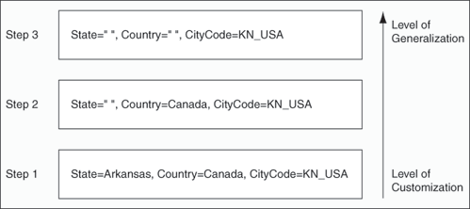

#### One-to-Many Mapping Support

You can map one value to multiple values in a domain value map. For example, a domain value map for payment terms can contain a mapping of payment terms to three values, such as discount percentage, discount period, and net credit period, as shown in Table.

| **Payment Term** | **Discount Percentage** | **Discount Period** | **Net Credit Period** |
| --- | --- | --- | --- |
| GoldCustomerPaymentTerm | 10 | 20 | 30 |
| SilverCustomerPaymentTerm | 5 | 20 | 30 |
| RegularPaymentTerm | 2 | 20 | 30 |

### Protecting Personally Identifiable Information

Protecting Personally Identifiable Information (PII) when outside the control of a security policy. PII refers to Social Security numbers, addresses, bank account numbers, and other similar information that is typically associated with one specific user and must generally be protected.

#### Overview of PII Data

The OWSM WS-Security policies provide a way to selectively encrypt information through message protection. However, there may be times when this information is outside of the control of a security policy and not encrypted, such as when it is being processed inside a SOA composite.

Your business practices may require that information, and particularly PII information, be encrypted even as it flows within your applications.

If this is true for your environment, PII information should remain encrypted as the message flows to various components. For example, in the case of SOA, it means that PII must be encrypted at the entry point of a SOA composite and must be decrypted at the reference binding exit point.

The oracle/pii_security_policy policy is provided to encrypt data for this purpose.

#### Understanding the PII Security Policy

The oracle/pii_security_policy contains the following settings and configuration properties that specify exactly which PII data you want to protect. You can set these attributes when you attach a policy, and override them as required.

* encryption-algorithm — The data encryption algorithm, which must be AES/CBC/PKCS5Padding.
* algorithm — The key derivation algorithm, which must be PBKDF2.
* Salt — A non-null and non-empty salt for key derivation. The default value is pii-security.
* Iteration — The iteration count for key derivation. The default is 1000.
* Keysize — The size of the key for key derivation. The default is 128.
* request.xpaths — A comma-separated list of XPaths for the request. Default value is blank. For example, //ns2:ShipToLocationId.
* request.namespaces — A comma-separated list of namespaces for the request, where each namespace has a prefix and URI separated by the equals = sign. Default value is blank.
* response.xpaths —A comma-separated list of XPaths for the response. Default value is blank. For example, //ns2:ShipToLocationId.
* response.namespaces — A comma-separated list of namespaces, where each namespace has a prefix and URI separated by the equals = sign. Default value is blank.
* csf.key — The oracle/pii_security_policy policy uses the password CSF key attribute you specify to generate a symmetric key. This key is then used to encrypt and decrypt the PII data. Default value is pii-csf-key.
* reference.priority —

#### PII Policy XPath Expressions

* You use XPath expressions to specify the PII data to be protected.
* If the result of the XPath is a text node, the contents of the text node are encrypted. Empty text nodes (that is, containing all whitespace) are not encrypted or decrypted.
* If any XPath returns multiple nodes, all of them are encrypted. If nothing is returned, it is ignored.
* The specified XPaths will be evaluated with the first element child of env:Body set as the root node.

<soap:Envelope xmlns:soap="http://schemas.xmlsoap.org/soap/envelope/">

<soap:Body

xmlns:ns1="http://xmlns.oracle.com/apps/prc/po/editDocument/purchaseOrderService/types/">

<ns1:createPurchaseOrder>

<ns1:createOrderEntry

xmlns:ns2="http://xmlns.oracle.com/apps/prc/po/editDocument/purchaseOrderService/">

<ns2:DocumentStyleId>1</ns2:DocumentStyleId>

<ns2:ProcurementBuId>204</ns2:ProcurementBuId>

<ns2:BuyerId>100010026863783</ns2:BuyerId>

<ns2:RequisitioningBuId>204</ns2:RequisitioningBuId>

<ns2:SupplierId>559</ns2:SupplierId>

<ns2:SupplierSiteId>5058</ns2:SupplierSiteId>

<ns2:SupplierContactId>100000011552368</ns2:SupplierContactId>

<ns2:ApprovalActionCode>BYPASS</ns2:ApprovalActionCode>

<ns2:DocumentDescription>DO NOT TOUCH THIS ORDER (V15)</ns2:DocumentDescription>

<ns2:PurchaseOrderEntryLine>

<ns2:LineTypeId>1</ns2:LineTypeId>

<ns2:ItemId>199</ns2:ItemId>

<ns2:Quantity>10</ns2:Quantity>

<ns2:UnitOfMeasureCode>Ea</ns2:UnitOfMeasureCode>

<ns2:PurchaseOrderEntrySchedule>

<ns2:ShipToLocationId>207</ns2:ShipToLocationId>

<ns2:ShipToOrganizationId>207</ns2:ShipToOrganizationId>

<ns2:NeedByDate>2020-12-31</ns2:NeedByDate>

<ns2:PurchaseOrderEntryDistribution />

</ns2:PurchaseOrderEntrySchedule>

</ns2:PurchaseOrderEntryLine>

</ns1:createOrderEntry>

</ns1:createPurchaseOrder>

</soap:Body>

</soap:Envelope>

Some XPath examples are as follows:

* //ns2:ShipToLocationId

Use the // notation (descendant-or-self axis) to indicate that you want to search the whole body for ShipToLocationIds. These XPaths require a complete document search and are slower.

* /ns1:createPurchaseOrder/ns1:createOrderEntry/ns2:BuyerId

This XPath clearly specifies that you want to look at the createPurchaseOrder child of the body, and then the createOrderEntry child of the createPurchaseOrder, and finally the BuyerId child of createOrderEntry.

#### When Can You Use the PII Policy?

* **Single SOA Composite Use Case**

You can attach the pii_security_policy policy only to a SOA composite and only to protect PII within that composite. No other SOA use case is supported.

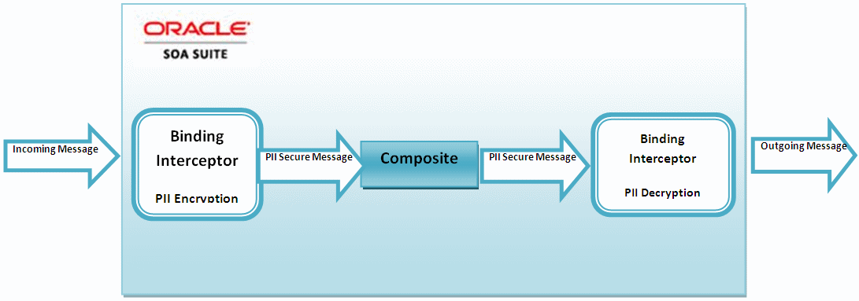

* [**PII at the JCA Binding Use Case**](https://docs.oracle.com/middleware/1213/owsm/concepts/owsm-security-concepts.htm#CFHGHBGE)

You can attach the PII policy to JCA adapters for both SOA and Oracle Service Bus.

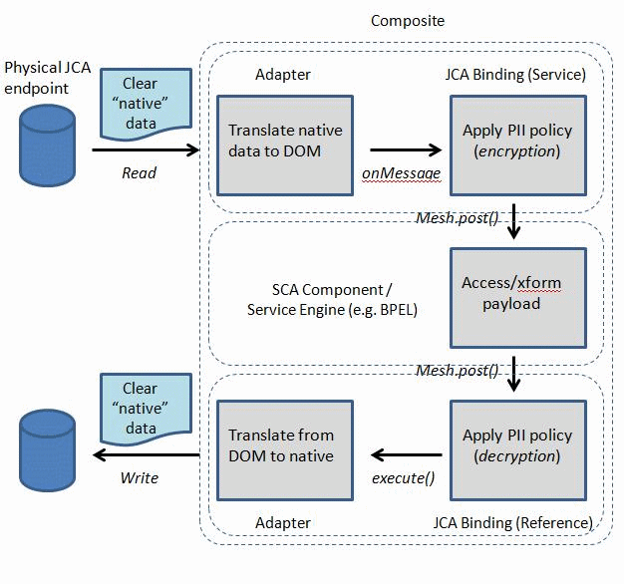

### ****Subprocess in Oracle SOA Suite 12C****

**Subprocess** is one of the new features in SOA 12c and as the name suggests, It is a **piece of code** which is embedded with the **BPEL** or outside BPEL component that can be reused across.

**There are two types of Subprocess:**

* Inline Subprocess
* Standalone Subprocess

1. **Inline Subprocess:**

* It is part of the BPEL which allows the same code to be reused within the same BPEL.
* Whenever we identify some set of activities being used multiple times within a particular BPEL, we can add those activities in a scope. Then we right click on the scope to convert this reusable piece into subprocess.
* This scope is replaced by a call shape and the set of activities become a reusable asset within the same BPEL process which can be called multiple times leveraging the call shape.

**Steps to create an Inline Subprocess:**

1. Identify the reusable piece of code and push it into a scope.

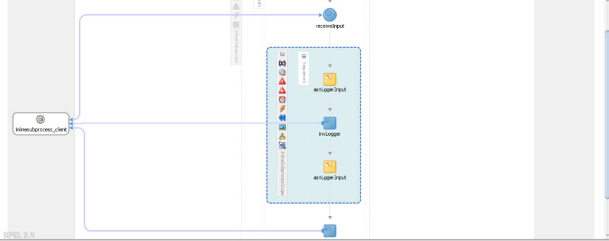

1. Right click on the scope and select the option “**convert it into a subprocess**“.

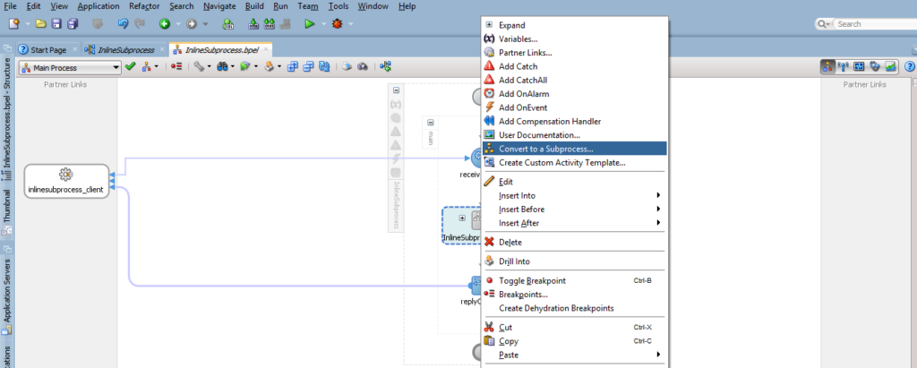

1. Scope is replaced by a call shape and an inline subprocess is created.

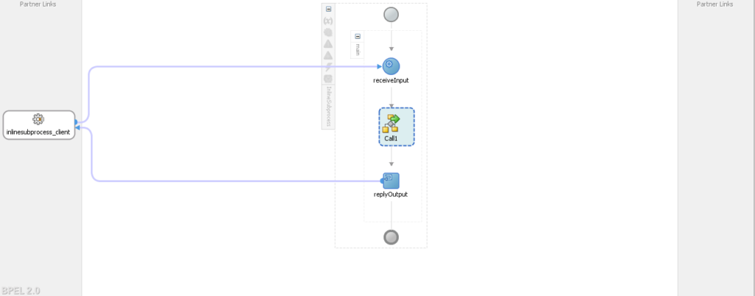

1. **Standalone Subprocess:**

* It is part of the BPEL which allows the same code to be reused across different BPEL components within the same composite.
* Whenever we identify some set of activities being used multiple times across different BPEL components within the same composite, we can add those activities in a standalone subprocess.
* This subprocess can be called from different BPEL components.

**Steps to create a Standalone subprocess:**

1. Right click on the service component lane in the composite and select the **subprocess** option to configure a standalone.

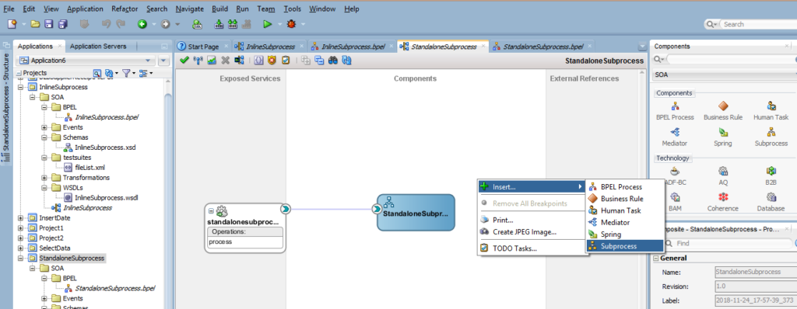

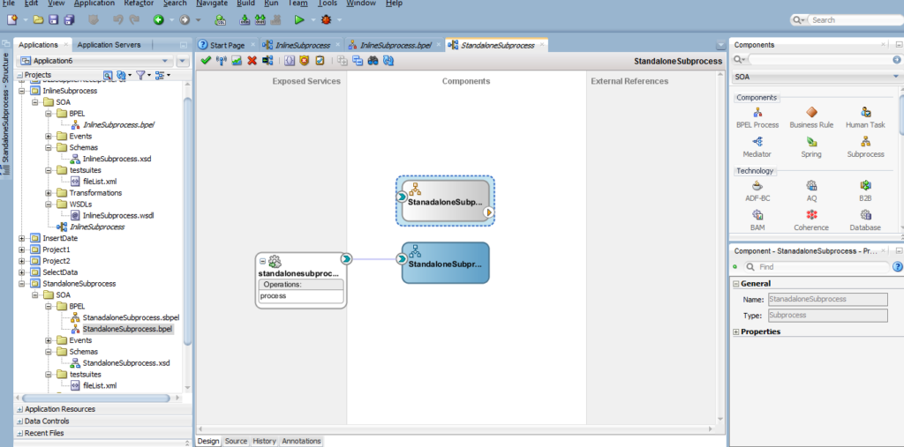

1. Open the BPEL component where you want to reuse the standalone subprocess. Insert a call shape and select the standalone subprocess which is required to be reused.

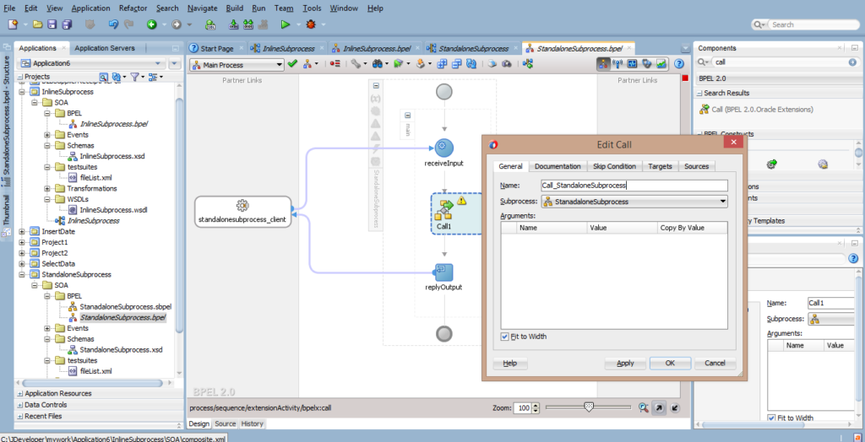

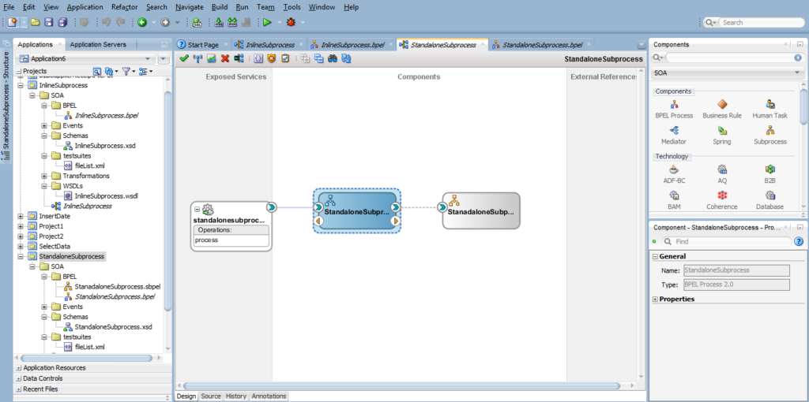

So, this is about the Subprocess and all about the**Subprocesses in SOA 12C.**

# SOA TASKS

### Working with AQ Tables, AQ Adapter, Files and File Adapter

sqlplus system/password as SYSDBA

-- Grant access to execute AQ

GRANT connect, resource TO soademo IDENTIFIED BY soademo;

GRANT aq_user_role TO soademo;

GRANT execute ON sys.dbms_aqadm TO soademo;

GRANT execute ON sys.dbms_aq TO soademo;

GRANT execute ON sys.dbms_aqin TO soademo;

GRANT execute ON sys.dbms_aqjms TO soademo;

-- Create the Queue Table and Advanced Queue and Start the AQ

-- The following commands are executed as the soademo database user.

-- Create the Queue Table

connect soademo/soademo;

CREATE TYPE message_type AS OBJECT (

message_id NUMBER(15)

, header VARCHAR2(100)

, text VARCHAR2(100)

)

/

BEGIN

dbms_aqadm.create_queue_table (

queue_table => 'myQueueTable',

queue_payload_type => 'soademo.message_type',

multiple_consumers => false

);

END;

/

Create the AQ

BEGIN

dbms_aqadm.create_queue (

queue_name => 'userQueue',

queue_table => 'myQueueTable'

);

END;

/

-- Start the AQ

BEGIN

dbms_aqadm.start_queue (

queue_name => 'userQueue');

END;

/

-- To delete queue table and queue.

EXECUTE dbms_aqadm.stop_queue(queue_name => 'soademo.userQueue');

EXECUTE dbms_aqadm.drop_queue(queue_name => 'soademo.userQueue');

EXECUTE dbms_aqadm.drop_queue_table(queue_table => 'soademo.myQueueTable');

select * from all_queues where name = 'USERQUEUE';

SELECT * FROM MYQUEUETABLE;

-- Enqueue message directly in database.

DECLARE

queue_options DBMS_AQ.ENQUEUE_OPTIONS_T;

message_properties DBMS_AQ.MESSAGE_PROPERTIES_T;

message_id RAW(16);

my_message SOADEMO.message_type;

v_user_name varchar2(100);

v_user_id varchar2(100);

v_resp_id varchar2(100);

v_resp_appln_id varchar2(100);

BEGIN

my_message := SOADEMO.message_type (1234,'TEST','XYZ');

-- message_properties.CORRELATION := 'QUORUM2AR_INV';

-- ENQUEUE

DBMS_AQ.enqueue (queue_name => 'SOADEMO.USERQUEUE',

enqueue_options => queue_options,

message_properties => message_properties,

payload => my_message,

msgid => message_id);

dbms_output.put_line('Enqueue successfully for SOA service MSG ID '||message_id);

commit;

END;

#### Configuring AQ Adapter

* Login to weblogic server console
* Go to deployments 🡪Select AQ Adapter 🡪 Configuration 🡪 Outbound Connection Pools

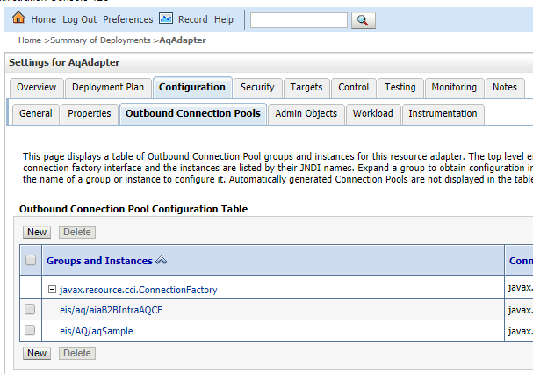

* Select new 🡪 Select default 🡪 Enter JNDI name 🡪 Click on finish.

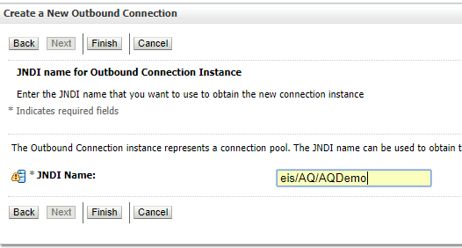

* You can able to see the AQ adapter we created.

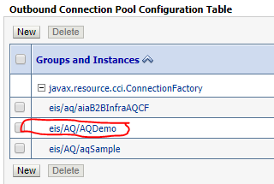

* Give the name of the AQ data source you want to create in AQ adapter.

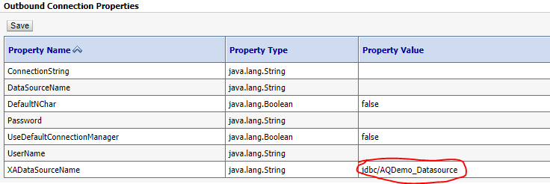

* Click on Save.

**Create AQ Datasource**

* Go to services 🡪 Data source 🡪 New
* Select defaults and give the database connection details.

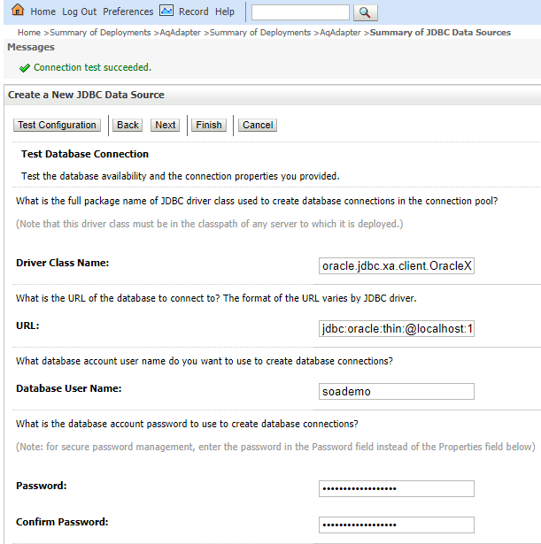

* Click next and test the configuration and select next.
* Select the server to deploy datasource.

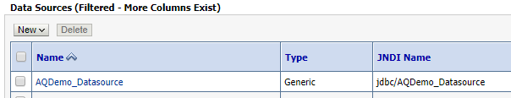

#### Composite to Read the message from xml file and Enqueue Message in AQ

* Create a project with empty Composite.

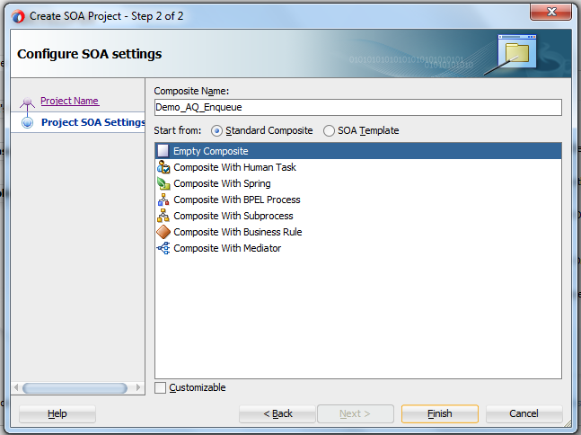

**Crate QueueMessage.xsd file as the input source**

<?xml version="1.0" encoding="windows-1252" ?>

<xsd:schema xmlns:xsd="http://www.w3.org/2001/XMLSchema"

xmlns="http://www.example.org"

targetNamespace="http://www.example.org"

elementFormDefault="qualified">

<xsd:element name="InputMessage">

<xsd:annotation>

<xsd:documentation>

A sample element

</xsd:documentation>

</xsd:annotation>

<xsd:complexType>

<xsd:sequence>

<xsd:element name="msgId" type="xsd:int"/>

<xsd:element name="header" type="xsd:string"/>

<xsd:element name="text" type="xsd:string"/>

</xsd:sequence>

</xsd:complexType>

</xsd:element>

</xsd:schema>

#### Create a file adapter to read message from XML file

* Select the File adapter from the Service Adapters and drag on the External Reference area. Give the name for the file adapter.

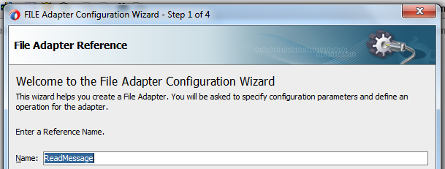

* Select Read File from Operation Type.

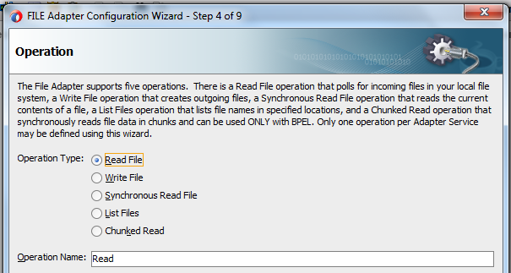

* Give the physical path to read the file and give the file naming convention.

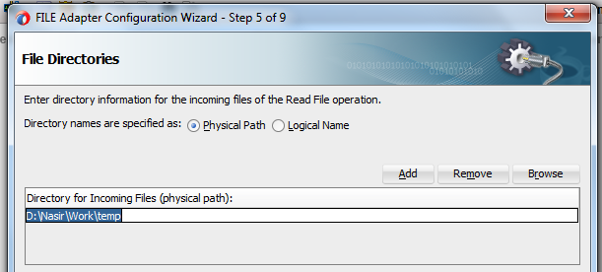

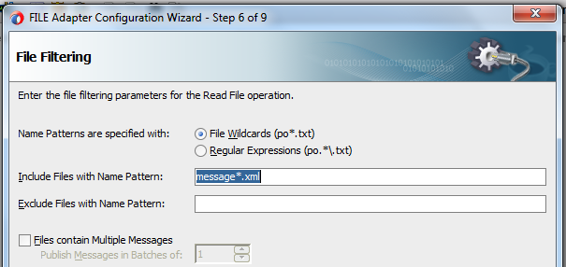

* Select the message type by clicking on the magnifying icon. Select Input Message we have created.

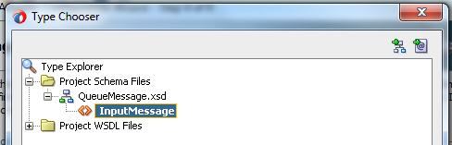

* Select next and click on finish.

#### Create AQ Adapter for Enqueue operation

* Drag AQ adapter on the Exposed Services area and give the Service Name

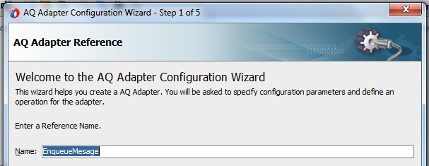

* Select the Enqueue from the Operation type.

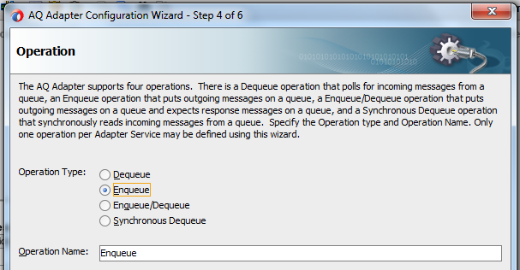

* Select the database schema and select queue by clicking on the browse button.

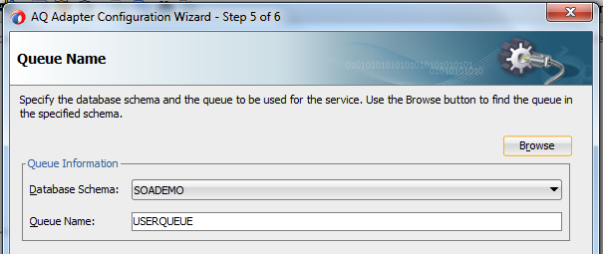

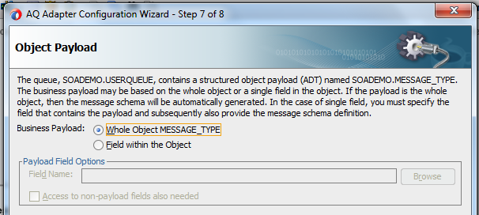

* Select the complete object type and click on finish. AQ adapter is created.

#### Create Mediator component to route the messages

* Drag and drop mediator component from the Service Components and name it. Select ‘Define Interface Later’ in template and click on Ok.
* Wire from AQ adapter to mediator and then from mediator to file adapter.

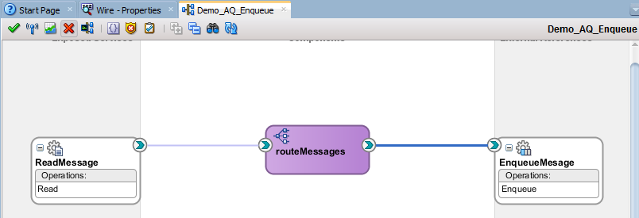

* Double click on the mediator components and open it. Click on the transformation icon and open the Transformation Mapping.
* Select + icon to create new mapper file.
* Click on OK.

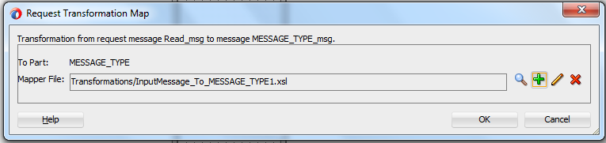

* Give the transformation in the new xsl file.

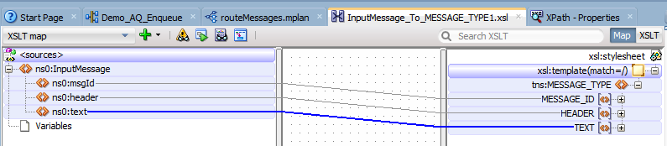

* Composite is ready. Compile, Deploy and test it.

#### Composite for Dequeue Message from AQ and write into XML file

* Create a new project with empty Composite

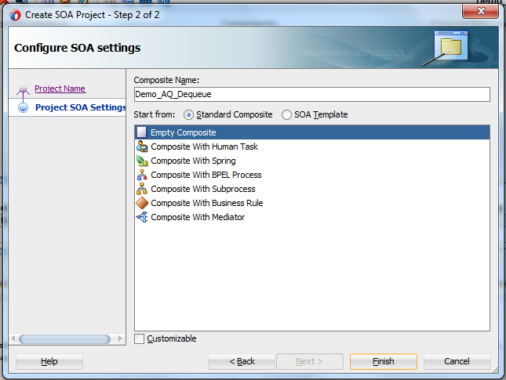

#### Create AQ Adapter for Dequeue operation

* Drag AQ adapter on the Exposed Services area and give the Service Name

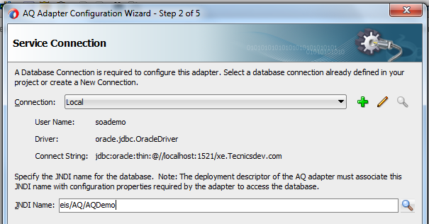

* Select the Dequeue from the Operation type.

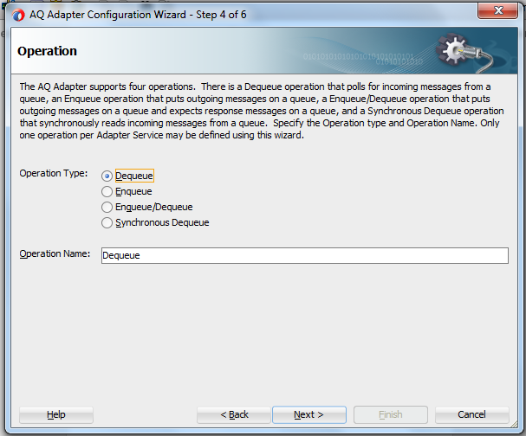

* Select the database schema and select queue by clicking on the browse button.

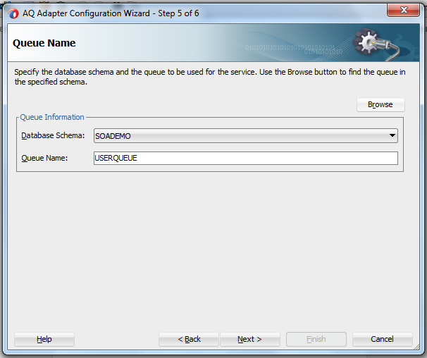

* Select the complete object type and click on finish. AQ adapter is created.

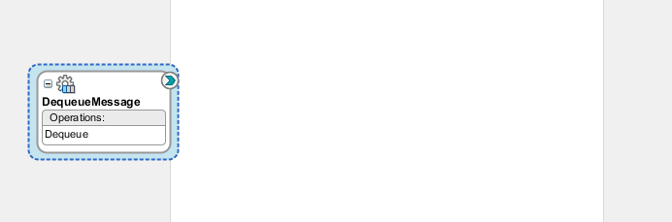

#### Create a file adapter to write messages into XML file

* Select the File adapter from the Service Adapters and drag on the External Reference area. Give the name for the file adapter.

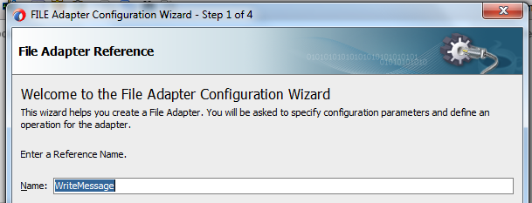

* Select Write File from Operation Type.

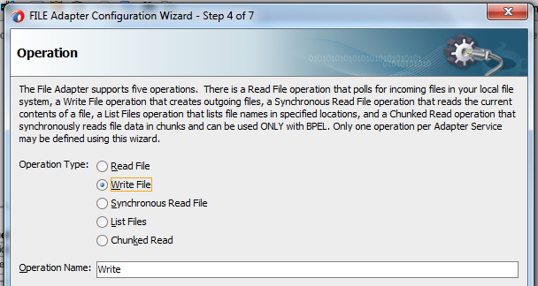

* Give the physical path to store the file and give the file naming convention.

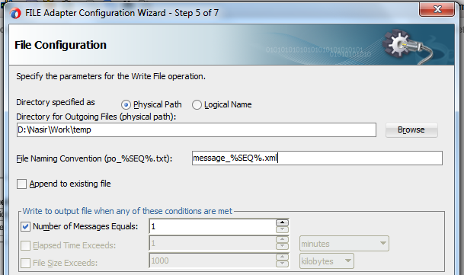

* Select the message type type by clicking on the magnifying icon.

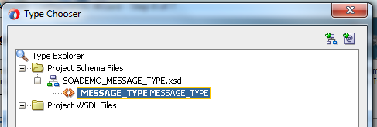

* Select next and click on finish.

#### Create Mediator component to route the messages

* Drag and drop mediator component from the Service Components and name it. Select ‘Define Interface Later’ in template and click on Ok.
* Wire from AQ adapter to mediator and then from mediator to file adapter.

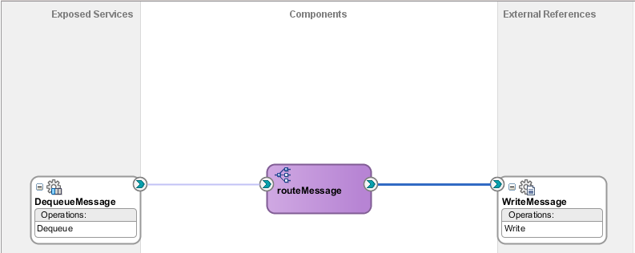

* Double click on the mediator components and open it. Click on the transformation icon and open the Transformation Mapping.
* Select + icon to create new mapper file.
* Click on OK.

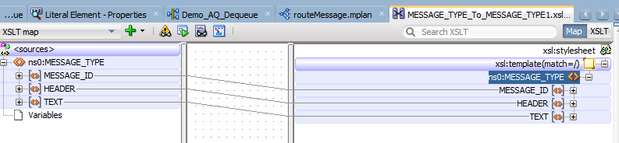

* Composite is ready. Compile, Deploy and test it.

### Working with Database Adapter

#### Selecting the data from Database

* Create a project.
* Go to new and select From Gallery.

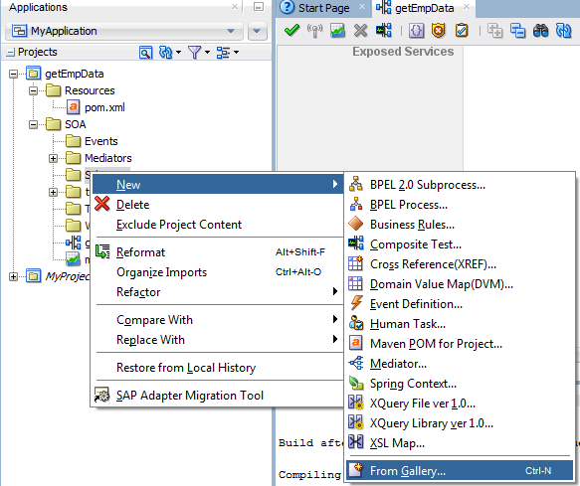

* Select xsd schema.

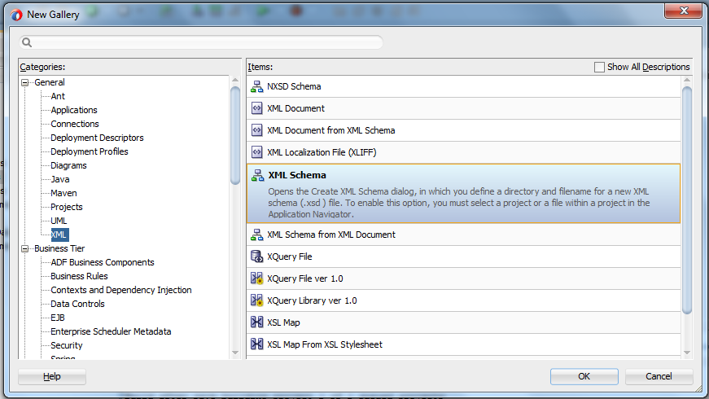

* Give the name of the xsd file and add the input and output variables accordingly.

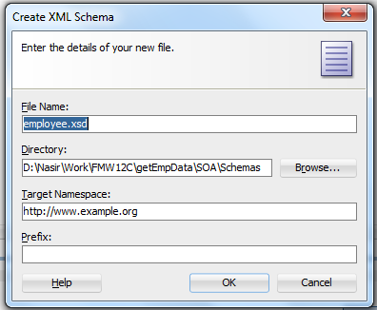

<?xml version="1.0" encoding="windows-1252" ?>

<xsd:schema xmlns:xsd="http://www.w3.org/2001/XMLSchema" xmlns="http://www.example.org"

targetNamespace="http://www.example.org" elementFormDefault="qualified">

<xsd:element name="request">

<xsd:annotation>

<xsd:document tation>A sample element</xsd:documentation>

</xsd:annotation>

<xsd:complexType>

<xsd:sequence>

<xsd:element name="empID" type="xsd:int"/>

</xsd:sequence>

</xsd:complexType>

</xsd:element>

<xsd:element name="response">

<xsd:complexType>

<xsd:sequence>

<xsd:element name="empName" type="xsd:string"/>

<xsd:element name="empDOJ" type="xsd:string"/>

<xsd:element name="empSal" type="xsd:string"/>

</xsd:sequence>

</xsd:complexType>

</xsd:element>

</xsd:schema>

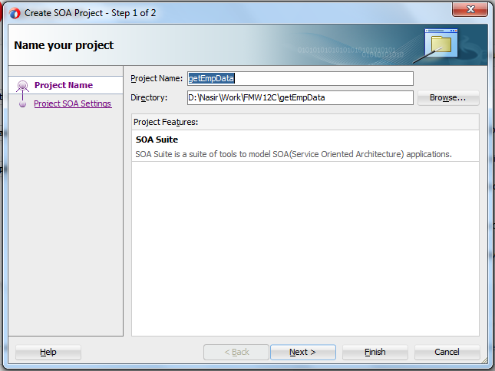

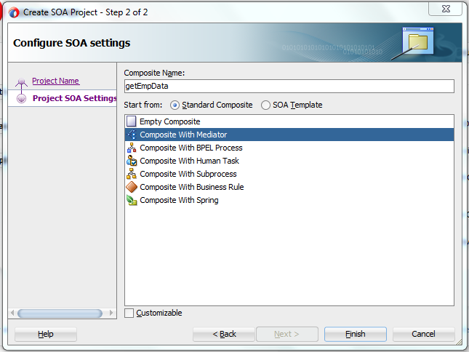

* Click on Finish.

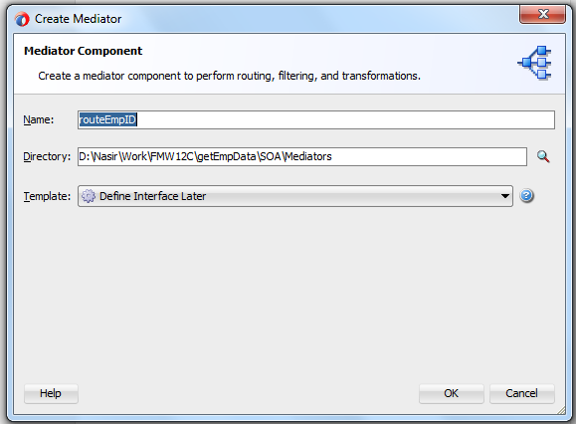

Enter the mediator name and select Template as Define Interface Later.

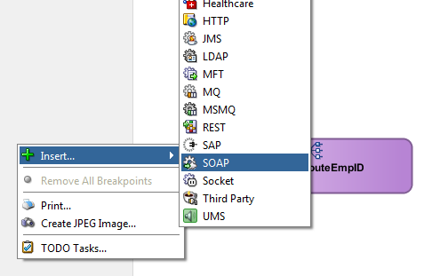

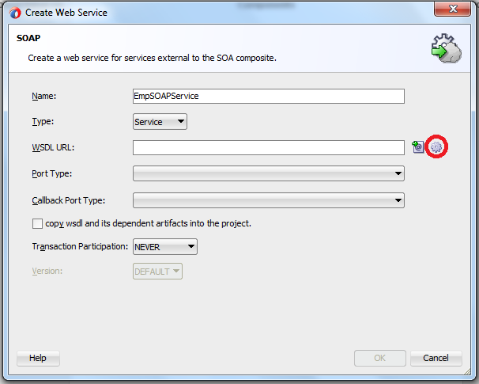

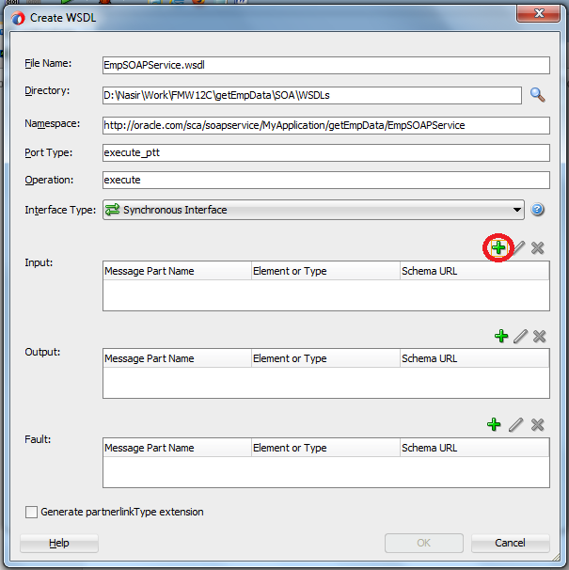

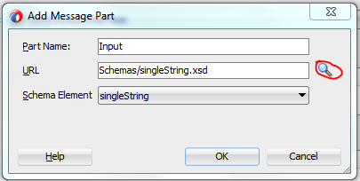

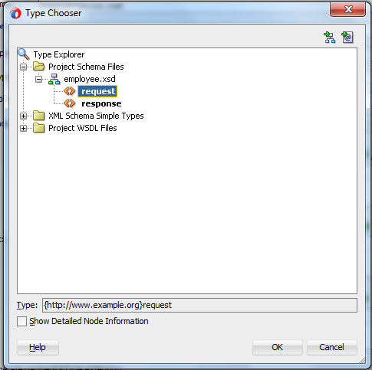

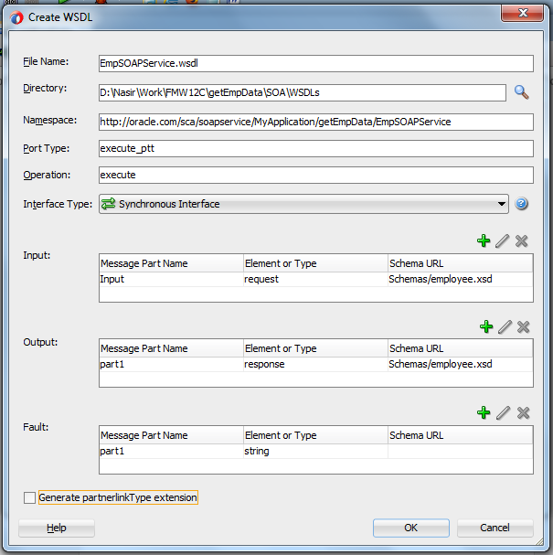

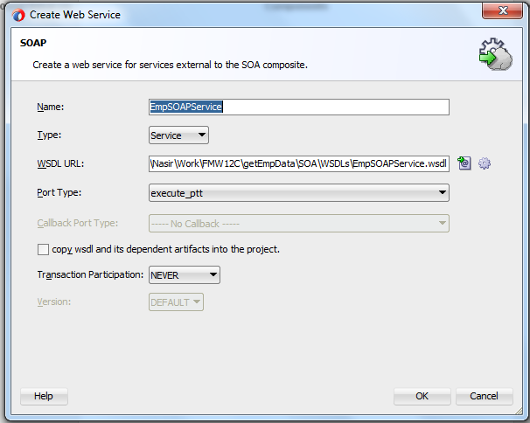

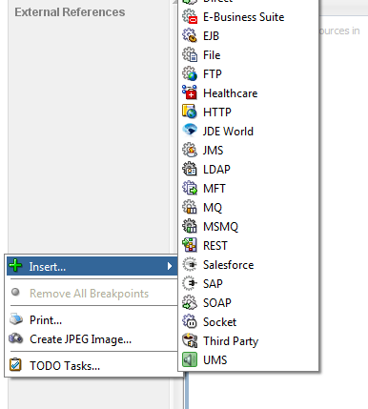

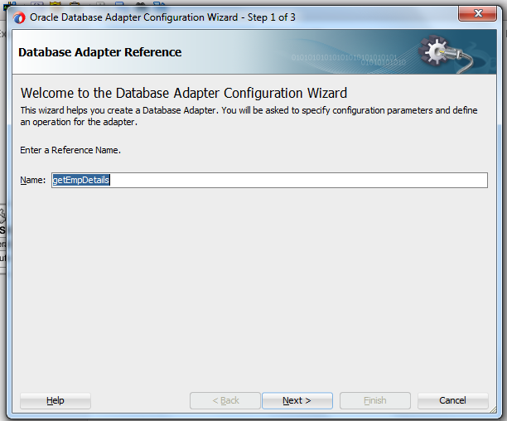

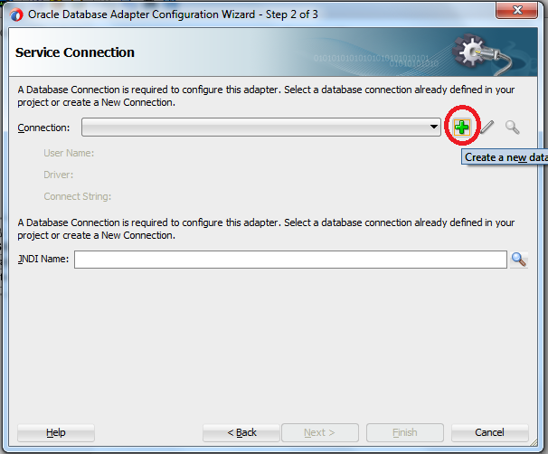

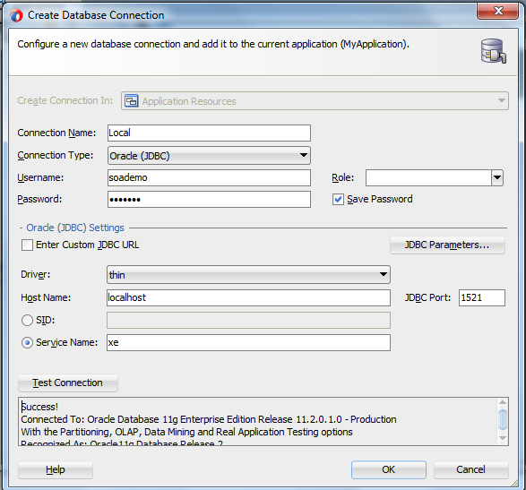

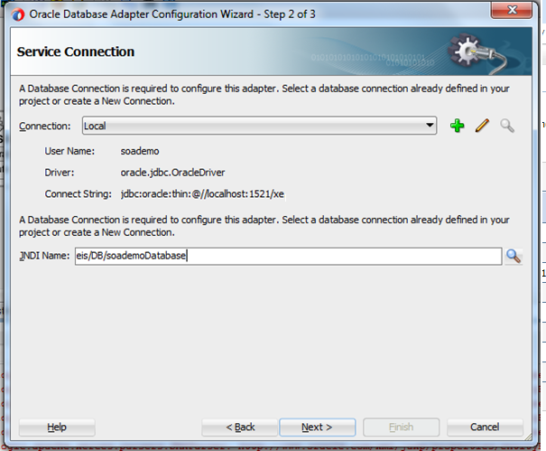

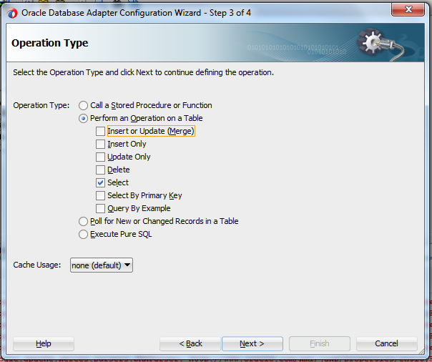

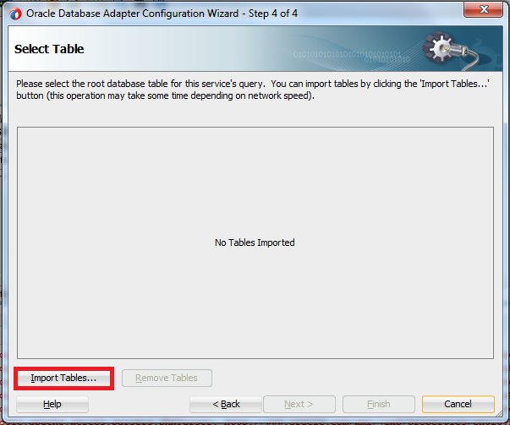

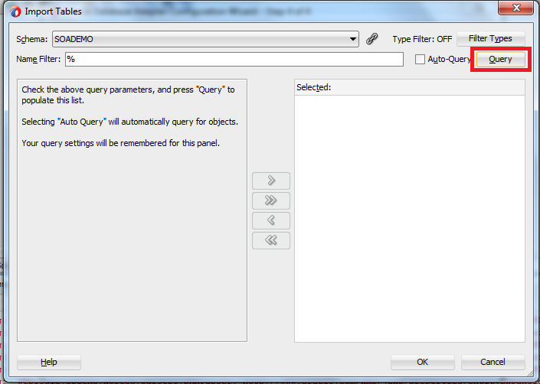

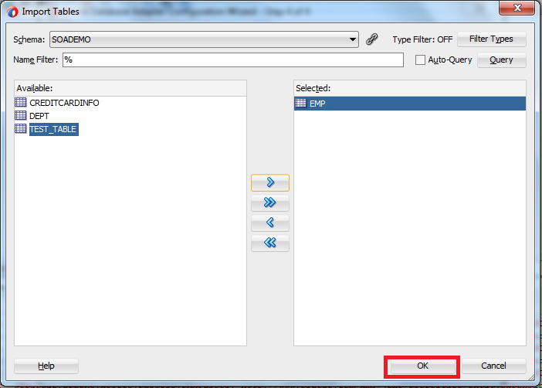

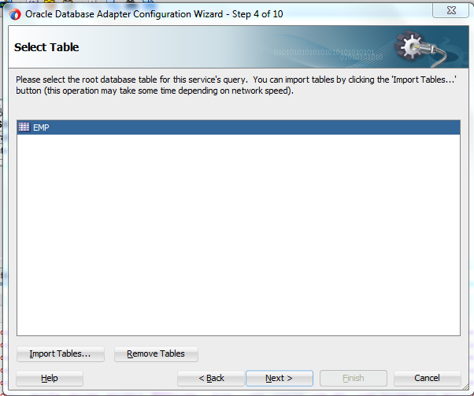

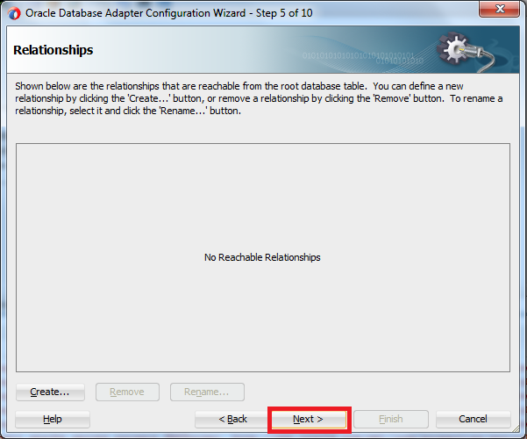

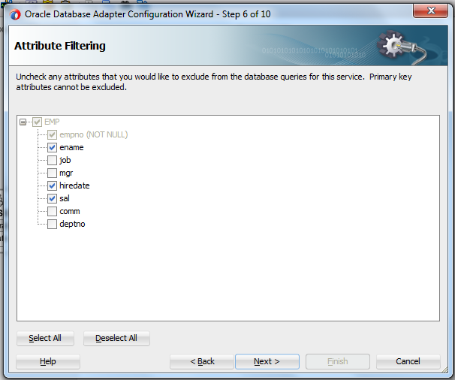

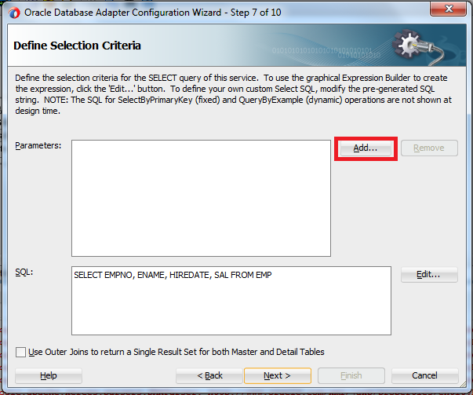

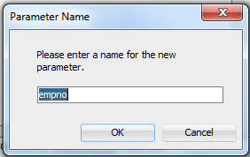

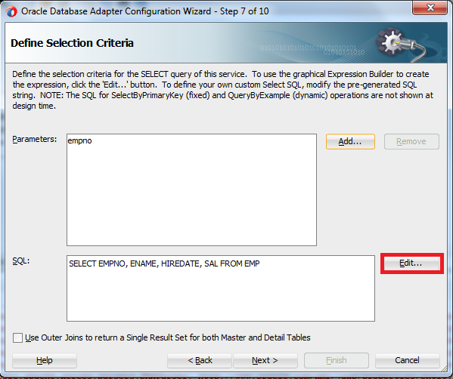

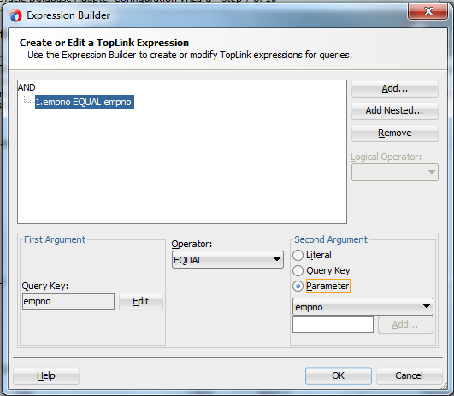

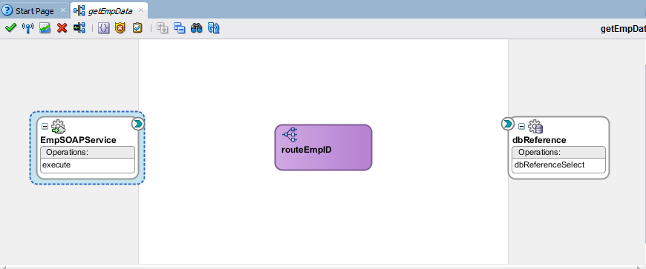

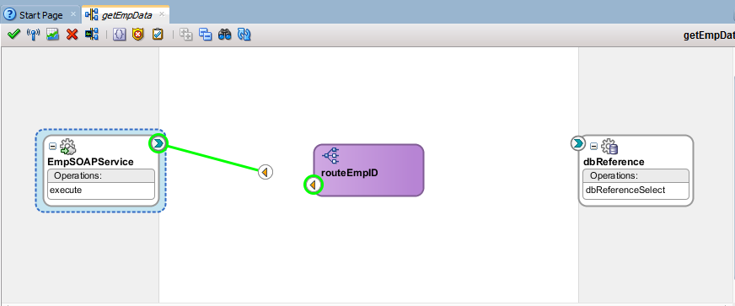

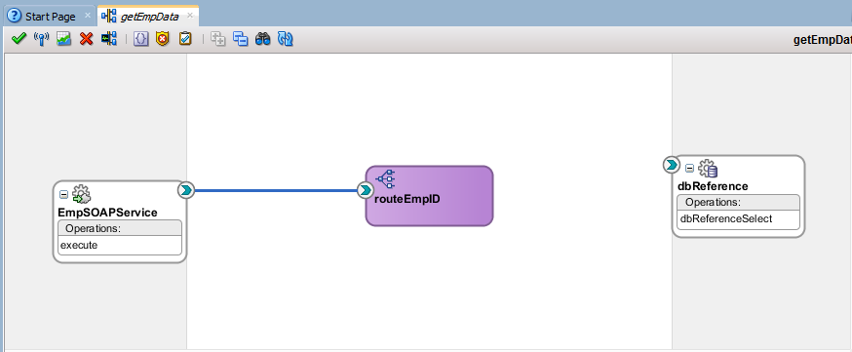

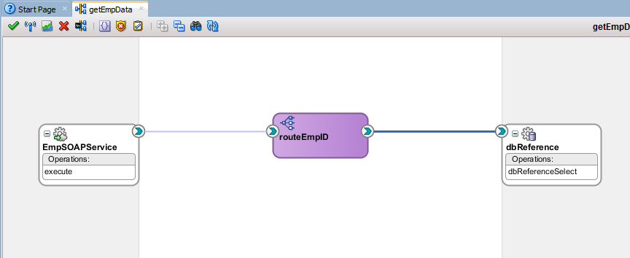

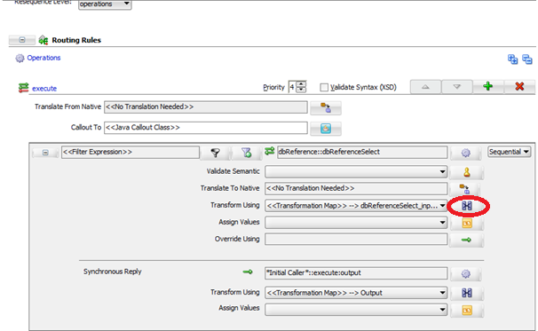

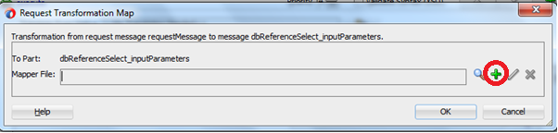

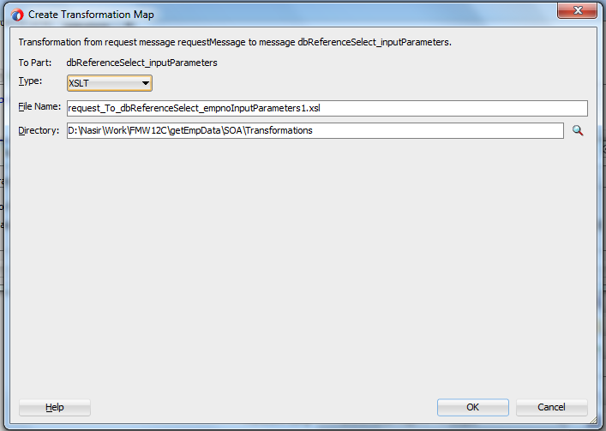

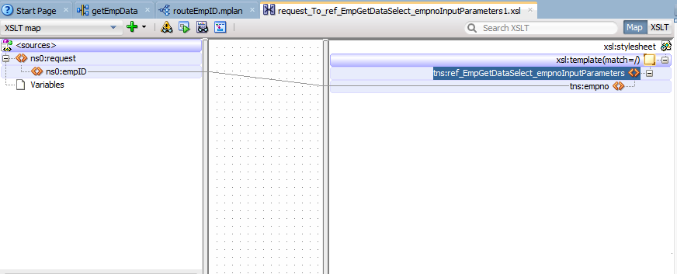

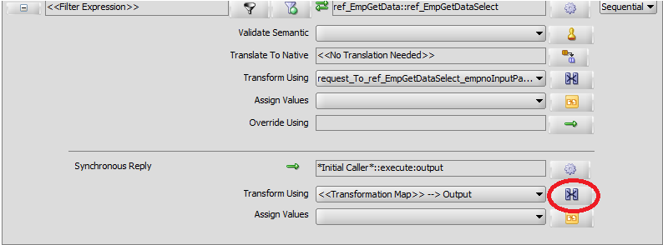

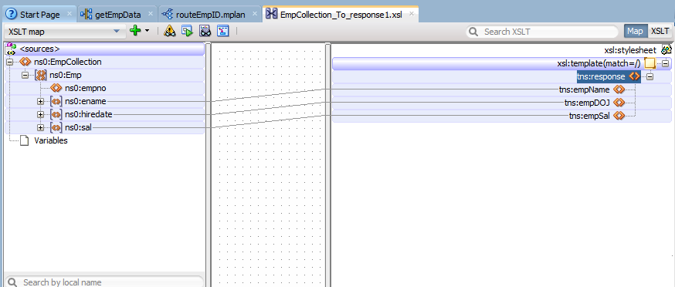

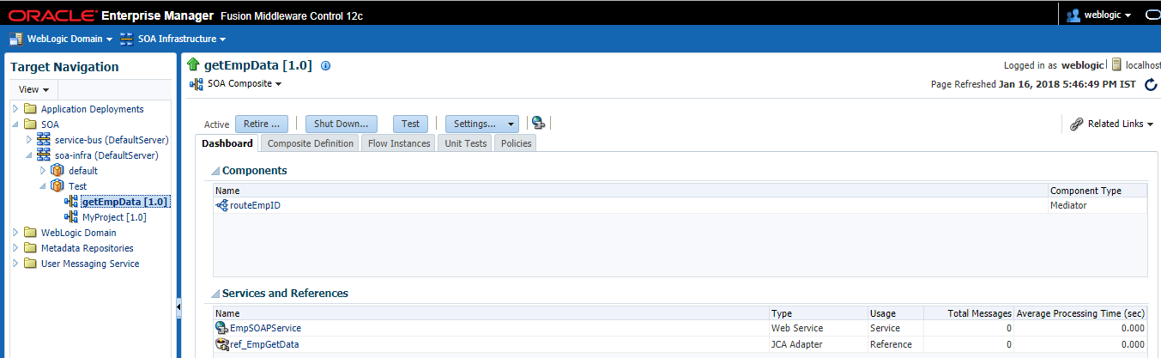

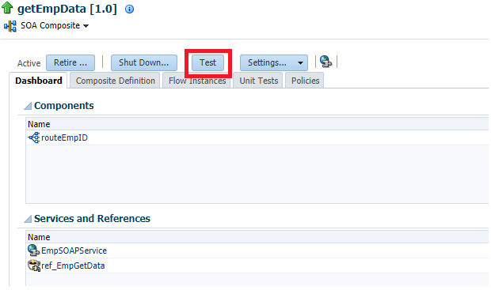

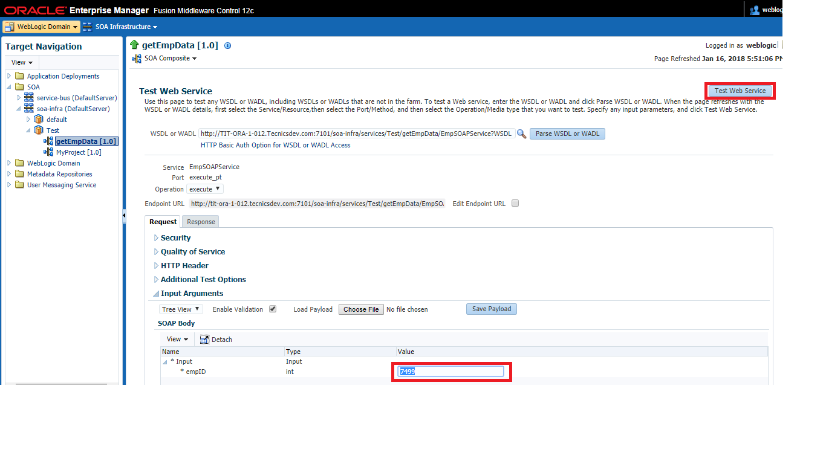

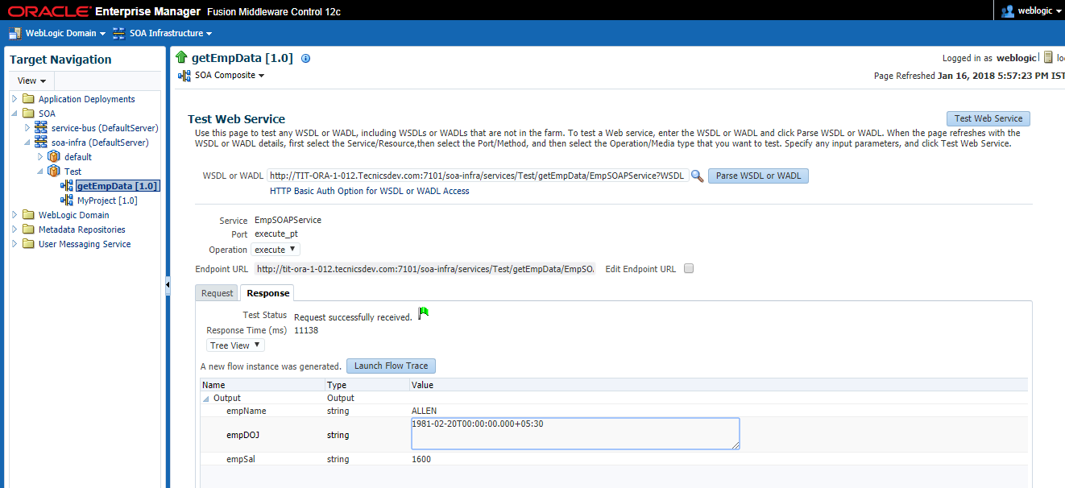

### Working with Transformations

#### Using if in Transformation

<xsl:if test="ns0:deptno > 20">

<ns0:deptno>999</ns0:deptno>

</xsl:if>

#### 

#### Using for-each in Transformation

<xsl:for-each select="/ns0:EmpCollection/ns0:Emp">

<ns0:Emp>

<ns0:empno>

<xsl:value-of select="ns0:empno"/>

</ns0:empno>

<ns0:ename>

<xsl:value-of select="ns0:ename"/>

</ns0:ename>

<ns0:mgr>

<xsl:value-of select="ns0:mgr"/>

</ns0:mgr>

</ns0:Emp>

</xsl:for-each>

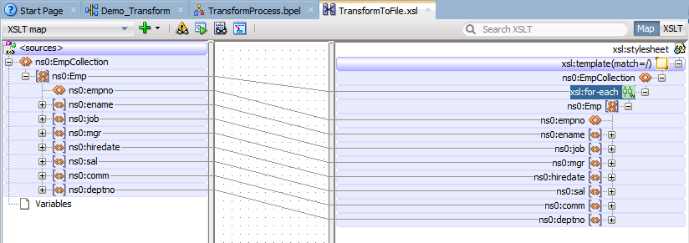

#### Using for-each for parent-child in Transformation

<ns0:DeptCollection>

<xsl:for-each select="/ns0:DeptCollection/ns0:Dept">

<ns0:Dept>

<ns0:dname>

<xsl:value-of select="ns0:dname"/>

</ns0:dname>

<ns0:empCollection>

<xsl:for-each select="ns0:empCollection/ns0:Emp">

<ns0:Emp>

<ns0:ename>

<xsl:value-of select="ns0:ename"/>

</ns0:ename>

<ns0:sal>

<xsl:value-of select="ns0:sal"/>

</ns0:sal>

</ns0:Emp>

</xsl:for-each>

</ns0:empCollection>

</ns0:Dept>

</xsl:for-each>

</ns0:DeptCollection>

#### 

#### Using choose in Transformation

<xsl:choose>

<xsl:when test="ns0:deptno = 10">

<ns0:deptno>100</ns0:deptno>

</xsl:when>

<xsl:when test="ns0:deptno = 20">

<ns0:deptno>200</ns0:deptno>

</xsl:when>

<xsl:otherwise>

<ns0:deptno><xsl:value-of select="ns0:deptno"/></ns0:deptno>

</xsl:otherwise>

</xsl:choose>

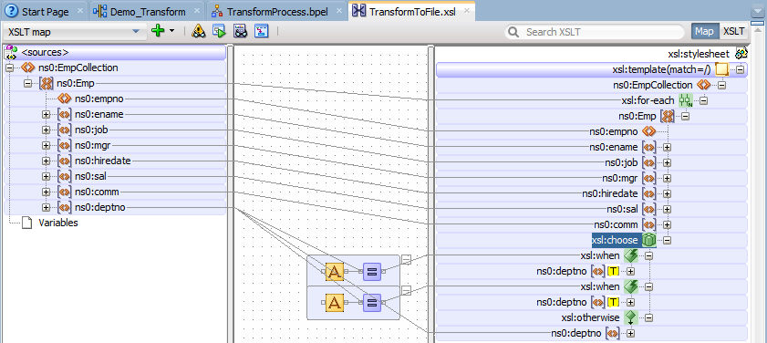

### Create Domain Value Maps

You can create a domain value map by using the Create Domain Value Map(DVM) File dialog in Oracle JDeveloper.

#### Create a domain value map

1. In the Application Navigator, right-click the project in which you want to create a domain value map and select **New**.

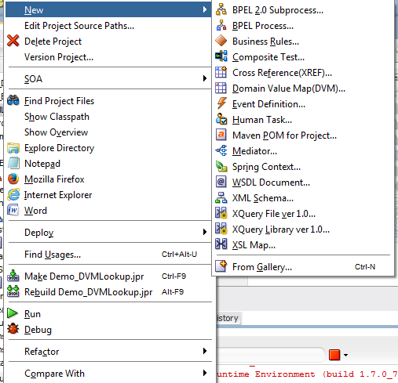

1. In the **Items** list, select **Domain Value Map(DVM)** and click **OK**.
2. In the **File Name** field, enter the name of the domain value map file. For example, specify CityCodes to identify a domain value map for city names and city codes.
3. In the **Description** field, enter a description for the domain value map. For example, Mappings of city names and city codes. This field is optional.
4. In the **Domain Name** field, enter a name for each domain. For example, you can enter CityCode in one **Domain Name** field and CityName in another. Each domain name must be unique in a domain value map.
5. In the **Domain Value** field, enter a value corresponding to each domain. For example, enter BO for the CityCode domain and Boston for the CityName domain, as shown in Figure.

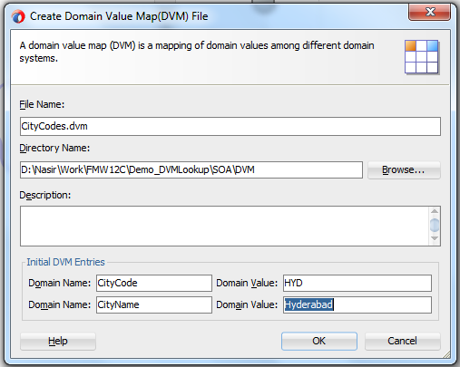

1. Click **OK**.
2. The Domain Value Map Editor is displayed. Click on ‘+’ symbol to add more values.

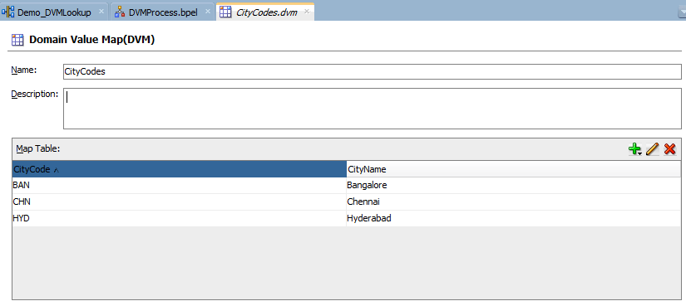

1. A file with extension .dvm is created and appears in the Application Navigator, as shown in Figure.

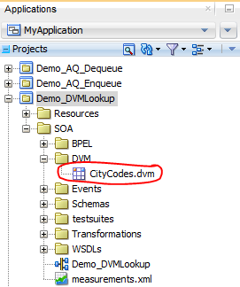

#### Use domain value map in Assign activity

1. Drag and drop the assign activity.

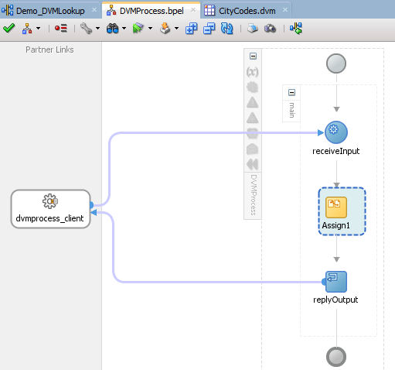

1. Assign the output as dvm:lookupValue('DVM/CityCodes.dvm','CityCode',bpws:getVariableData('inputVariable','payload','/client:process/client:input'),'CityName','No data matched')

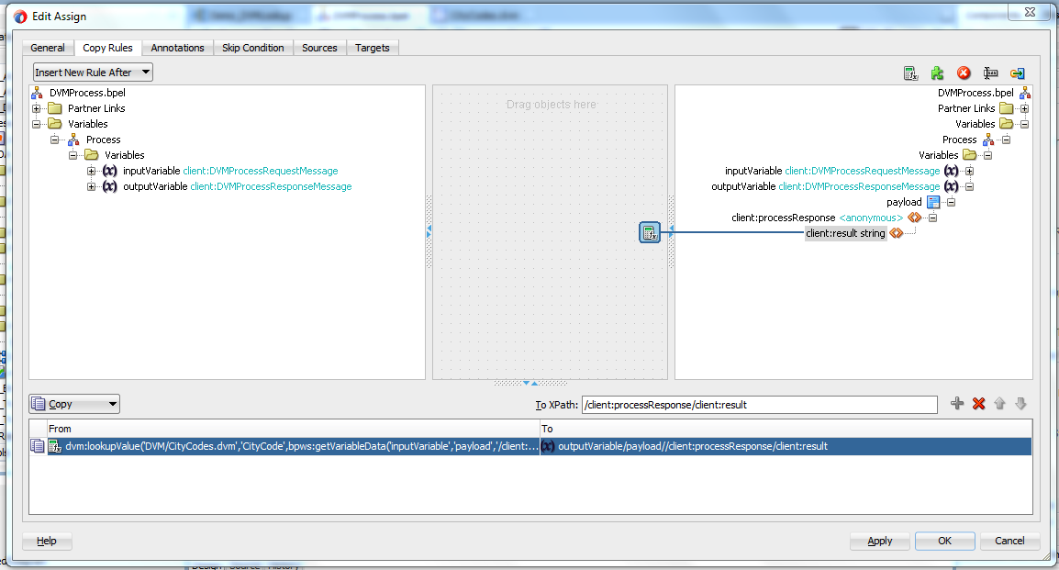

1. Compile, deploy and test.

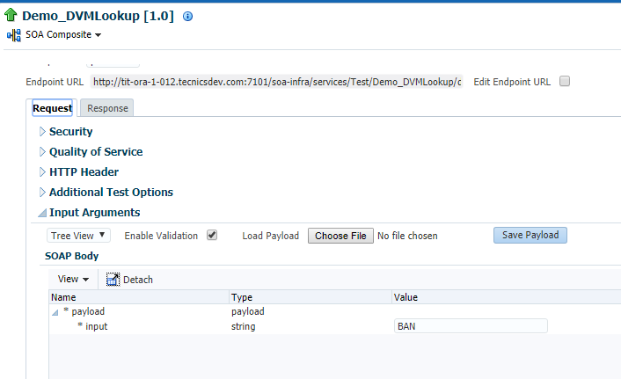

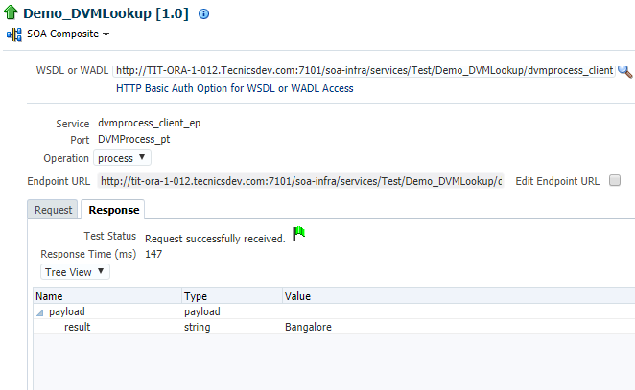

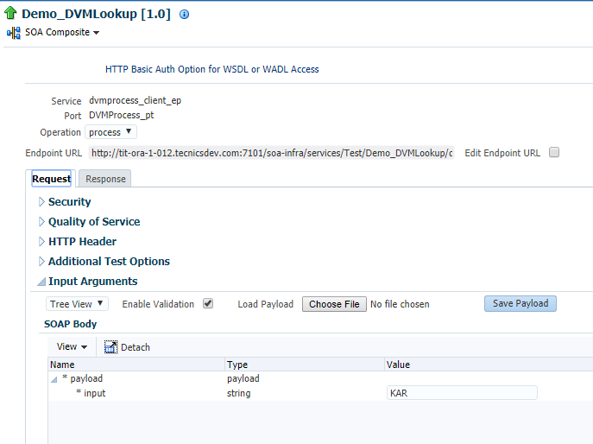

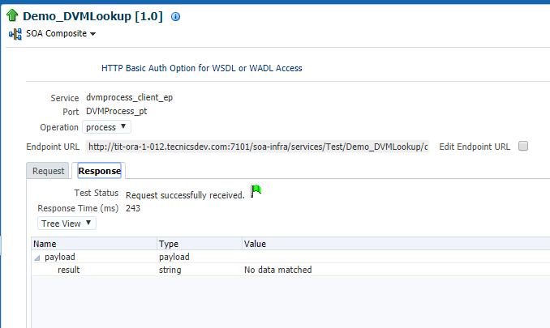

#### Use Domain Value Map Functions in Transformations

The domain value map functions can be used for transformations with a BPEL process service component or an Oracle Mediator service component. Transformations are performed by using the XSLT Mapper, which is displayed when you create an XSL file to transform the data from one XML schema to another.

**To use the lookupValue1M function in a transformation:**

1. In the Application Navigator, double-click an XSL file to open the XSLT Mapper.
2. In the XSLT Mapper, expand the trees in the **Source** and **Target** panes.
3. In the Component Palette, click the down arrow, and then select **Advanced**.
4. Select **DVM Functions**, as shown in Figure.

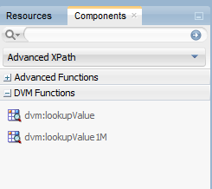

1. Drag and drop **lookupValue1M** onto the line that connects the source to the target.
2. A **dvm:lookupValue1M** icon appears on the connecting line.

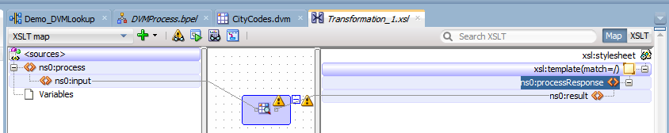

1. Double-click the **lookupValue1M** icon.

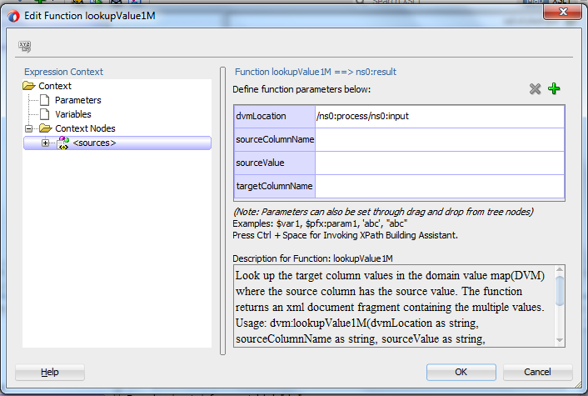

1. Specify values for the following fields in the Edit Function – lookupValue1M dialog:
2. In the **dvmLocation** field, enter the location URI of the domain value map file or click **Browse** to the right of the **dvmLocation** field to select a domain value map file. You can select an already deployed domain value map from the metadata service (MDS) and also from the shared location in MDS. This can be done by selecting the Resource Palette.
3. In the **sourceColumnName** field, enter the name of the domain value map column that is associated with the source element value, or click **Browse** to select a column name from the columns defined for the domain value map you previously selected.
4. In the **sourceValue** field, enter a value or press **Ctrl-Space** to use the XPath Building Assistant. Press the up and down arrow keys to locate an object in the list, and press **Enter** to select an item.
5. In the **targetColumnName** field, enter the name of the domain value map column that is associated with the target element value, or click **Browse** to select the name from the columns defined for the domain value map you previously selected.
6. Click **Add** to add another column as the target column and then enter the name of the column.
7. A populated Edit Function - lookupValue1M dialog is shown in Figure.

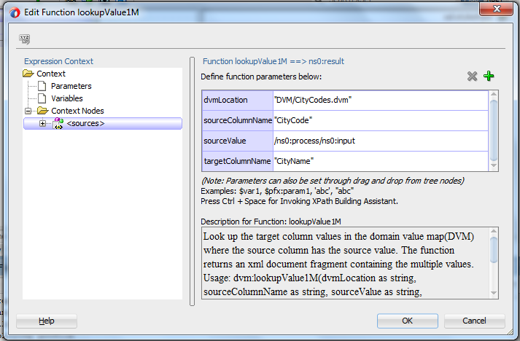

### Security

#### Web Service Authentication and Authorization using OWSM Policies in SOA

To protect your web service from unauthorized access you must secure your web service. We can secure our service in number of way. Here we will discuss how we can secure our web services using custom OWSM policies. We will configure our services to enforce Authentication and Authorization using weblogic’s Default Authenticator and Authorizer.

Step 1:

**Admin Console Activity: User and Group Creation**

1. Go to Admin console

Domain Structure -> Security Realms -> myrealm -> Users and Groups -> Users tab  
Create 3 different users as as shown below: user_one, user_two, user_three

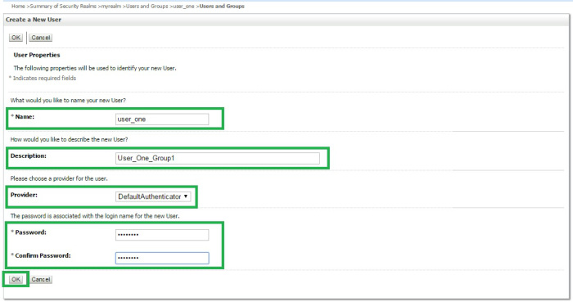

Follow similar step and create user **user_two** and **user_three**.

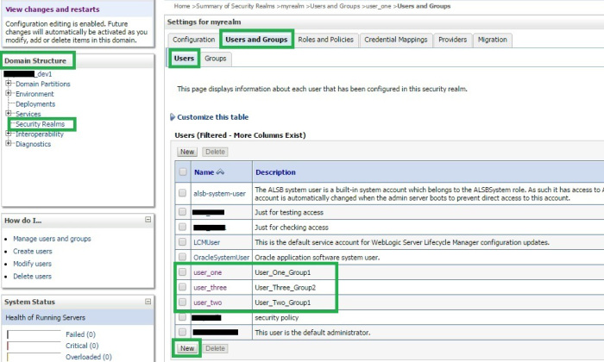

1. Create 2 Groups: **Group1** and **Group2** as shown below

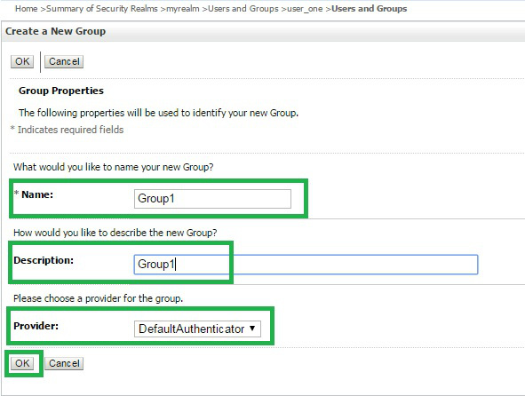

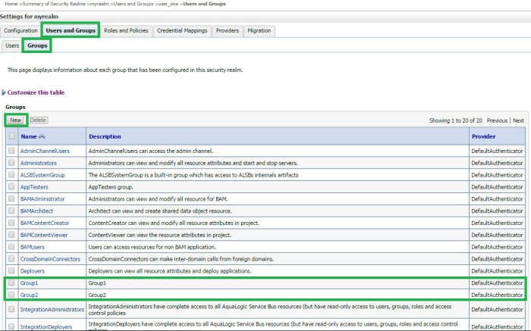

1. Go back to *Users* tab and click on the created user. Go to *Groups* tab and assign group to that user as shown below. Assign **user_one** and **user_two** to **Group1** and **user_three** to **Group2**.

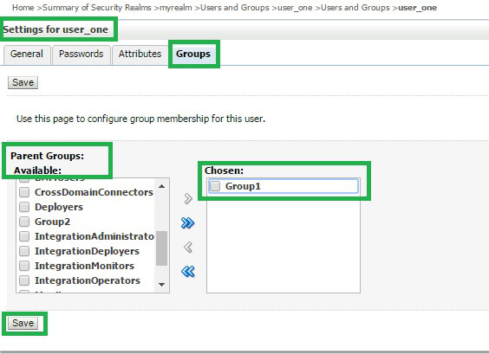

**Step 2:**

**EM Console Activity: Custom Authentication and Authorization policy creation**

1. Log In to EM console.
2. Go to *WSM Policies* as shown below.

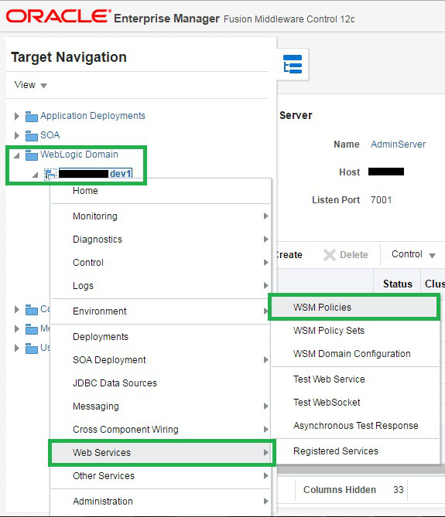

Step 2.1: Create custom authorization policy**:**

1. Search **%oracle/binding_authorization_permitall_policy%.**Select binding authorization security policy that appears below and Click on “*Create Like*“.

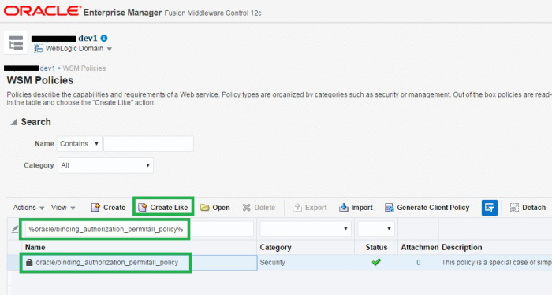

1. Change the policy name in *General* tab as shown below.

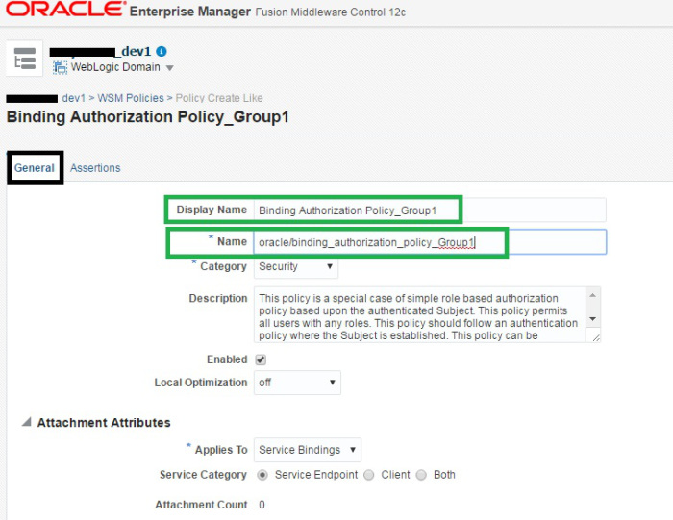

1. Go to *Assertions* tab.

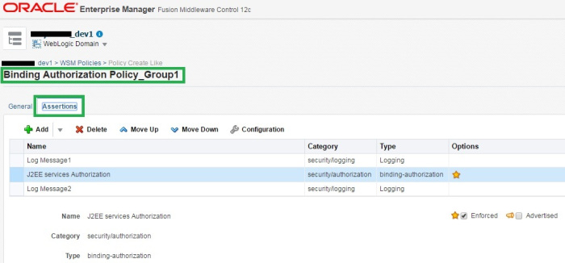

Scroll down to Details section and locate option : Authorization Permission

Select option Selected Roles then click on **Add** as shown below.

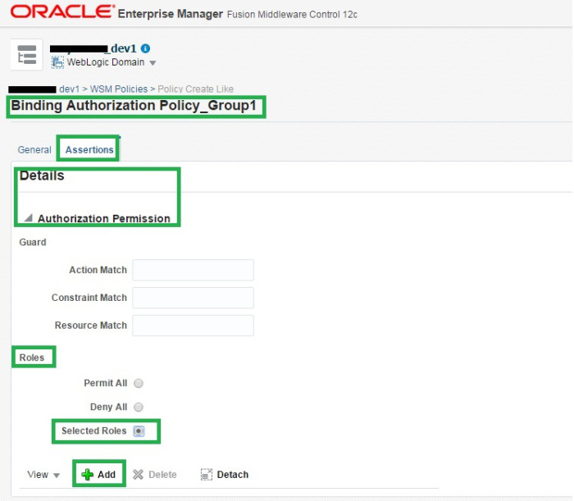

1. Find the group Group1 we have created in Admin Console. Select that and click on option Add Selected. Once added click on Add Enterprise Roles.

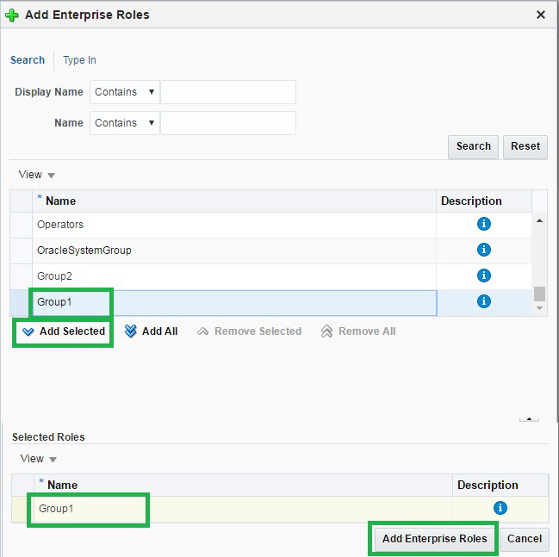

1. Your custom authorization policy should look like below. Click on Save button to save settings.

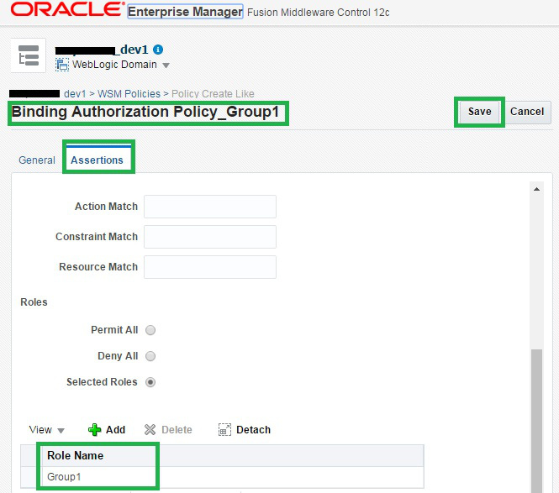

1. Our authorization policy is now created.

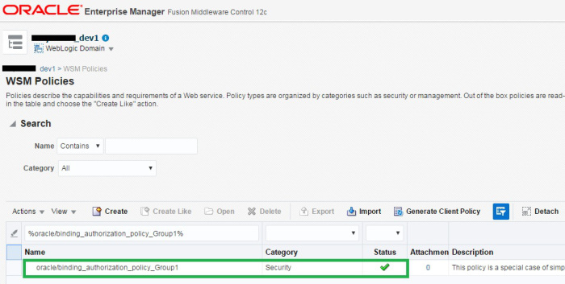

**Step 2.2: Create custom authentication policy:**

1. Search **%oracle/wss_username_token_service_policy%.**Select the wss service policy that appears below and Click on “*Create Like*“.

Note : If you are using your service over SSL, use  **oracle/wss_username_token_over_ssl_service_policy**instead.

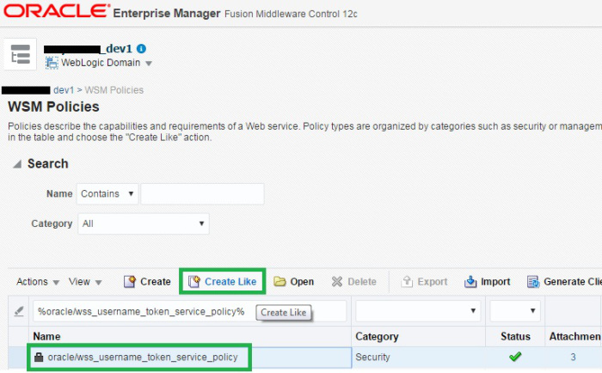

1. Change the name of policy as shown below and click on Save.

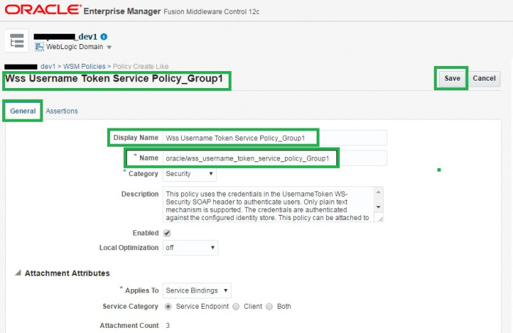

1. Similarly create authentication and authorization policies with *Group2.*

Authentication Policy:

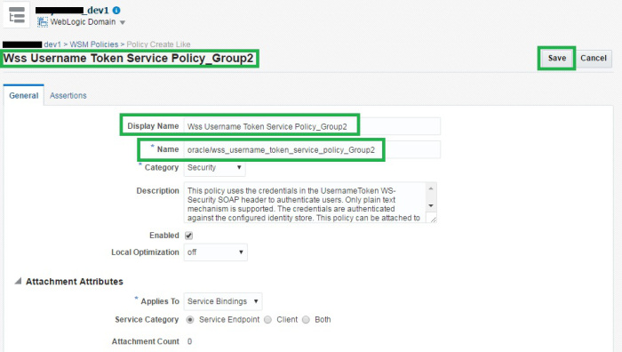

Authorization Policy:

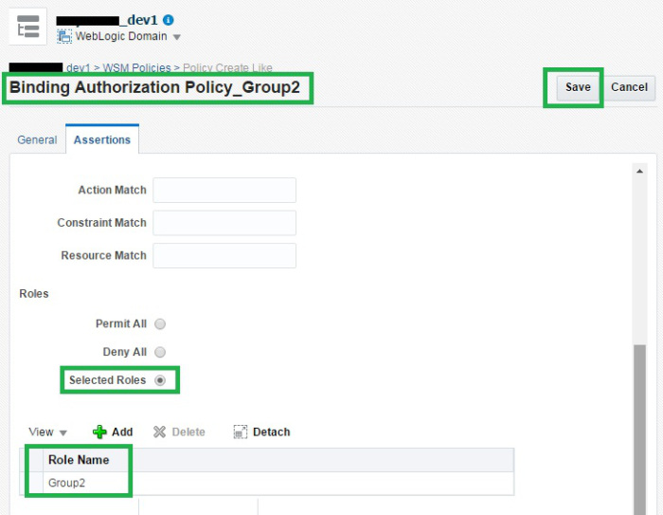

Step 3:

**EM Console Activity : Attach policies to Services**

We have 2 different service. Attach policies with Group1 role to **NameDVMLookUp** service and policies with Group2 role to **HelloWorld** service as shown below.

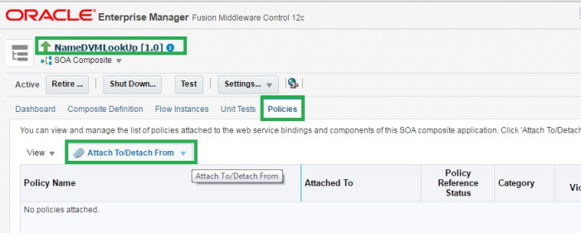

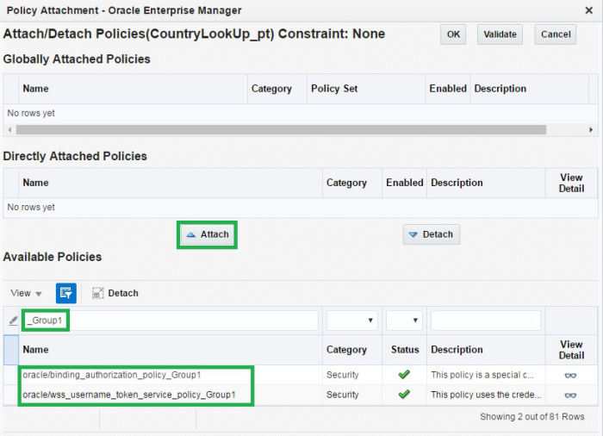

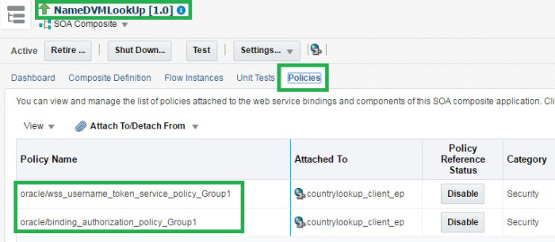

Similarly for HelloWorld :

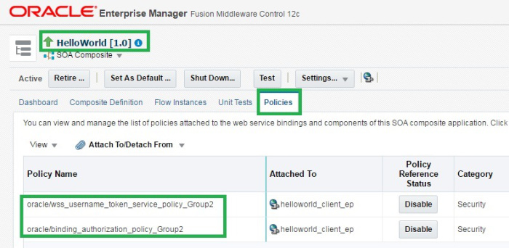

**Testing:**

Testing NameDVMLookUp service with valid user[user_one or user_two]

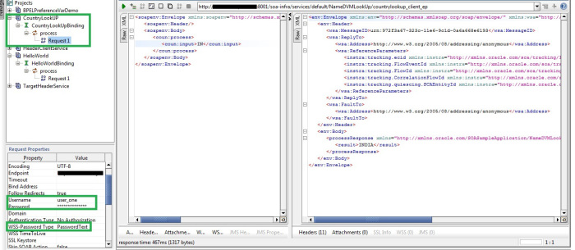

Testing NameDVMLookUp service with invalid user[*user_three*]

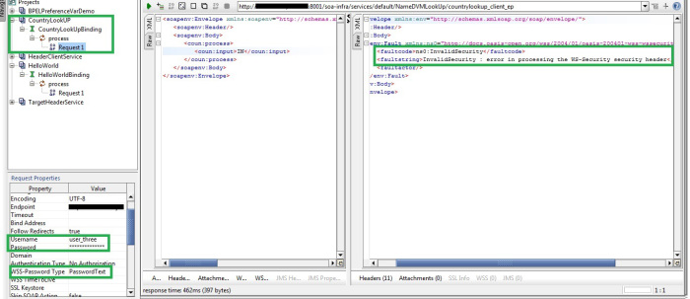

Testing HelloWorld service with valid user[*user_three*]

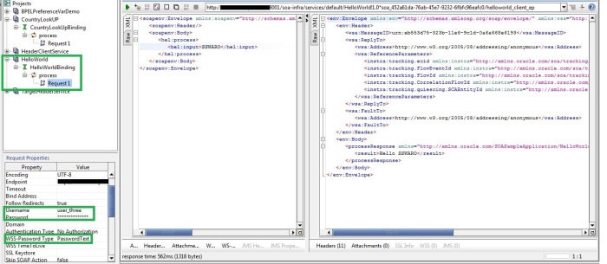

Testing HelloWorld service with invalid user[*user_one or user_ two*]

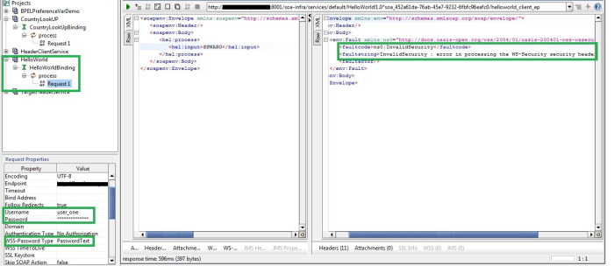

**Conclusion:**

As we have configured in admin console both user *user_one*and *user_two*are in same group *Group1*and *user_three*in *Group2*. The authorization custom policy attached to *NameDVMLookUp*service have only one role attached as enterprise role which is *Group1*and the authorization policy attached to *HelloWorld*service have role attached to it is *Group2*. So all the users in *Group1*can access the web services to which *oracle/binding_authorization_policy_Group1* policy is attached. Similarly the users in *Group2*can access the web services attached with policy *oracle/binding_authorization_policy_Group2*.

# Realtime scenarios

### Date Handling

String to Date (Default date in xslt is 'YYYY-MM-DD')

Input : 2018/12/06

Output : 06-DEC-18

Expression : xp20:format-dateTime (translate ('2018/12/06','/', '-' ), '[D01]-[MN,*-3]-[Y01]' )

Input : 2018/12/06

Output : 2018-12-06

Expression : translate ('2018/12/06', '/', '-' )

### Flow and Instance ID

Flow id : ora:getFlowId()

Instance id : ora:getInstanceId()

### Java Embeded activity to conver base64 binary

<extensionActivity>

<bpelx:exec name="JavaEmbeddingToDecode">

<![CDATA[try{

String encodeddata = (String)getVariableData("Base64Var");

oracle.soa.common.util.Base64Decoder decoder = new oracle.soa.common.util.Base64Decoder();

String decoded = null;

decoded = decoder.decode(encodeddata);

setVariableData("DecodedStrVar",decoded);

} catch(Exception e){

e.printStackTrace();

addAuditTrailEntry(e);

}]]>

</bpelx:exec>

</extensionActivity>

### Reading a large file using chunk read concept

Linenumber and Column number are the variables where we tell from which line and which column to start.

<variable name="isEOF" type="xsd:string"/>

<variable name="lineNumber" type="xsd:string"/>

<variable name="columnNumber" type="xsd:string"/>

<variable name="noDataFound" type="xsd:string"/>

<variable name="isMessageRejected" type="xsd:string"/>

<variable name="rejectionReason" type="xsd:string"/>

<assign name="Assign">

<copy>

<from>'false'</from>

<to expressionLanguage="urn:oasis:names:tc:wsbpel:2.0:sublang:xpath1.0">$isEOF</to>

</copy>

<copy>

<from>'1'</from>

<to expressionLanguage="urn:oasis:names:tc:wsbpel:2.0:sublang:xpath1.0">$lineNumber</to>

</copy>

<copy>

<from>'1'</from>

<to expressionLanguage="urn:oasis:names:tc:wsbpel:2.0:sublang:xpath1.0">$columnNumber</to>

</copy>

</assign>

<invoke name="CallGetFileData" partnerLink="ref_FILE_ReadWellCompletion" portType="ns3:SynchRead_ptt"

operation="SynchRead" inputVariable="CallGetFileDataInput"

outputVariable="CallGetFileDataOutput" bpelx:invokeAsDetail="no">

<bpelx:toProperties>

<bpelx:toProperty name="jca.file.FileName" variable="VarFileDetails">

<bpelx:query>ns6:FileName</bpelx:query>

</bpelx:toProperty>

<bpelx:toProperty name="jca.file.Directory" variable="VarFileLocaation"/>

<bpelx:toProperty name="jca.file.LineNumber" variable="lineNumber"/>

<bpelx:toProperty name="jca.file.ColumnNumber" variable="columnNumber"/>

</bpelx:toProperties>

<bpelx:fromProperties>

<bpelx:fromProperty name="jca.file.LineNumber" variable="lineNumber"/>

<bpelx:fromProperty name="jca.file.ColumnNumber" variable="columnNumber"/>

<bpelx:fromProperty name="jca.file.IsEOF" variable="isEOF"/>

<bpelx:fromProperty name="jca.file.IsMessageRejected" variable="isMessageRejected"/>

<bpelx:fromProperty name="jca.file.RejectionReason" variable="rejectionReason"/>

<bpelx:fromProperty name="jca.file.NoDataFound" variable="noDataFound"/>

</bpelx:fromProperties>

</invoke>

# Oracle Service bus

Re-usability is one of the fundamental concepts of SOA, which can lead to cost benefit. The service has to be well designed and exposed through a generic-enough interface. There may be many applications that have designed by keeping a little re-use in mind. It is not a good idea to reengineer all your applications for reuse. But we can achieve this by virtualization layer that can map arcane interfaces to more re-usable ones, as well as expose them over more standard protocols (SOAP or REST, for instance) than what they natively exposed.

Another problem is that the business requirements change as the business requirements evolves. A simple change in the application can lead to the effect on all the clients who are using the application. That’s why we required an intermediate layer which can deliver agility for the rapid changing business requirements.

The key element to build this virtualization layer is a service bus, coupled to a service registry and repository to ensure governance and discoverability.

### What is Bus?

The service bus decouples the different components of a service in the form of asynchronous events like topic in publish/subscribe pattern that allows every part to be decoupled from the other part and we do not need to span transactions or hold connections between the internal components that would ultimately cause a degradation in the performance of the system.

### Resources in Oracle Service Bus

 In Oracle Service Bus world, all the artifacts are called the OSB resources. In a typical SOA environment, there will be a need to share the different resources across the projects. The resources can be anything like WSDLs, XSDs, Proxy, Business service etc..

We cannot create all kinds of resources in the OSB Configuration Project. For example creating WSDL or XSD in configuration project will give the error. We can only create the Global Resources like Proxy Server, JNDI Provider and SMTP Server. All these resources that can be created in the OSB Configuration Project can be accessed from different OSB projects present in the Configuration Project.

### Proxy Services and Business Services

Oracle Service Bus provides intelligent message brokering between business services (such as enterprise services and databases) and service clients (such as presentation applications or other business services) through proxy services that you can configure using Oracle Service Bus Console. Proxy services are Oracle Service Bus definitions of intermediary Web services that Oracle Service Bus implements locally on WebLogic Server. With Oracle Service Bus message brokering, service clients exchange messages with an intermediary proxy service rather than working directly with a business service.

Oracle Service Bus allows you to implement proxy services independently and configure them dynamically, as driven by your business needs without requiring costly infrastructure development efforts. The configuration functions are separated from the management functions in Oracle Service Bus Console. A proxy service can route messages to multiple business services; you can choose to configure a proxy service with an interface that is independent of the business services with which the proxy service communicates. In such cases, you can configure a message flow definition to route a message to the appropriate business service and map the message data into the format required by the business service’s interface.

### Message Flows and Pipelines

In Oracle Service Bus, a message flow is the implementation of a proxy service. You configure the logic for the manipulation of messages using proxy service message flow definitions. This logic includes such activities as transformation, publishing, and reporting, which are implemented as individual actions within the stages of a pipeline.

Pipelines are one-way processing paths that include no branching. A pipeline is a named sequence of stages containing actions, representing a non-branching one-way processing path. It is used to specify the message flow for service requests and responses.

### Pipeline Pairs

Pipeline pairs are request and response pipelines. The request pipeline definition specifies the actions that Oracle Service Bus performs on request messages to the proxy service before invoking a business service or another proxy service. The response pipeline definition specifies the processing that Oracle Service Bus performs on responses from the business or proxy service that the proxy service invokes before returning a response to a client.

Each pipeline consists of a sequence of stages, each stage containing actions. However, a single service-level request pipeline might optionally branch out into operational pipelines (you can configure one default operational pipeline at most one per operation). The determination of the operation is done through user-selected criteria. The response processing starts with the relevant operation pipeline which then joins into a single service-level response pipeline.

# Oracle Service bus TASKS

### Pipeline Pairs

1. Let’s get started with OSB application creation. Go to File 🡪 New Application 🡪 Service Bus Application.

|  |
| --- |
| [OSB Application](http://4.bp.blogspot.com/-IlCcOTLsOGc/U8fw023YdEI/AAAAAAAAF0A/6bjchEP6hPA/s1600/OSB12c_create_new_application_1.png) |
|  |

1. Name your application and OSB project.

[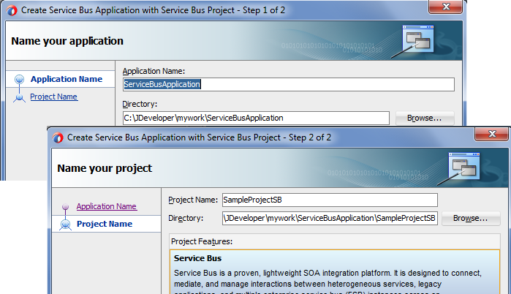](http://2.bp.blogspot.com/-p3k_zwe-tA8/U8fxM83bEmI/AAAAAAAAF0U/FO6sTfR7U4k/s1600/OSB12c_create_new_project_2.png)

1. Add required folder structure as per your naming standards. To add a new folder right click on required folder or file under which you want to add the folder then go to New 🡪 From Gallery.

[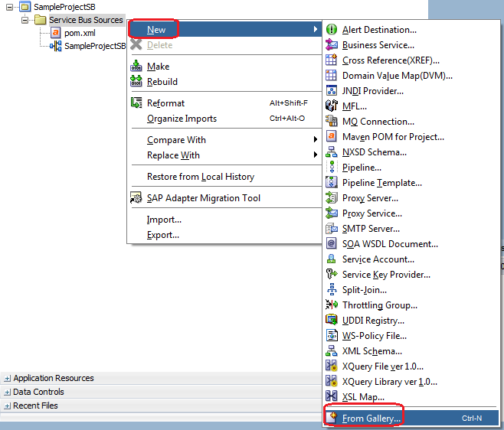](http://4.bp.blogspot.com/-NEKocUoXMZE/U8fw1hp-l4I/AAAAAAAAF0E/TAAgMWPLT3o/s1600/OSB12c_create_new_folder_3.png)

1. Choose Folder from Items list and rename the folder.

[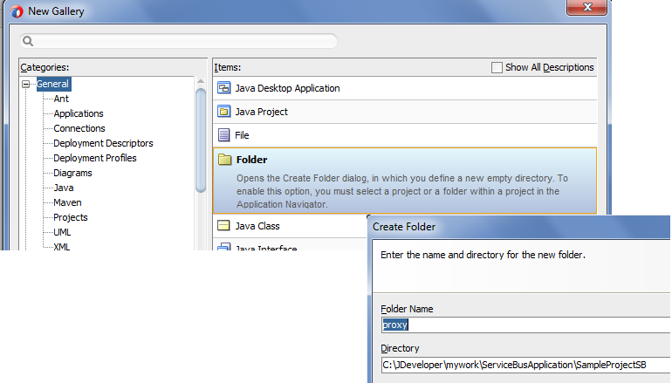](http://3.bp.blogspot.com/-uV6OSfbtxs4/U8fw3a9SHMI/AAAAAAAAF0M/rDn_1Lsseb8/s1600/OSB12c_create_new_folder_4.png)

1. Repeat above step for all other folders.
2. Now we add business service to the project which will invoke the HelloWorld SOA Composite which we created in previous post, to add the business service drag “HTTP” adapter to composite.

[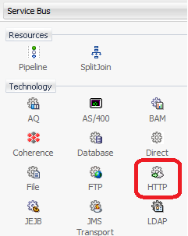](http://3.bp.blogspot.com/-Ec9hjAw6CRI/U8fwf_Clz_I/AAAAAAAAFzM/WOEIwJyoxP8/s1600/OSB12c_create_Add_HTTP_5.png)

1. Name your business service and make sure transport in HTTP. Click on Next.

[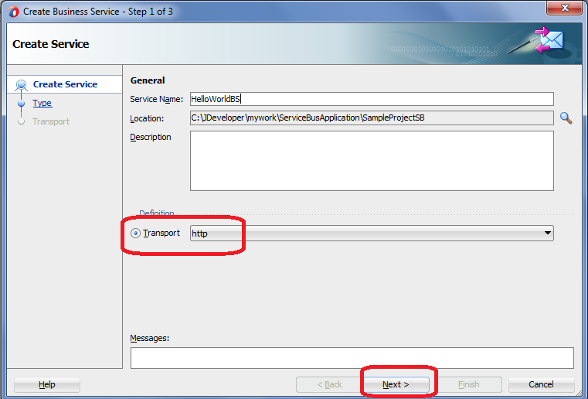](http://2.bp.blogspot.com/-r19YppMrDRk/U8fwxg7QK9I/AAAAAAAAFzk/8srBxGTmULU/s1600/OSB12c_create_Business_Service_Name_6.png)

1. Choose WSDL option and browse HelloWorld Composite WSDL file.

[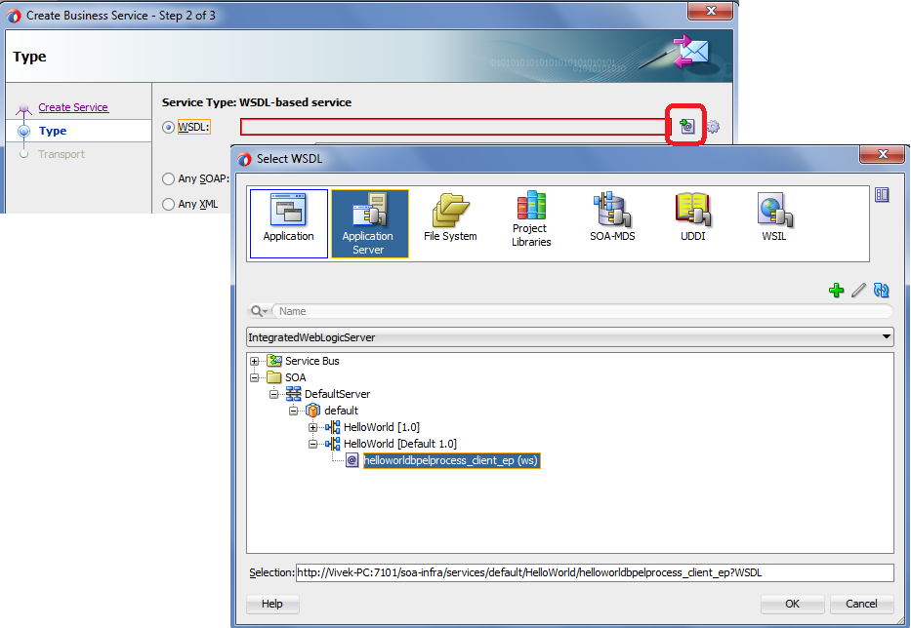](http://1.bp.blogspot.com/-F4R75eyZR1Y/U8fwvrLpUNI/AAAAAAAAFzY/7n6xKZvTWAY/s1600/OSB12c_create_BS_Add_WSDL_7.png)

1. Wizard asked you to add required WSDL and XSD file of HelloWorld application to your OSB project. Check all and click on finish.

[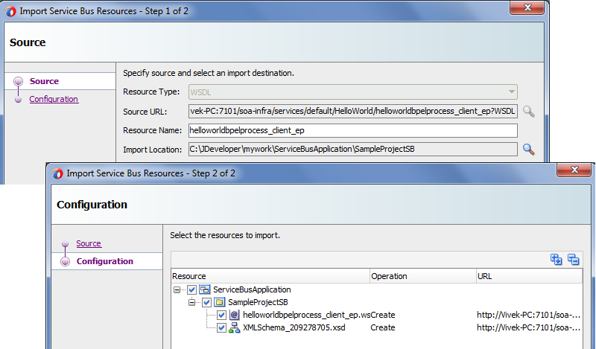](http://1.bp.blogspot.com/-NSg0GqTkRnA/U8fwwHbzpCI/AAAAAAAAFzc/xo80djmpPfM/s1600/OSB12c_create_BS_Add_WSDL_XSD_8.png)

1. Now we add the proxy service and Pipeline to the composite. Pipeline contains all the actions which need to be performed before invoking business service.

[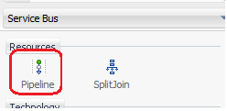](http://2.bp.blogspot.com/-HbpbKQrxoGo/U8fwTbGtU5I/AAAAAAAAFyk/jorbR1peDmM/s1600/OSB12c_Drag_Pipeline_9.png)

1. Name you pipeline and click on next.

[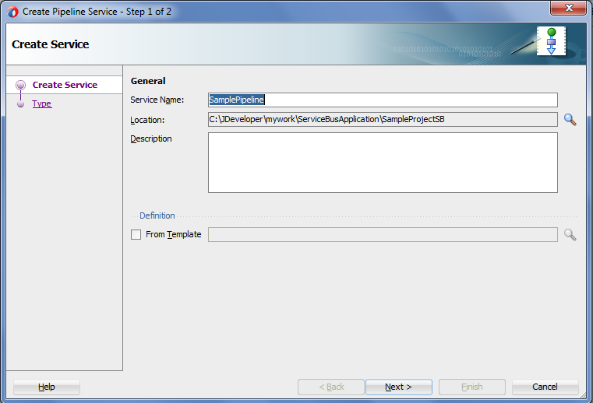](http://3.bp.blogspot.com/-q_jfP-Ossyc/U8fw0EC-LYI/AAAAAAAAFzw/kGq4EFKveTY/s1600/OSB12c_create_PIpleline_10.png)

1. You see Expose as a proxy option in the pipeline; this option will configure proxy service for you based on pipeline message type.
2. We use same HelloWorld WSDL file for the pipeline and proxy. Check the WSDL option and browse the HelloWorld WSDL file.

[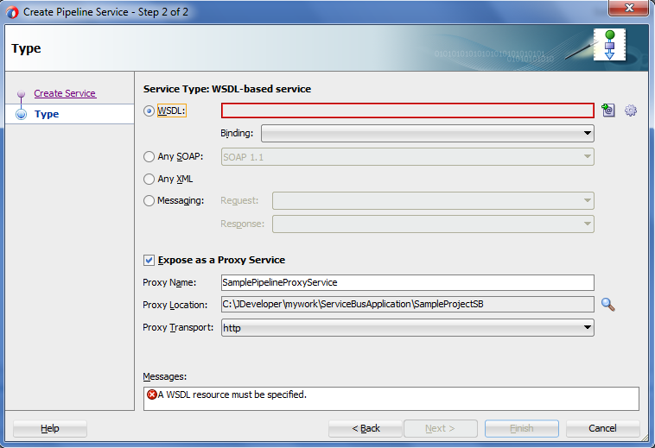](http://1.bp.blogspot.com/-jwMVWelfexI/U8fwZEYwsxI/AAAAAAAAFy8/1zy1jcxq3_c/s1600/OSB12c_Create_Proxy_11.png)

1. Once you add the HelloWorld WSDL file, your pipeline window should look like below.

[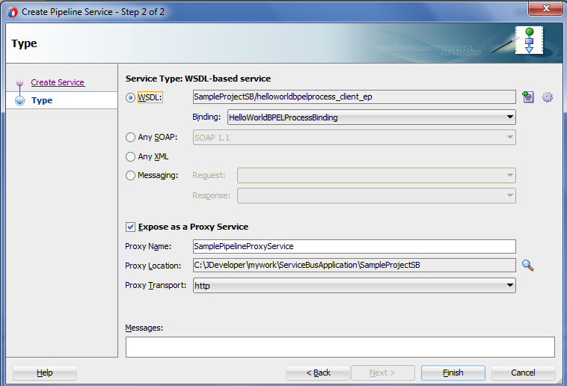](http://1.bp.blogspot.com/-Q1Hse2M_-8U/U8fw0RJBPYI/AAAAAAAAFz4/60mEz-CODgQ/s1600/OSB12c_create_Proxy_12.png)

1. Your flow looks like below. Now wire pipeline to business service.

[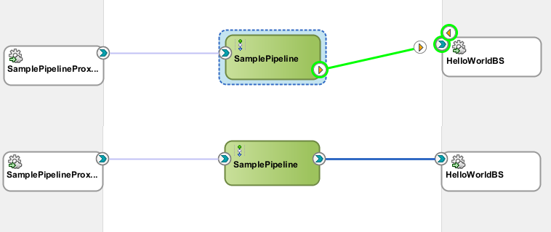](http://4.bp.blogspot.com/-f3wS4zNrlKk/U8f3ycQTZCI/AAAAAAAAF0g/CqE7Y3wHqP4/s1600/OSB12c_Final_Flow_13.png)

1. With the above step we are done with build part. Now we need to test on integrated server. To test it right click on proxy service and click on Run.

[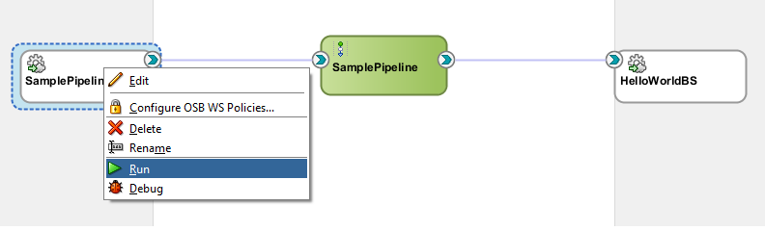](http://2.bp.blogspot.com/-_452j-DQcWY/U8f4JTfECQI/AAAAAAAAF0o/vuP1qu7FJqc/s1600/OSB12c_Testing_run_14.png)

1. This opens a OSB console for you. Provide request message and click on Execute.

[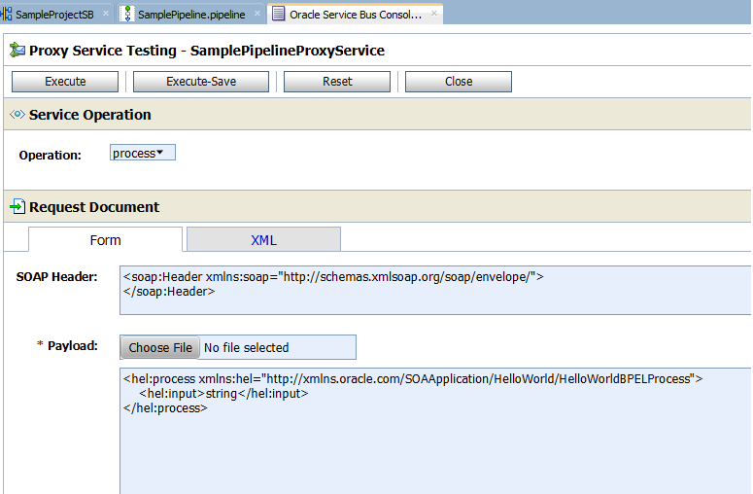](http://4.bp.blogspot.com/-ZHrjf4xvELY/U8f4kf8zseI/AAAAAAAAF0w/UDvJm617Q_4/s1600/OSB12c_Testing_request_15.png)

1. You should see response in same console.

[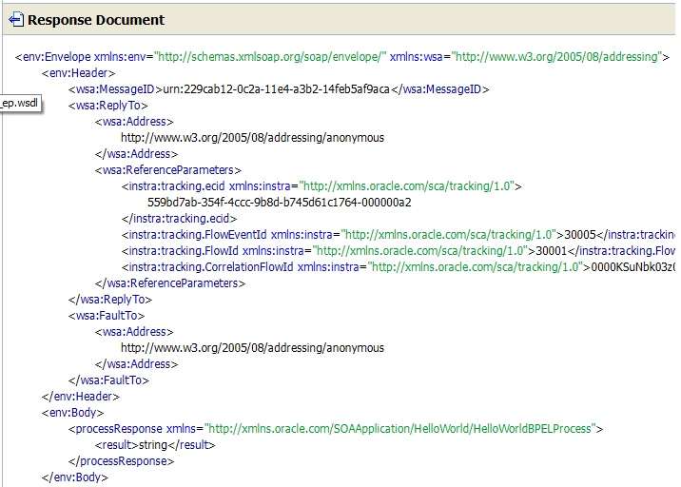](http://3.bp.blogspot.com/-Jn5bSUlt7iw/U8f41TJw7gI/AAAAAAAAF04/UQNyk0slS8A/s1600/OSB12c_Testing_response_16.png)

1. You can also check the flow in EM console.

[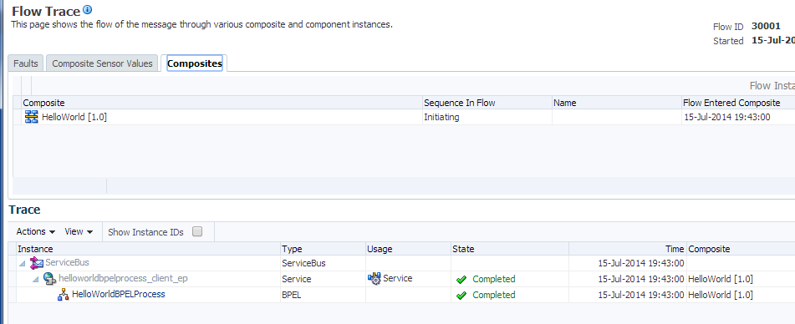](http://2.bp.blogspot.com/-NZUdXR9YYo4/U8f5O7SVmaI/AAAAAAAAF1A/5dZ2CU6bArU/s1600/OSB12c_Composite_Flow_17.png)

### Conditional Branch in SOA

#### Business case requirement:

* This is a simple use case for Employee Loan process in an organization
* When an employee of the organization submit the request for a loan, it goes through various process to get it approved
* Employee enters basic details like employee id, name, grade and loan amount requested in dollars and comments if any
* If entered loan amount in dollars is less than or equal to 4 thousands ($4K), then it goes through the default loan approval process
* Otherwise, if entered loan amount in dollars is greater than 4 thousands ($4K), then it goes to HR Manager for approval

**[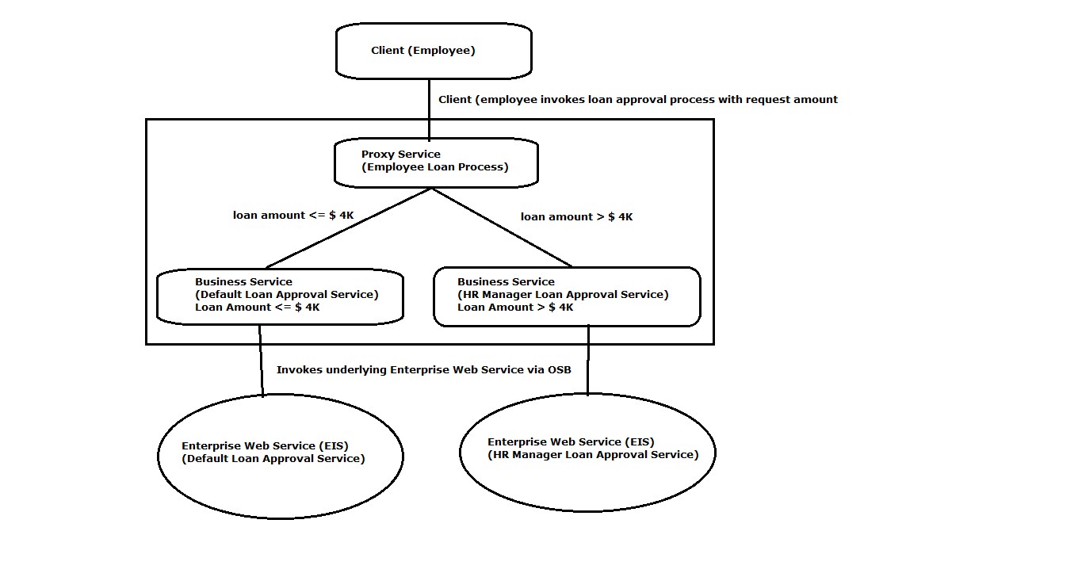](http://www.benchresources.net/wp-content/uploads/2015/05/0_OSB-12c_Conditional_Branch_example_Problem_statement_in_figure.png)**

#### Assumptions:

* There are two web services for Employee Loan Process up & running on the application server
* This web services can be invoked only through OSB
* Two web services are  
  1. Default Loan approval service  
  2. HR Manager Loan approval service
* For demo purpose, we will copy the WSDL and Schema files and paste in our Service Bus project under “Resources” folder  
  This web service roughly based on [**this article**](http://www.benchresources.net/metro-jax-ws-soap-based-web-service-using-top-down-approach), go through this article to understand the underlying web services part
* Download this web service project used in this demo example from download section (scroll to last)

 Let’s get started with designing OSB modules for Conditional Branch example in Oracle JDeveloper 12c IDE

1. Open New Project
2. File Menu –> New –> Project

**[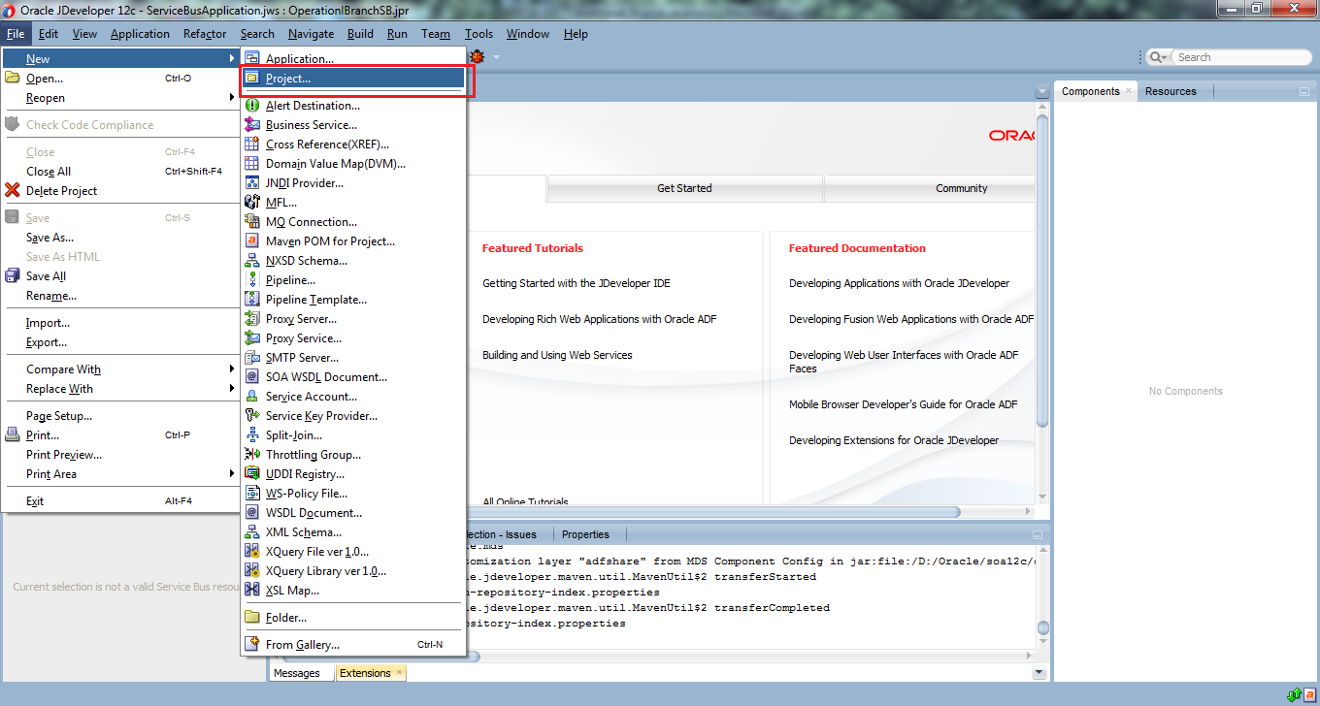](http://www.benchresources.net/wp-content/uploads/2015/05/1_OSB-12c_Conditional_Branch_example_New_Project.png)**

1. Select Service Bus Tier from available categories
2. Service Bus Tier –> Service Bus Project –> OK

This opens up wizard for New Service Bus Project

**[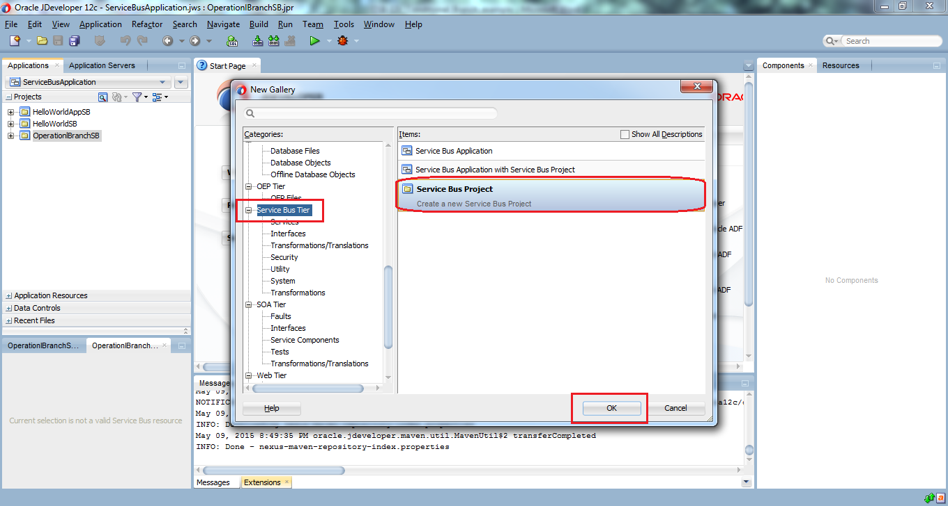](http://www.benchresources.net/wp-content/uploads/2015/05/2_OSB-12c_Conditional_Branch_example_New_Project_wizard.png)**

1. **Step 3:** Enter Project Name and its directory location for the new Service Bus Project
2. Leave the default values for demo; otherwise we can give more specific names in accordance with naming convention followed in the project
3. **Project Name:** ConditionalBranchSB
4. Click Finish

**[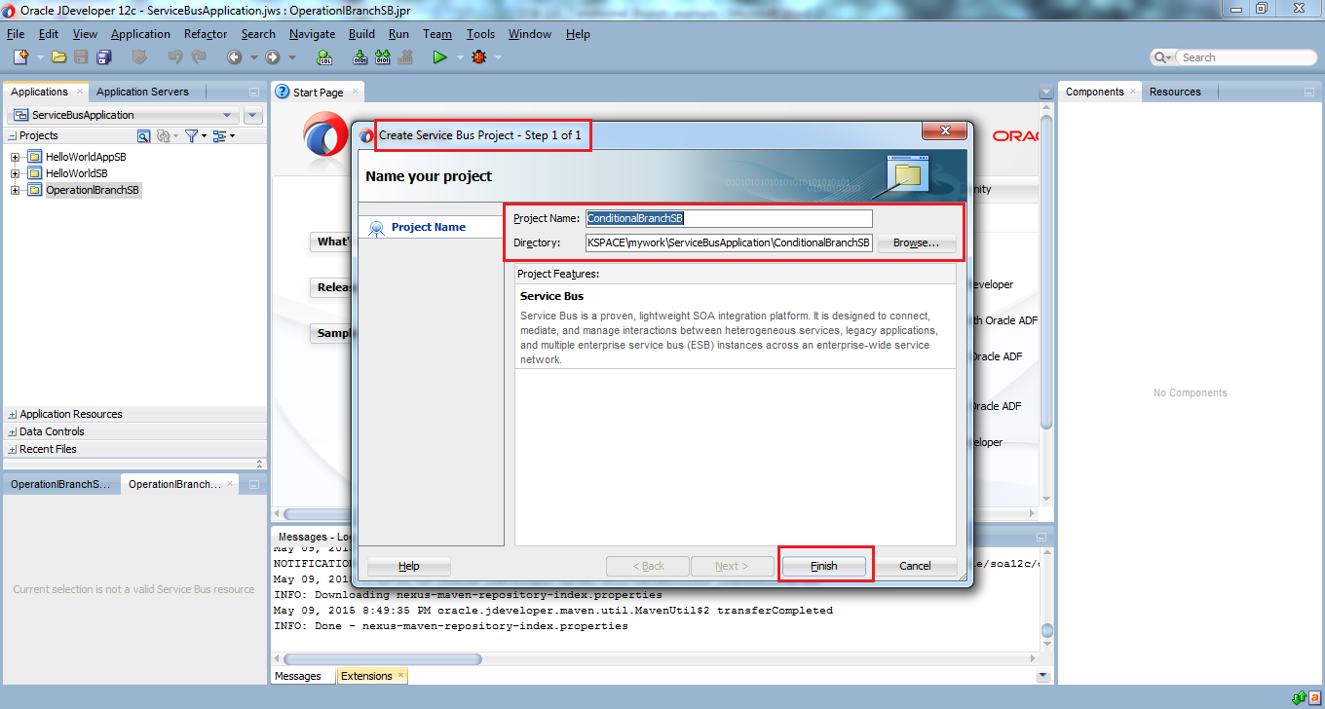](http://www.benchresources.net/wp-content/uploads/2015/05/3_OSB-12c_Conditional_Branch_example_New_Project_wizard_name.png)**

New Service Bus project will be created with required artifacts

1. Create required folders in accordance with project standards (naming conventions)

Generally, there should be

* **ProxyService** folder to place/store/save the proxy services which ends with .proxy
* **BusinessService** folder to place/store/save the business services which ends with .bix
* **Resources** folder to store all other required artifacts like WSDL, Schema and transformations files

Now, we will create above listed folders

1. Right click on the Service Bus project –> New –> Folder…

Opens up a new wizard

**[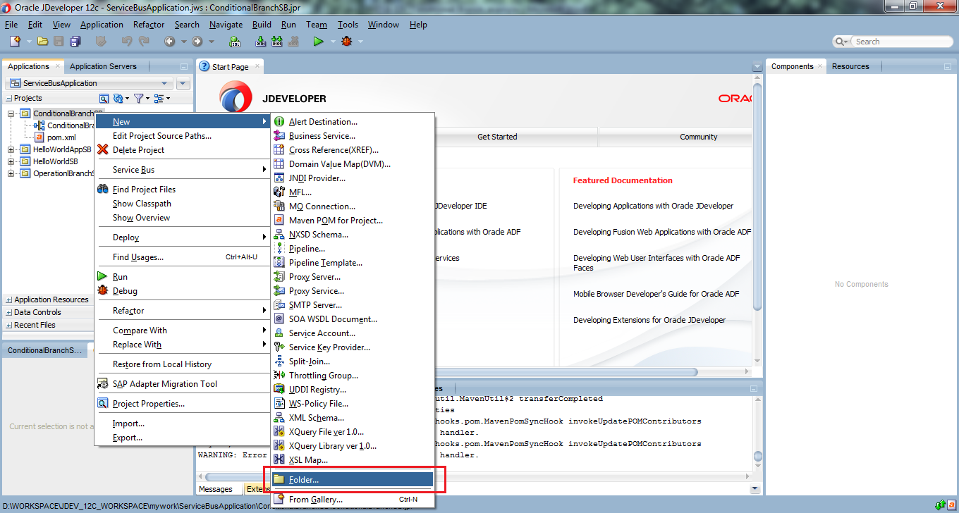](http://www.benchresources.net/wp-content/uploads/2015/05/4_OSB-12c_Conditional_Branch_example_New_Project_create_folder.png)**

**Note:** If you don’t find “**folder**” option directly, then click on “From Gallery” and from there choose folder option and continue with below next steps

1. Create Folder wizard –> enter folder name like, for example “*BusinessService*” for Business Service
2. Finally click OK –> to create folder

**[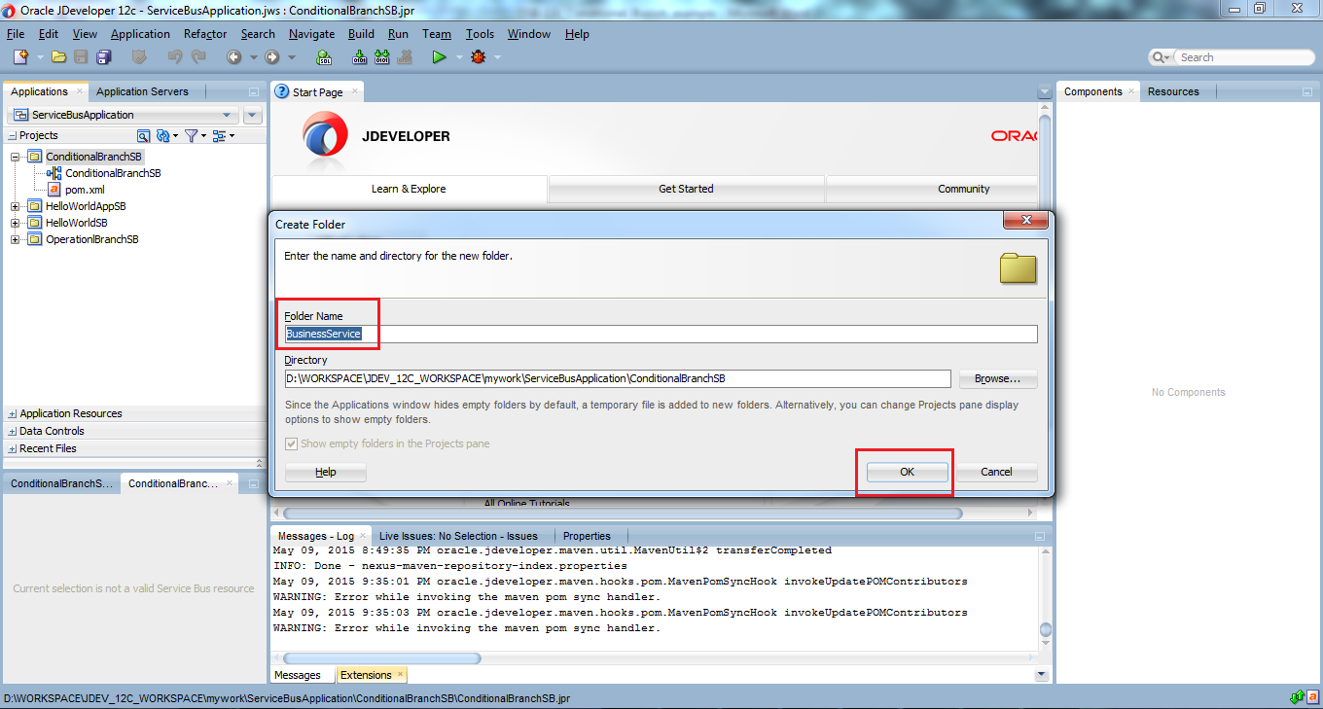](http://www.benchresources.net/wp-content/uploads/2015/05/5_OSB-12c_Conditional_Branch_example_New_Project_create_folder_b.png)**

1. Similarly, we can create “*ProxyService*” and “*Resources*” folders
2. After creating all three folders namely *ProxyService, BusinessService* and *Resources,* our project will look like below screenshot

**Note:** Also create “entities” & “wsdl” folders under “Resources” to store/keep Schema and WSDL files (separately)

**[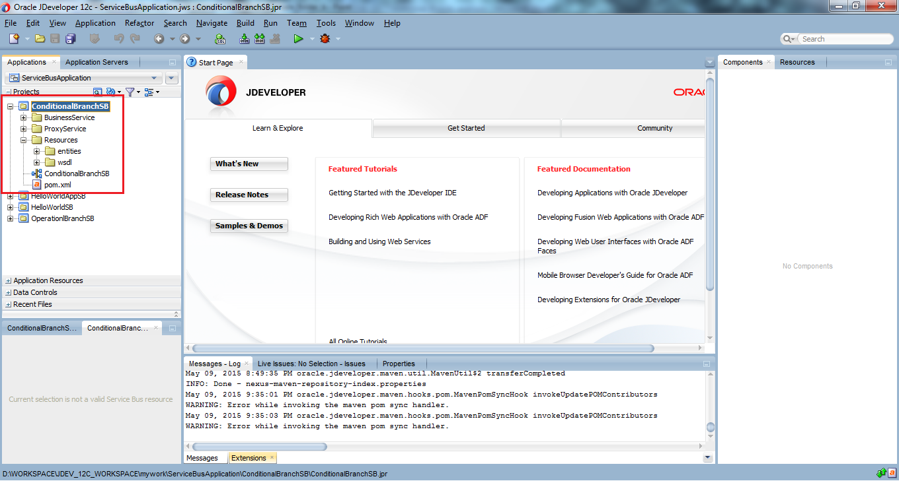](http://www.benchresources.net/wp-content/uploads/2015/05/6_OSB-12c_Conditional_Branch_example_New_Project_create_folder_c.png)**

1. Enterprise Information System (EIS) or Exposed Web Services

As we discussed in the **assumption** section, there are two web services up & running at URLs

<http://localhost:8080/EmployeeLoanService/services/DefaultLoanApprovalService?wsdl>

<http://localhost:8080/EmployeeLoanService/services/HRManagerLoanApprovalService?wsdl>

So we will copy Schema and WSDL files && paste it to the Resources folder as directed below

**XML Schema** –> under “entities” folder  
**WSDL** –> under “wsdl” folder

**[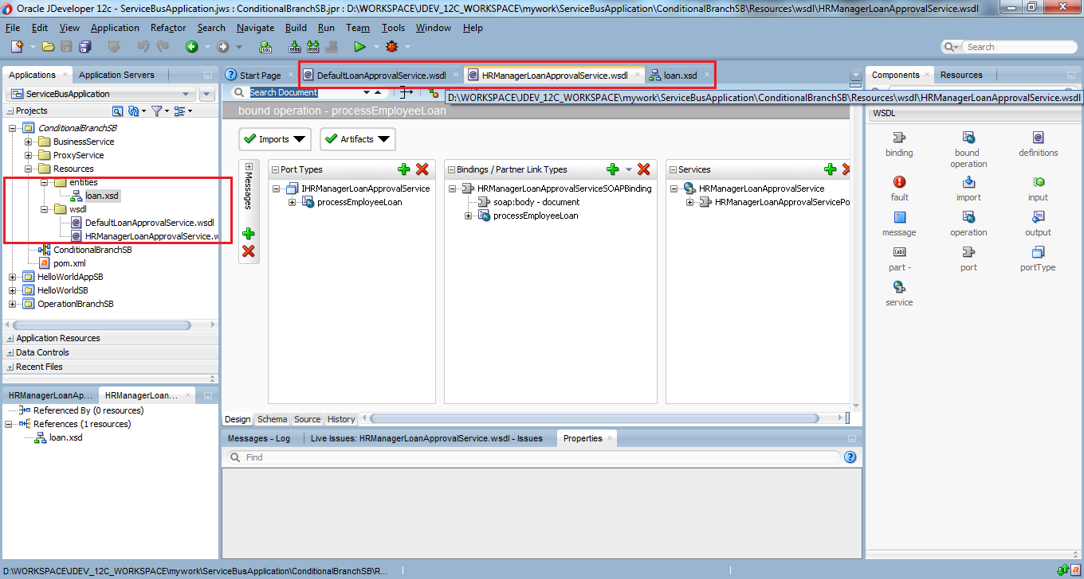](http://www.benchresources.net/wp-content/uploads/2015/05/7_OSB-12c_Conditional_Branch_example_New_Project_schema_wsdl.png)**

**Note:** Make sure those two web services are running

#### Business Service

1. Create Business Service to invoke the exposed Web Service

There are two Business Services

* Default Loan Approval Service
* HR Manager Loan Approval Service

Drag and drop HTTP component from Technology palate to External Services lane (Business Service in 11g)

**[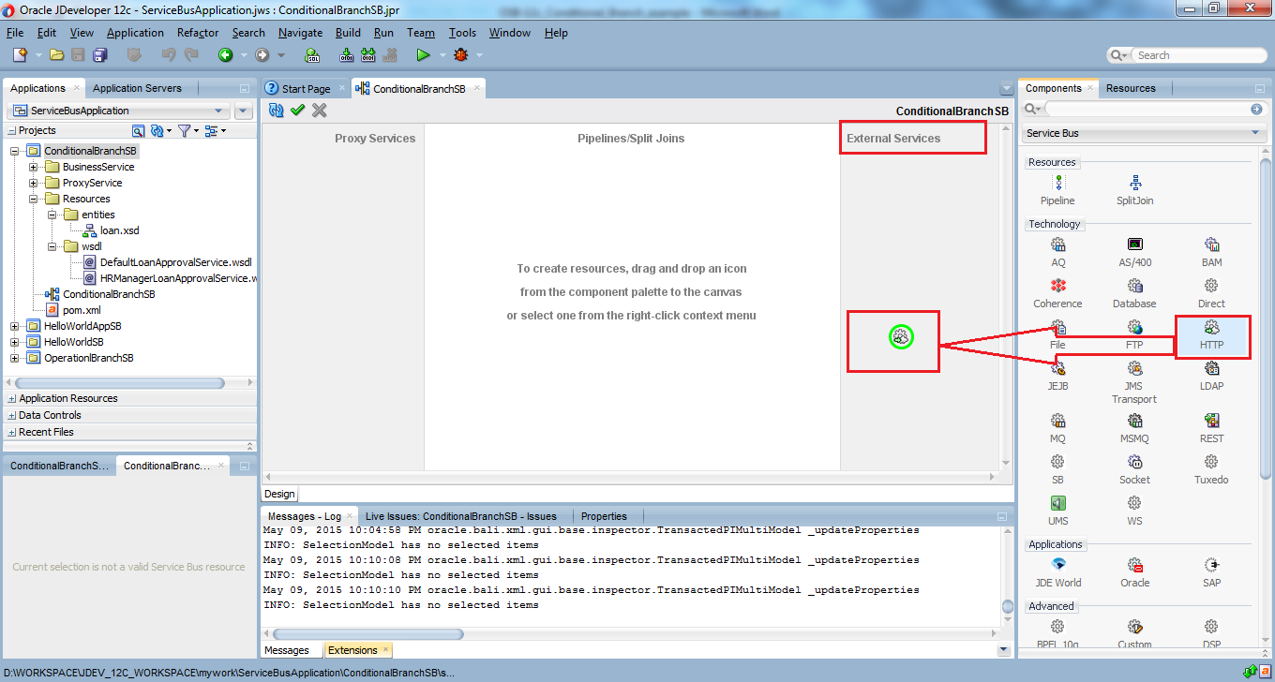](http://www.benchresources.net/wp-content/uploads/2015/05/8_OSB-12c_Conditional_Branch_example_New_Project_HTTP_component.png)**

Upon dropping, a new wizard pops up to enter the required details for Business Service or External Service

1. Fill up the mandatory details for Business Service (i.e **.bix** file)

**Service Name:** DefaultLoanApprovalServiceBS (append BS to the business service as a naming standard)  
**Location:** browse through “BusinessService” folder we created in earlier step  
**Transport:** http (keep it as it is)

1. Click Next

**[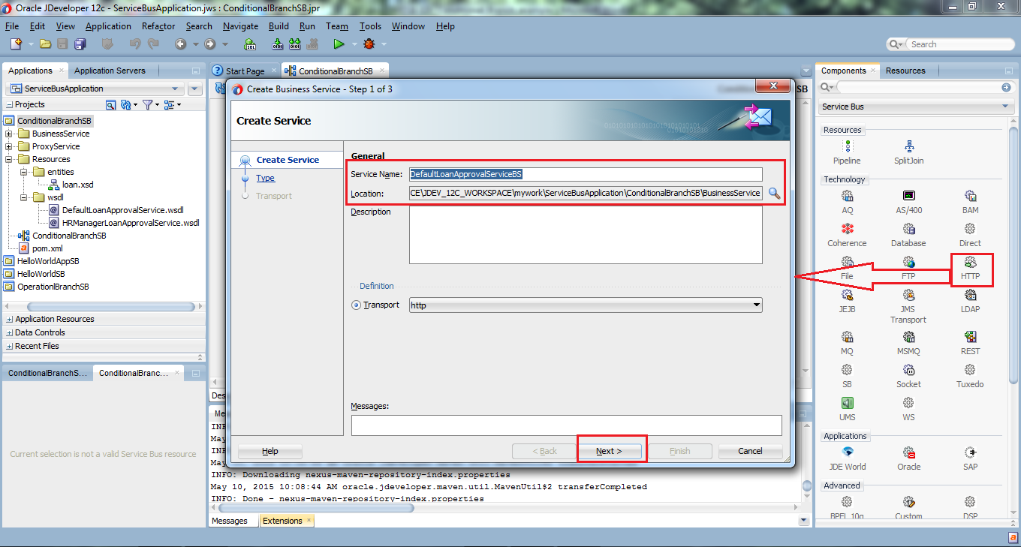](http://www.benchresources.net/wp-content/uploads/2015/05/9_OSB-12c_Conditional_Branch_example_New_Project_Business_wizard_6a.png)**

1. Select “*WSDL*” from four available options and browse to wsdl location by clicking first icon with green arrow mark pointing towards right hand side (i.e.; wsdl is placed under “*Resources/wsdl*” folder)
2. Choose “*Application*” and select correct WSDL we have stored for this project
3. Finally click OK and then click Next

**[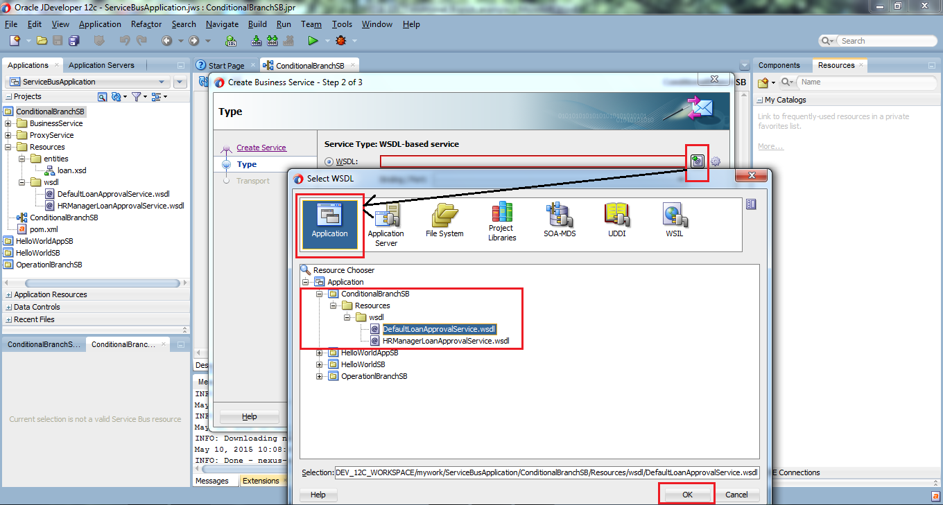](http://www.benchresources.net/wp-content/uploads/2015/05/10_OSB-12c_Conditional_Branch_example_New_Project_Business_wizard_6b.png)**

1. Create Business Service wizard –> populates wsdl file with port after reading the WSDL file we have chosen in the previous step
2. Click Next

**[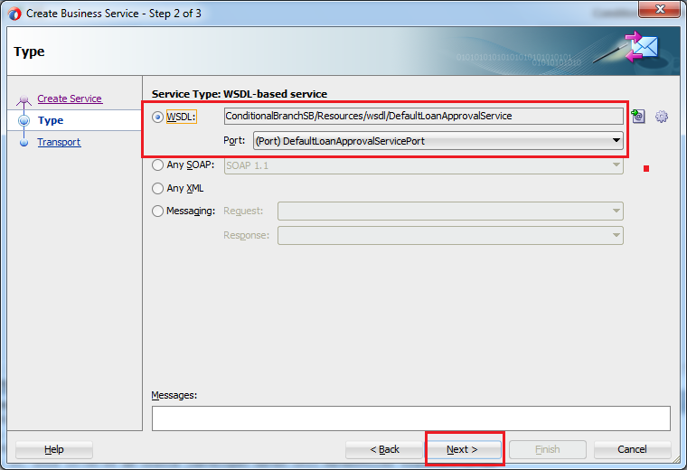](http://www.benchresources.net/wp-content/uploads/2015/05/11_OSB-12c_Conditional_Branch_example_New_Project_Business_wizard_6c.png)**

1. In step 3 of Create Business Service wizard –> populates the endpoint URI for the exposed web service to be invoked
2. Click Finish

**[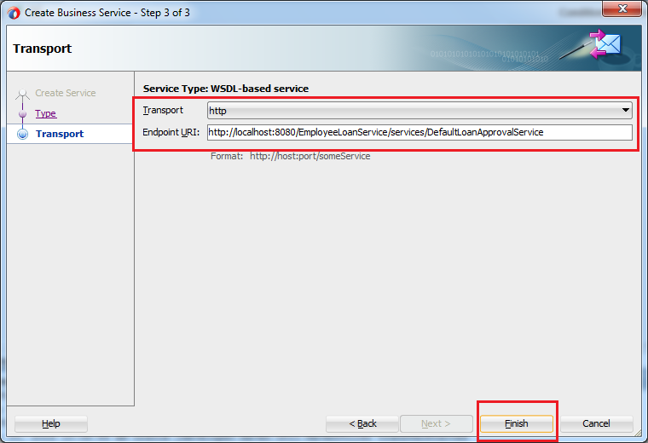](http://www.benchresources.net/wp-content/uploads/2015/05/12_OSB-12c_Conditional_Branch_example_New_Project_Business_wizard_6d.png)**

Similarly, we will create business service for second service i.e.; HR Manager Loan Approval Service

1. Fill up the mandatory details for Business Service (i.e *.bix* file)

**Service Name:** HRManagerLoanApprovalServiceBS (append BS to the business service as a naming standard)  
**Location:** browse through “BusinessService” folder we created in earlier step  
**Transport:** http (keep it as it is)

1. Click Next

**[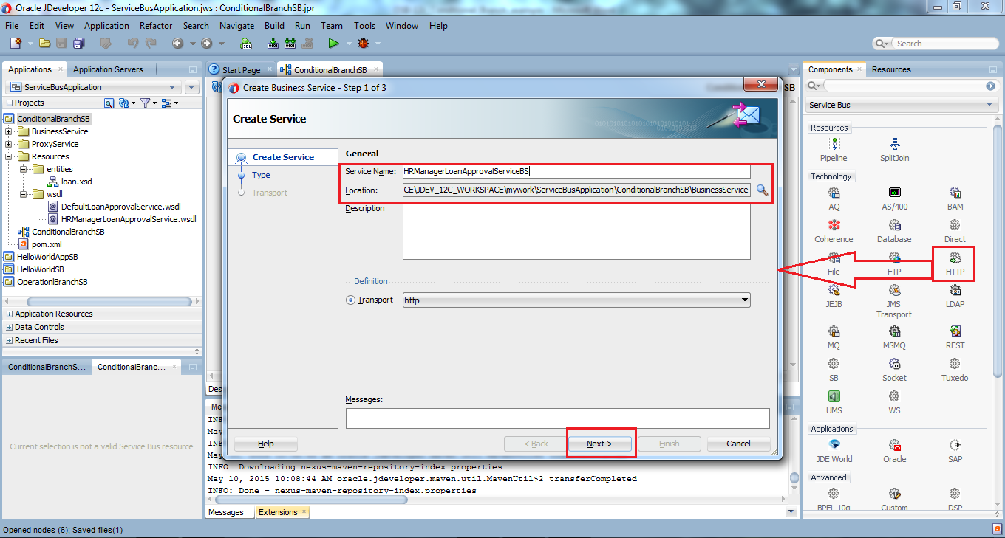](http://www.benchresources.net/wp-content/uploads/2015/05/13_OSB-12c_Conditional_Branch_example_New_Project_Business_wizard_7a.png)**

1. Select “*WSDL*” from four available options and browse to wsdl location by clicking first icon with green arrow mark pointing towards right hand side (i.e.; wsdl is placed under “Resources/wsdl” folder)
2. Choose “**Application**” and select correct WSDL we have stored for this project
3. Finally click OK and then click Next

**[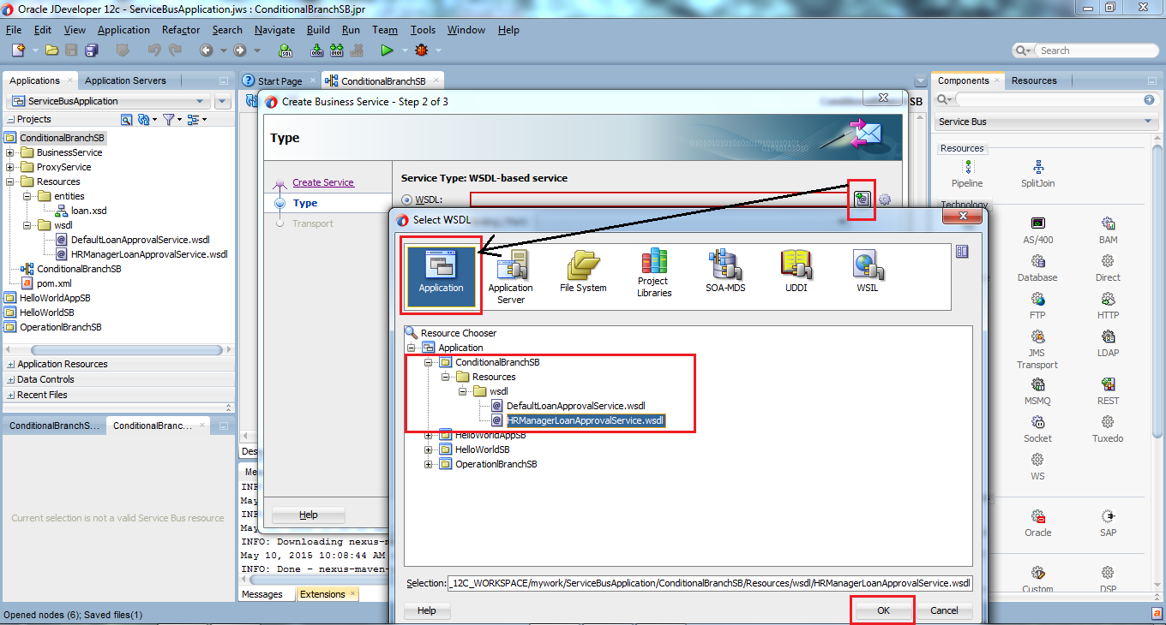](http://www.benchresources.net/wp-content/uploads/2015/05/14_OSB-12c_Conditional_Branch_example_New_Project_Business_wizard_7b.png)**

1. Create Business Service wizard –> populates wsdl file with port after reading the WSDL file we have chosen in the previous step
2. Click Next

**[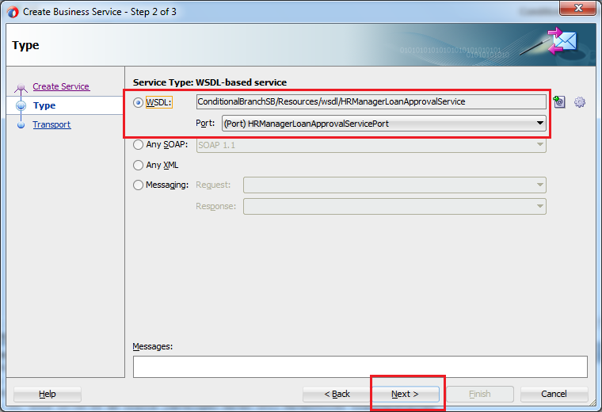](http://www.benchresources.net/wp-content/uploads/2015/05/15_OSB-12c_Conditional_Branch_example_New_Project_Business_wizard_7c.png)**

1. Create Business Service wizard –> populates the endpoint URI for the exposed web service to be invoked
2. Click Finish

**[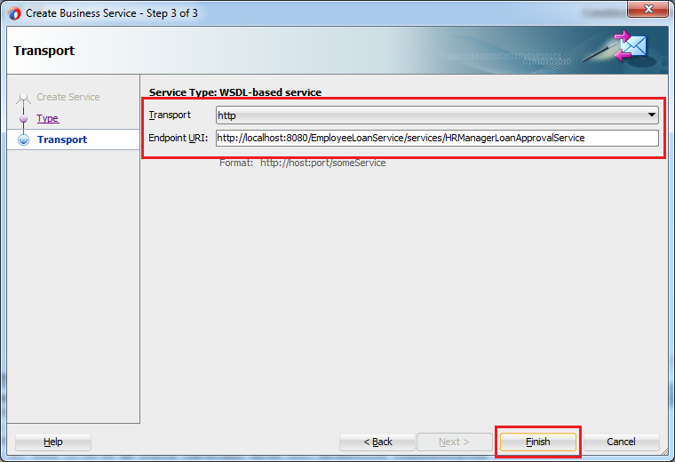](http://www.benchresources.net/wp-content/uploads/2015/05/16_OSB-12c_Conditional_Branch_example_New_Project_Business_wizard_7d.png)**

1. Finally both the Business Services are created
2. Business Service is created on the External Services lane and this resides under “*BusinessService*” folder

**[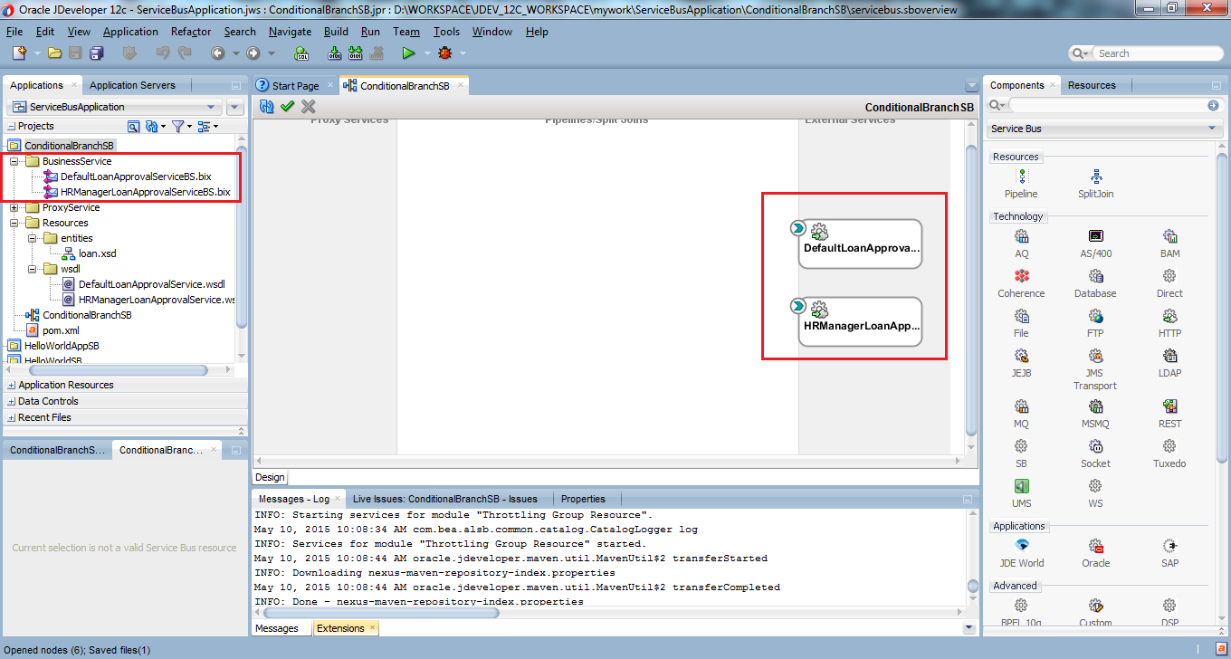](http://www.benchresources.net/wp-content/uploads/2015/05/17_OSB-12c_Conditional_Branch_example_New_Project_Business_services_created.png)**

#### Proxy Service

1. Create Proxy Service and add pipeline
2. Drag and drop HTTP component from Technology palate to Proxy Services

**[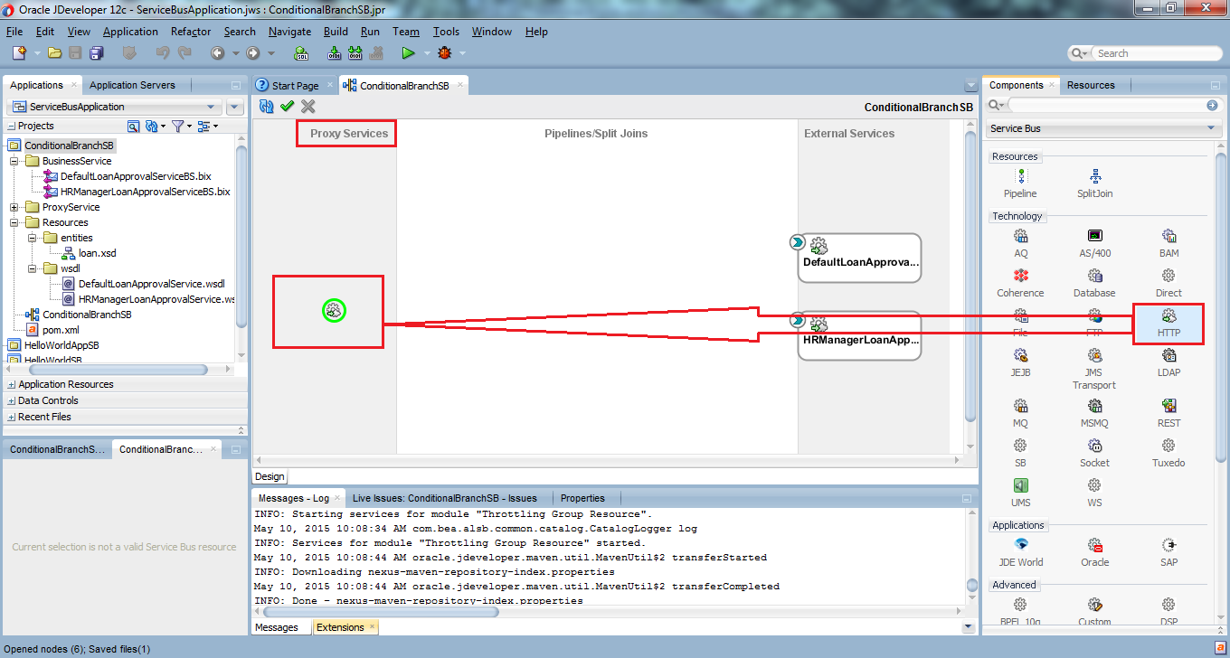](http://www.benchresources.net/wp-content/uploads/2015/05/18_OSB-12c_Conditional_Branch_example_New_Project_Proxy_service_wizard.png)**

1. Upon dropping, a new wizard pops up to enter the required details for Proxy Service
2. Fill up the mandatory details for Proxy Service (i.e *.proxy* file)

**Service Name:** EmployeeLoanProcessPS (append PS to the proxy service as a naming standard)  
**Location:** browse through “*ProxyService*” folder we created in earlier step  
**Transport:** http (keep it as it is)

1. Keep “*Generate Pipeline*” checked for creating pipeline along with Proxy Service
2. Click Next

**[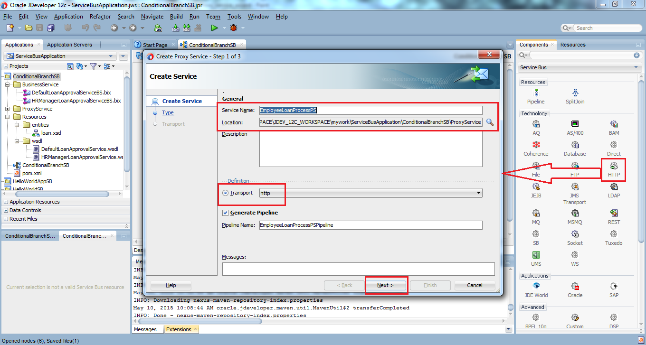](http://www.benchresources.net/wp-content/uploads/2015/05/19_OSB-12c_Conditional_Branch_example_New_Project_Proxy_service_wizard_9a.png)**

1. We will use “Default Loan Approval Service” WSDL for this demo example

**Note:** In a complex business scenarios, WSDL file of BS & PS are different

**[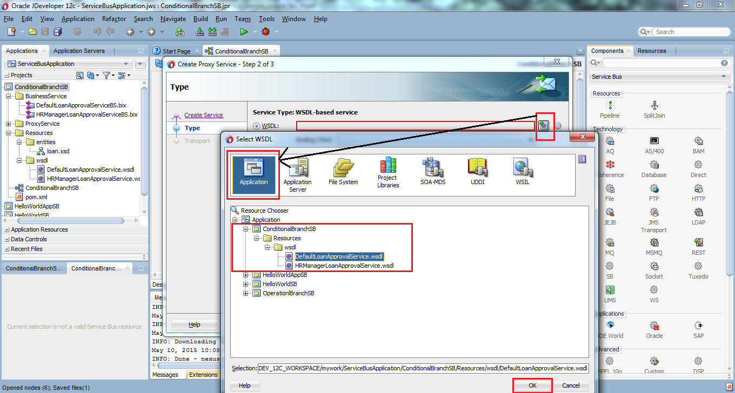](http://www.benchresources.net/wp-content/uploads/2015/05/20_OSB-12c_Conditional_Branch_example_New_Project_Proxy_service_wizard_9b.png)**

1. Create Proxy Service wizard –> populates wsdl file with port after reading the WSDL file we have chosen in the previous step
2. Click Next

**[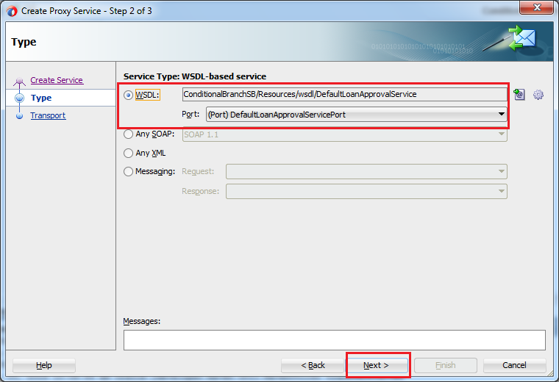](http://www.benchresources.net/wp-content/uploads/2015/05/21_OSB-12c_Conditional_Branch_example_New_Project_Proxy_service_wizard_9c.png)**

1. Create Proxy Service wizard –> populates endpoint URI
2. Click Finish

**[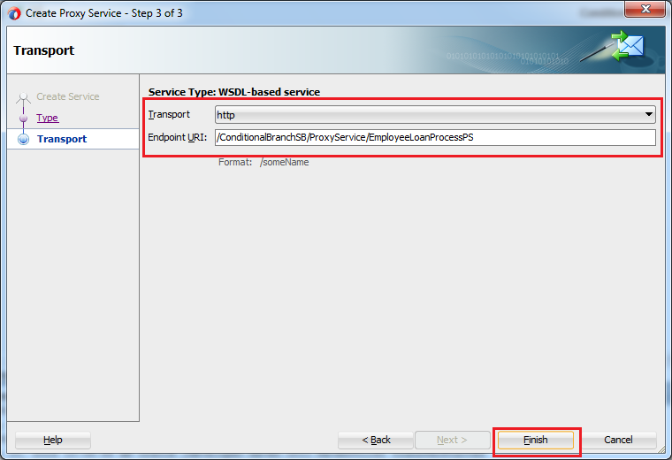](http://www.benchresources.net/wp-content/uploads/2015/05/22_OSB-12c_Conditional_Branch_example_New_Project_Proxy_service_wizard_9d.png)**

1. Finally Proxy Service is created
2. Proxy Service is created on the Proxy Services lane and this resides under “*ProxyService*” folder

**[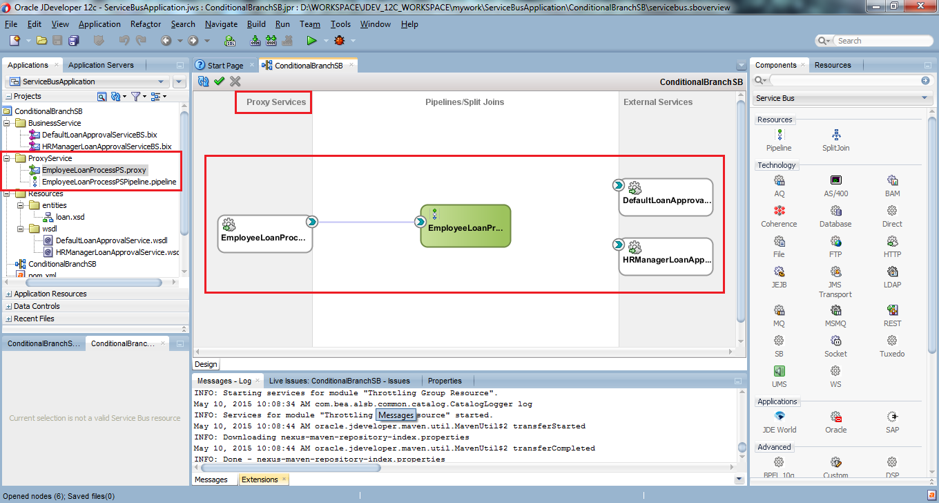](http://www.benchresources.net/wp-content/uploads/2015/05/23_OSB-12c_Conditional_Branch_example_New_Project_Proxy_service_created.png)**

1. Double-click on the *EmployeeLoanProcessPSPipeline* which opens up in new editor with .pipeline extension (green-color round-cornered rectangle type figure in the Pipelines/Split Joins)
2. Opens up EmployeeLoanProcessPSPipeline.pipeline file in an editor

**[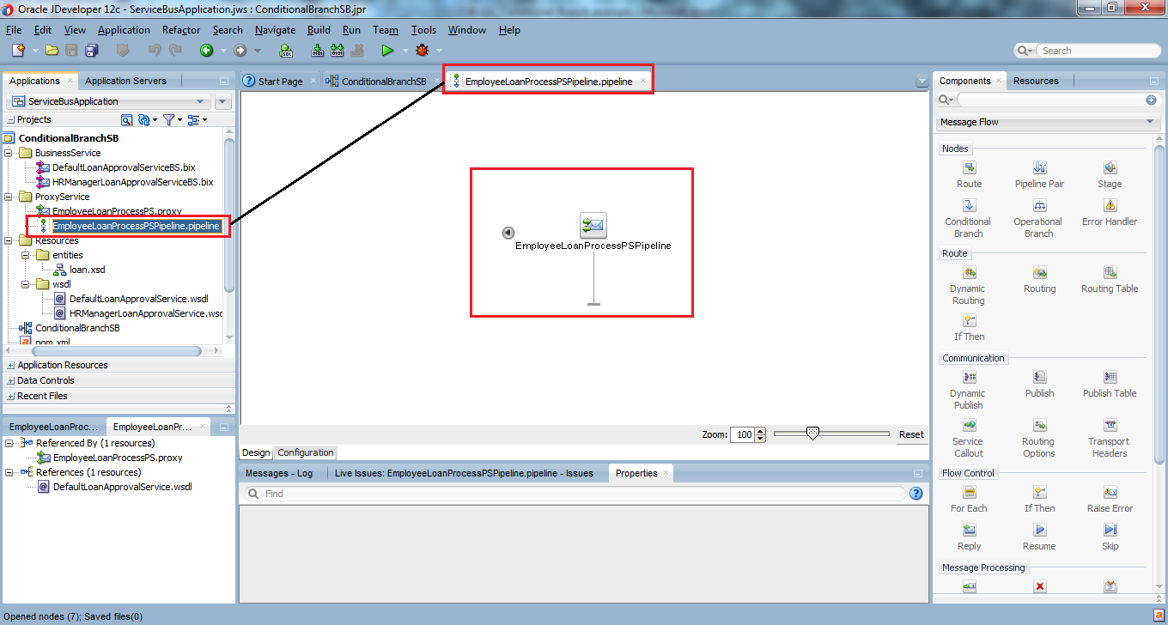](http://www.benchresources.net/wp-content/uploads/2015/05/24_OSB-12c_Conditional_Branch_example_New_Project_pipeline_editor.png)**

1. Conditional Branch node

**Conditional Branch:**We can have different routes based on the conditions exposed at the Proxy Service level

In this example, we got two conditions exposed at the Proxy Service level namely

* amountInDollars <= 4000
* amountInDollars > 4000

So using **conditional branch** node, we can expose different routes based on the conditions depending on the business requirements with always mandatory default branch

Reason for default branch is to route the incoming request, if nothing matches the exposed condition at the Proxy Service level

1. Drag and drop “*Conditional Branch*” from “*Message Flow*” under the category “*Nodes*”

**[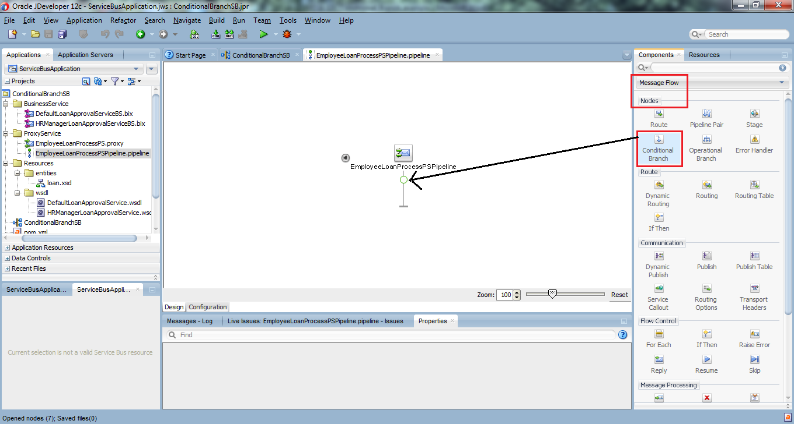](http://www.benchresources.net/wp-content/uploads/2015/05/25_OSB-12c_Conditional_Branch_example_New_Project_drag_cond_branch.png)**

Add one more branch to the already existing two branches **[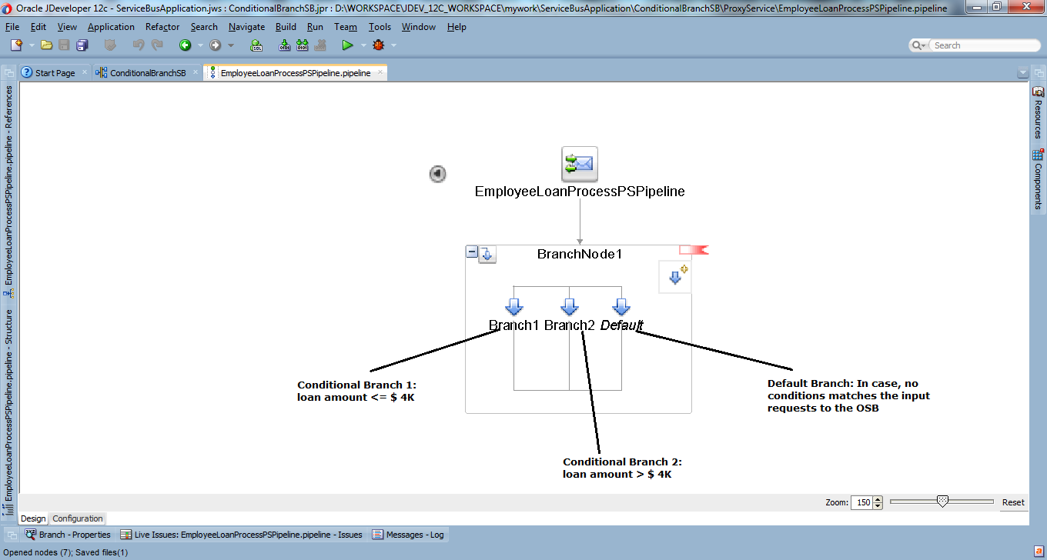](http://www.benchresources.net/wp-content/uploads/2015/05/26_OSB-12c_Conditional_Branch_example_New_Project_drag_cond_branch_ADD.png)**

**Error:** Red-ribbon type error mark on top-right corner is because, we haven’t set conditions in Conditional Branch (after setting conditions & saving would vanishes all errors)

1. Add condition expression to *”Conditional Branch”* node (from Conditional Flow – Properties)

* click BranchNode1 which opens up Conditional Flow – Properties in the dialog box
* select “body” in the Expression field
* click “fx” icon next to <XPath>

**[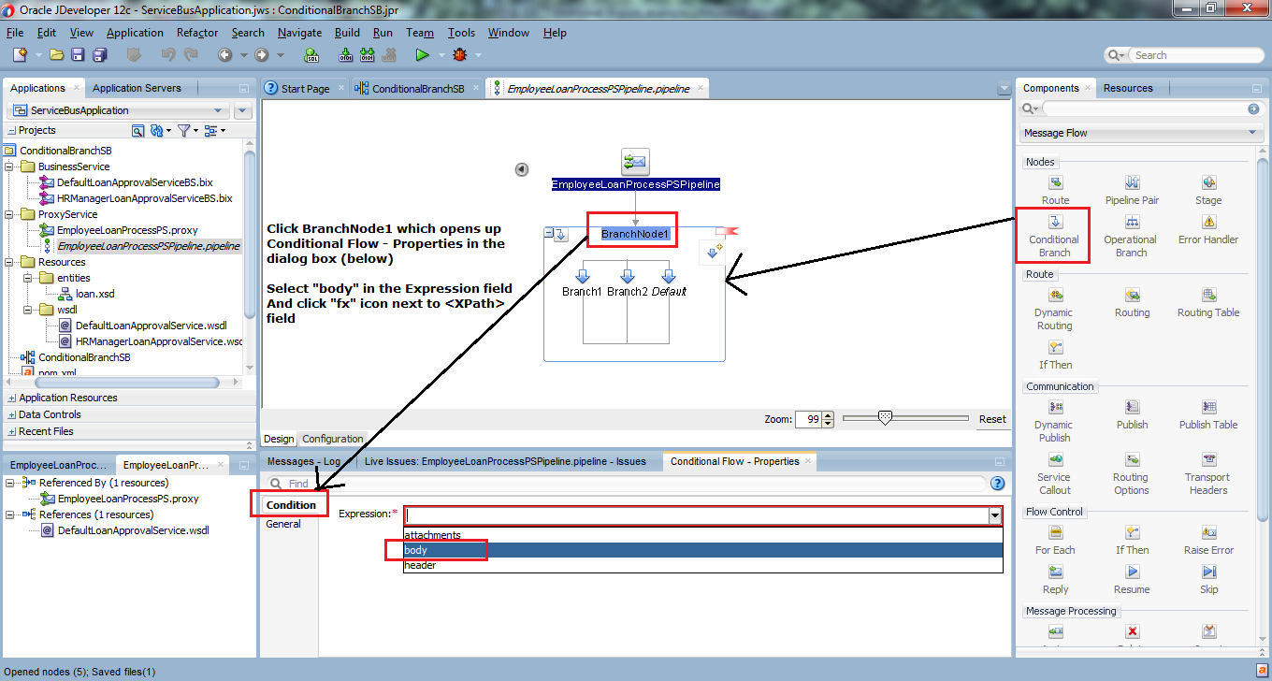](http://www.benchresources.net/wp-content/uploads/2015/05/27_OSB-12c_Conditional_Branch_example_New_Project_drag_cond_branch_ADD_condition.png)**

Select the attribute from input request body element to be evaluated

In this example, **amountInDollars** from the request and click “Insert Into Expression”

And this is entered into Expression box at the top

**Expression:** ./loan:ProcessLoanRequestType/loan:amountInDollars

**[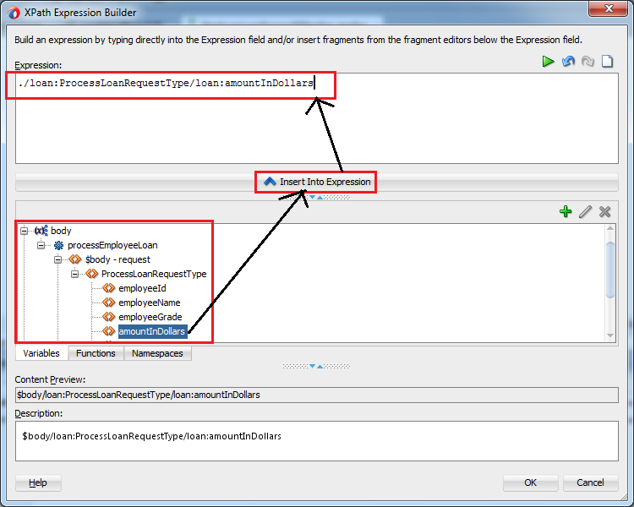](http://www.benchresources.net/wp-content/uploads/2015/05/28_OSB-12c_Conditional_Branch_example_New_Project_drag_cond_branch_ADD_condition_insert.png)**

1. Add conditions to all branches under “Conditional Branch” node

**Conditional Branch 1:** loan amount in dollars **<=** 4000

**[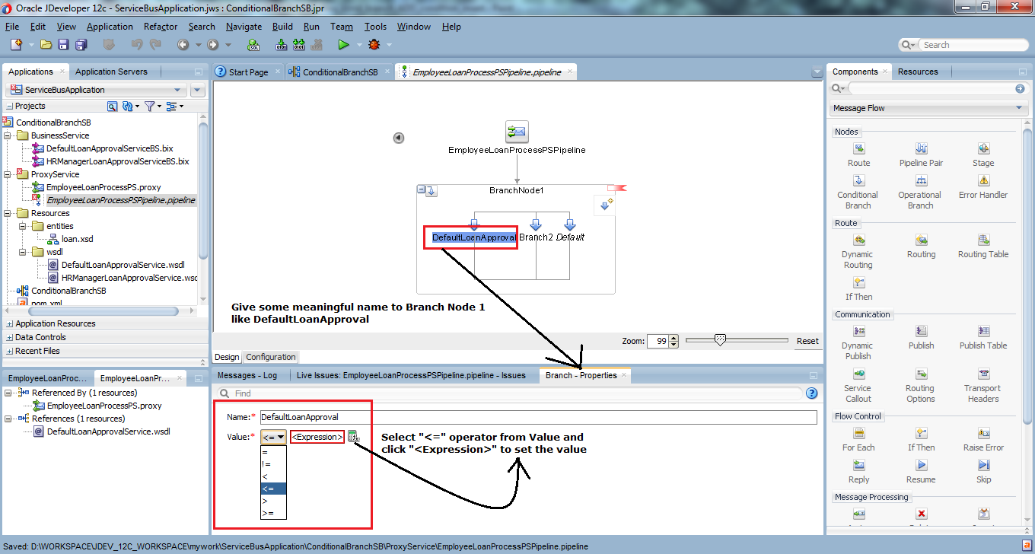](http://www.benchresources.net/wp-content/uploads/2015/05/29_OSB-12c_Conditional_Branch_example_New_Project_add_cond_to_branch_node_1.png)**

1. Enter the value “4000” for the comparison to go in this branch
2. Click OK

**[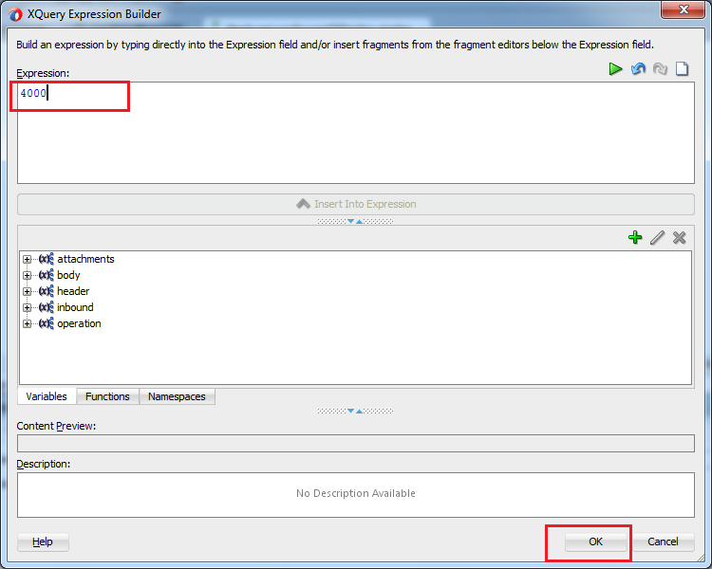](http://www.benchresources.net/wp-content/uploads/2015/05/30_OSB-12c_Conditional_Branch_example_New_Project_add_cond_to_branch_node_1_enter_values.png)**

**Conditional Branch 2:** loan amount > 4000

Similarly, do it for second branch as well but this time instead of “<=”, select “>” operator from the drop-down from the values (under Properties)

**[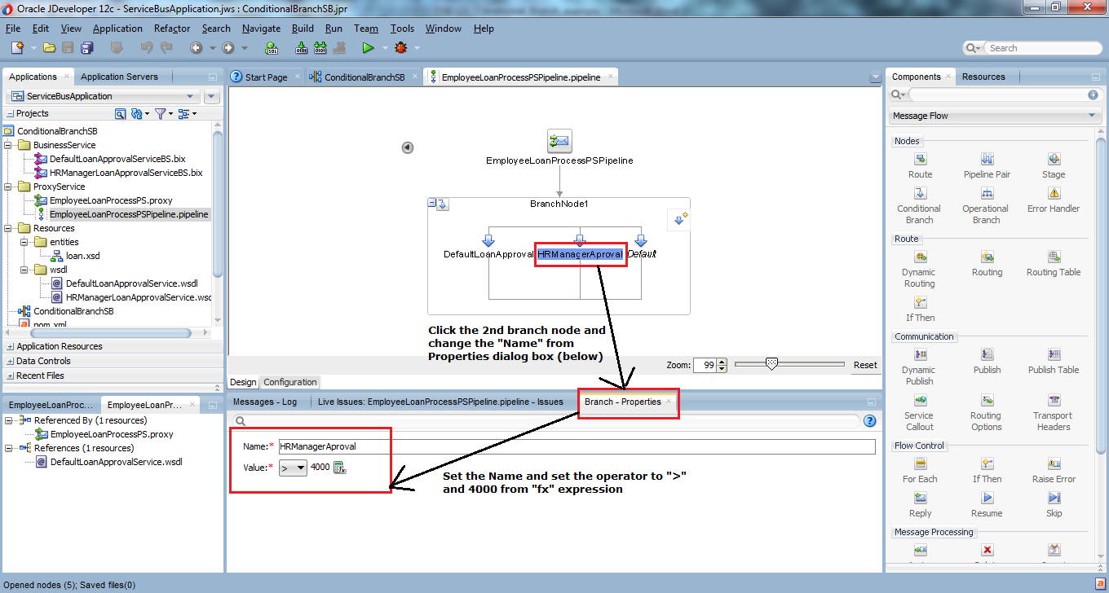](http://www.benchresources.net/wp-content/uploads/2015/05/31_OSB-12c_Conditional_Branch_example_New_Project_add_cond_to_branch_node_2_enter_values.png)**

**Note:** If any condition doesn’t fall under these two conditions (<=4000 or >4000), then default branch will come into picture (but safely all conditions are covered and there is no need to set any routing to business service for default branch)

1. Add Routing node to each conditional branches (skip adding Routing node to Default branch)

**Error:** Red-ribbon type error mark on each top-right corner is because, we haven’t chose any specific business service

**Advantage of OSB 12c over OSB 11g**

* When we drag and drop the Routing, it automatically have a Route node in place
* Whereas in 11g, we need to drag and drop Route node first before Routing node

**[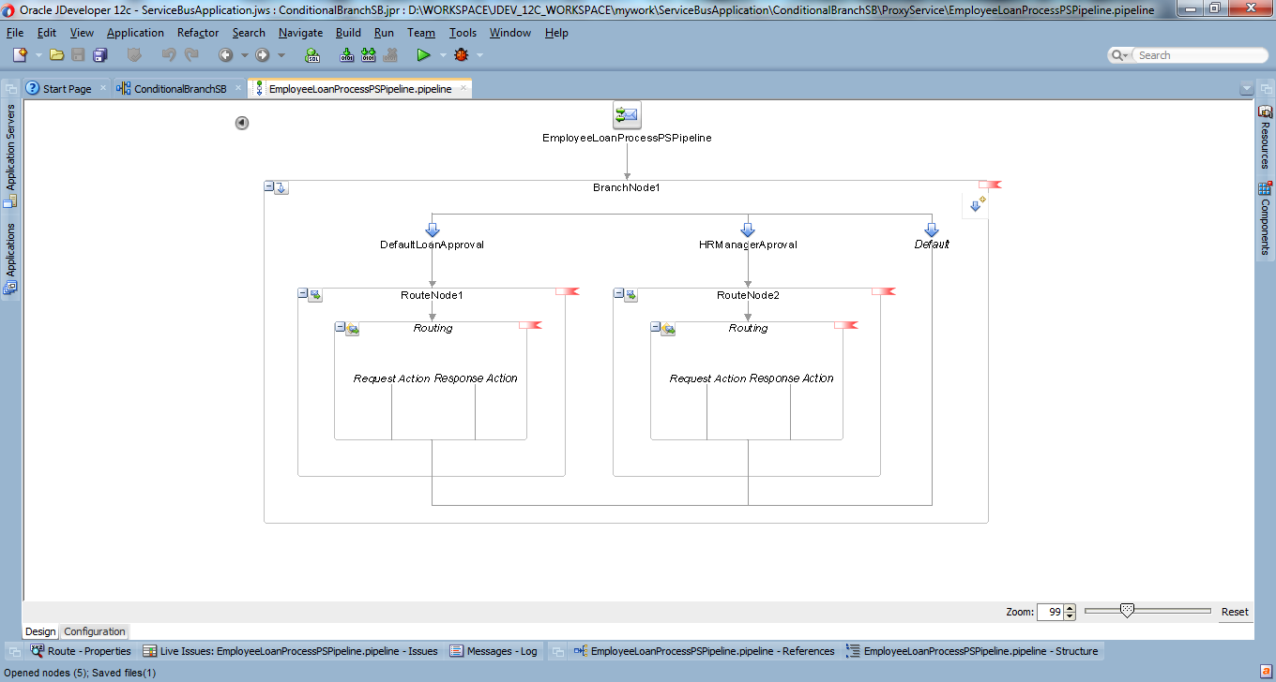](http://www.benchresources.net/wp-content/uploads/2015/05/32_OSB-12c_Conditional_Branch_example_New_Project_add_routing_to_each_branch_nodes.png)**

**Note:** once we select and set the business service in the Routing, then red-ribbon type error mark will vanish after saving all

1. Add business service to all Routing node
2. Click on Routing –> opens corresponding properties in the dialog box below
3. Click browse icon next to Service* –> opens “Resource Chooser” –> select service to be routed
4. Finally Click OK

**[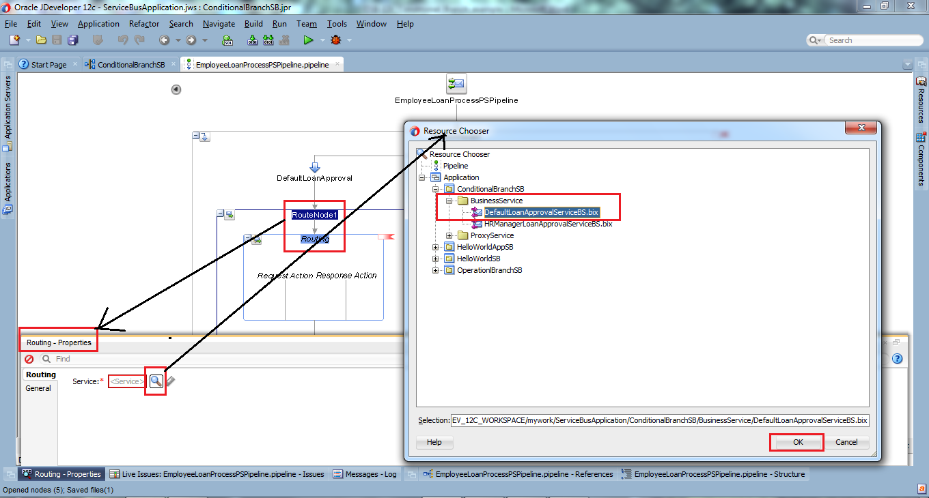](http://www.benchresources.net/wp-content/uploads/2015/05/33_OSB-12c_Conditional_Branch_example_New_Project_add_BS_to_routing_node.png)**

1. Similarly, do it for second operation as well (as said earlier red-ribbon type error vanished)

**[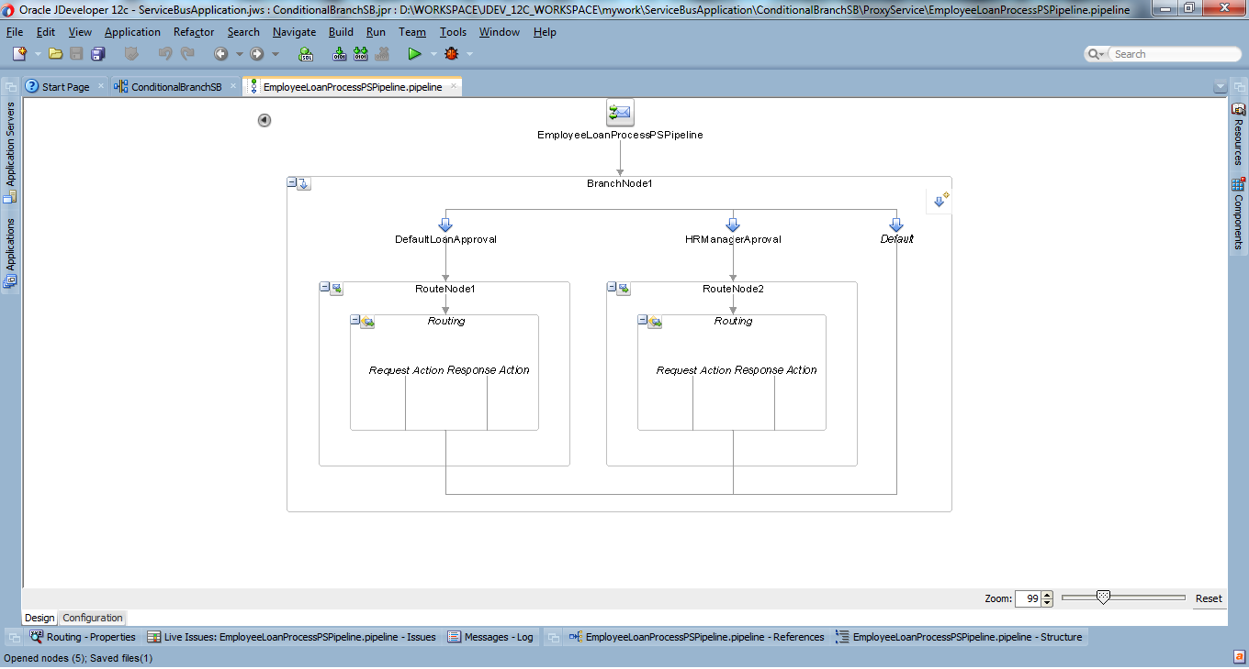](http://www.benchresources.net/wp-content/uploads/2015/05/34_OSB-12c_Conditional_Branch_example_New_Project_cond_branch_after_adding_BS_services.png)**

1. Add transformation logic for the Proxy Service (i.e.; EmployeeLoanProcessPSPipeline.pipeline) using assign/replace node

Generally,

* Request document to the input of OSB and request document to the input of Enterprise Service isn’t same at all time
* So, we need to add transformation logic to convert the request document received at the input of OSB –> to the input of External/Business Service
* Judiciously use **assign**, **replace**, **rename** nodes
* Invoking other services using “**Service Callout**” or “**Java Callout**” node to enrich the input request document before invoking External/Business Service

**Note:** Above points implies for response thread in the response pipeline of the pipeline-pair

But in our case, we don’t need any transformation logic as both Proxy Service and Business Service are roughly based on the same WSDL

Time to test !!

Testing Service Bus project –> deploying into IntegratedWeblogicServer

**[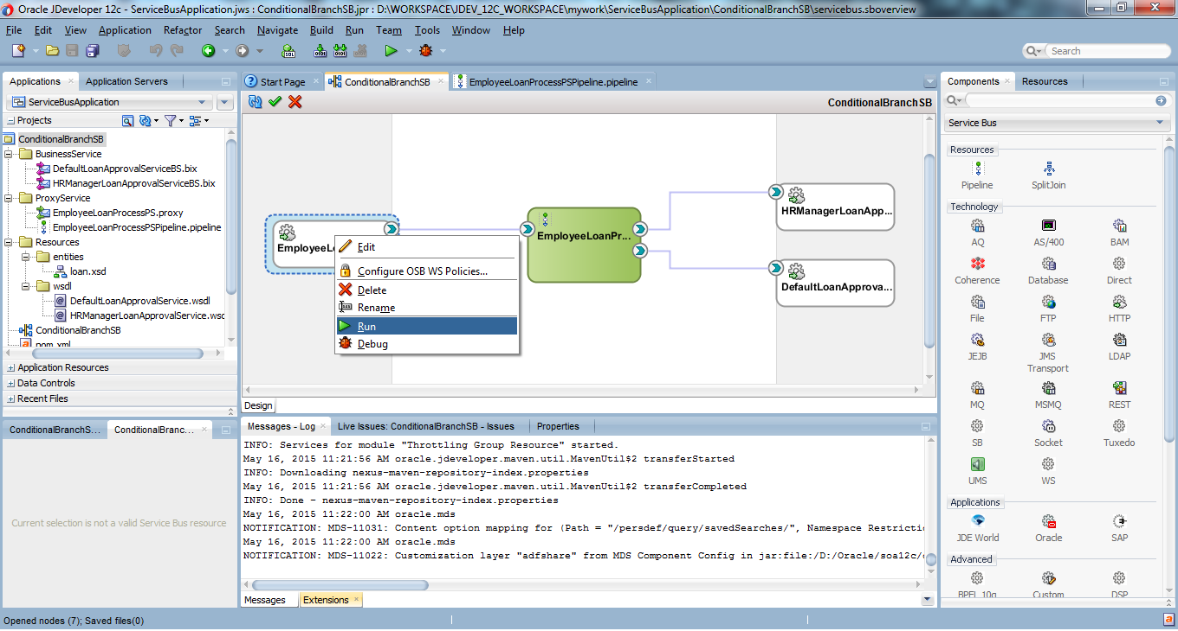](http://www.benchresources.net/wp-content/uploads/2015/05/35_OSB-12c_Conditional_Branch_example_New_Project_cond_branch_example_testing_run.png)**

**Testing**

This will open our traditional OSB console, where we can input and execute this sample mock service.

Enter necessary employee details requesting a loan amount of $. 3685

**Note:** Amount entered by the user is less than $. 4K, therefore OSB will route to default loan approval service

**[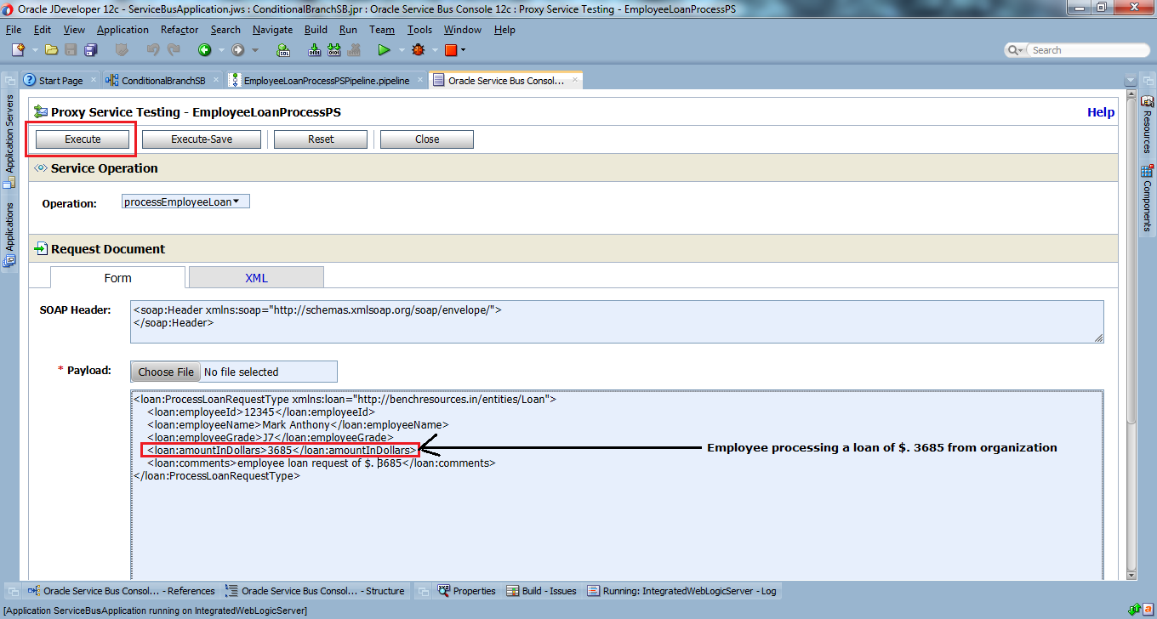](http://www.benchresources.net/wp-content/uploads/2015/05/36_OSB-12c_Conditional_Branch_example_New_Project_cond_branch_example_testing_run_execute.png)**

**Note:**Make sure enterprise web service is up and running, otherwise error will be thrown

Request document and Response document

**[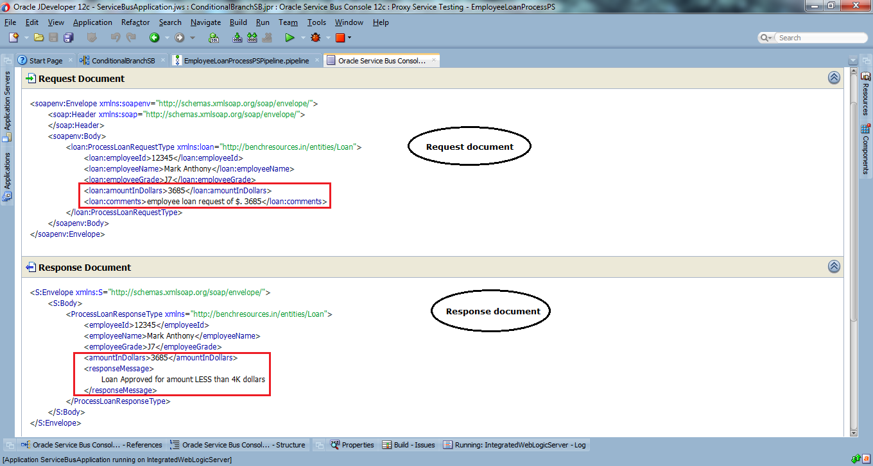](http://www.benchresources.net/wp-content/uploads/2015/05/37_OSB-12c_Conditional_Branch_example_New_Project_cond_branch_example_testing_result_output.png)**

Similarly, we can test for other case i.e.; entering loan amount of greater than $. 4K where OSB routes to HR Manager Approval service

**[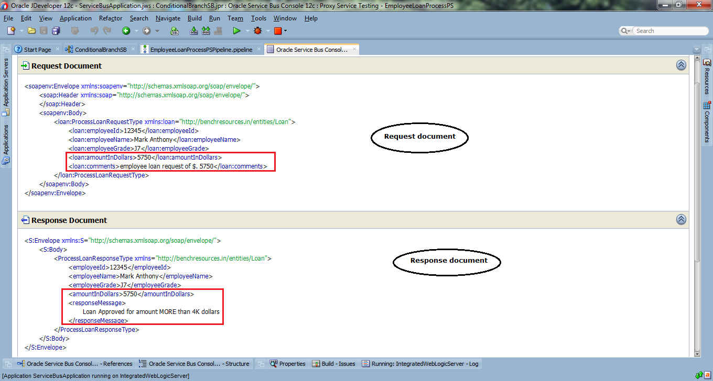](http://www.benchresources.net/wp-content/uploads/2015/05/38_OSB-12c_Conditional_Branch_example_New_Project_cond_branch_example_testing_result_output_2.png)**

The same can be tested through Service console (OSB console) at [**http://localhost:7101/sbconsole**](http://localhost:7101/sbconsole) (change the port number, if you have configured something else)

### Run a composite for JMS queue.

JMS Queu : queue_JMS_TriggerEvent

Message Selector : process = ‘ReadMessage’

java -cp /u01/cronscripts/jar/ProcessTriggerUtility-jar-with-dependencies.jar com.noble.ProcessTriggerUtility.JMSSender "t3://host:port" SOAJMSConnectionFactory "queue_JMS_TriggerEvent" "ReadMessage" /u01/cronscripts/jar